85 *Sullivan’s Island Comprehensive Plan 2018-2028: Land Use Element*

**CHAPTER 9: NATURAL RESOURCES ELEMENT**

HOW WE SUSTAIN

*Sullivan’s Island Comprehensive Plan 2018-2028: Natural Resources Element* 86

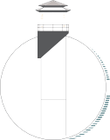

Natural resources refer to living and non-living things that exist independently from human intervention. Residents of

Sullivan’s Island have long held that recognizing and preserving its rich diversity of natural resources is one of the central components of developing the Town’s Comprehensive Plan.

This element will describe not only the Island’s physical and natural characteristics, but also consider various environmental challenges of life on a barrier island. Additionally, this element will strive to develop a policy framework to ensure future development on the Island remains sustainable and resilient

in the face of impending adverse environmental conditions. Achieving this goal will require a multifaceted planning effort between community stakeholders and Town elected officials with collaboration of the Town’s administration.



*In developing the goals and objectives for the Natural Resources element, sustainability and resiliency were two key concepts used by the Planning Commission and Steering Committee.*

*These terms are broadly defined as…*

*Sustainability “meeting the needs of the present without compromising the ability of future generations to meet their own needs.” 1*

*~Our Common Future*

*Community Resilience “the ability to prepare and plan for, absorb, recover from, and more successfully adapt to adverse events.” 2*

*~Urban Land Institute*

By maintaining the core values of sustainability and community resilience, the goals and objectives of this plan can help in preparing Sullivan’s Island when facing future storm events and the stark realities of sea-level rise.

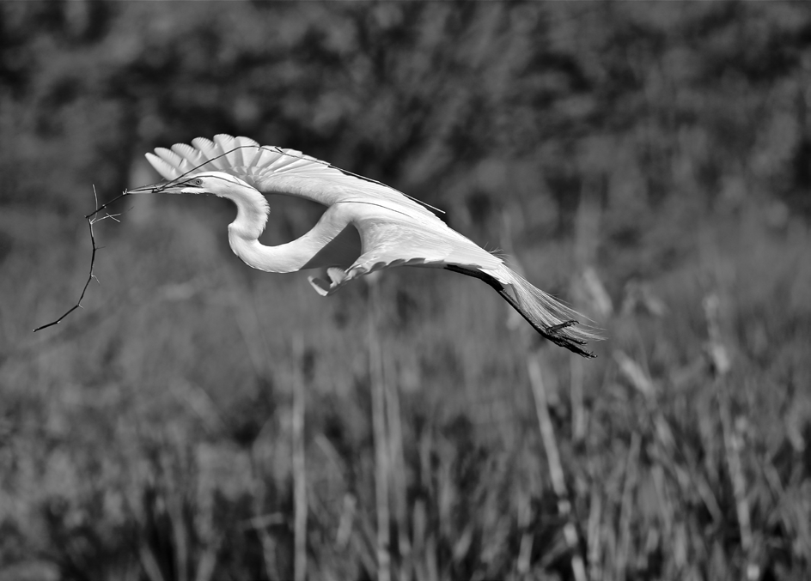

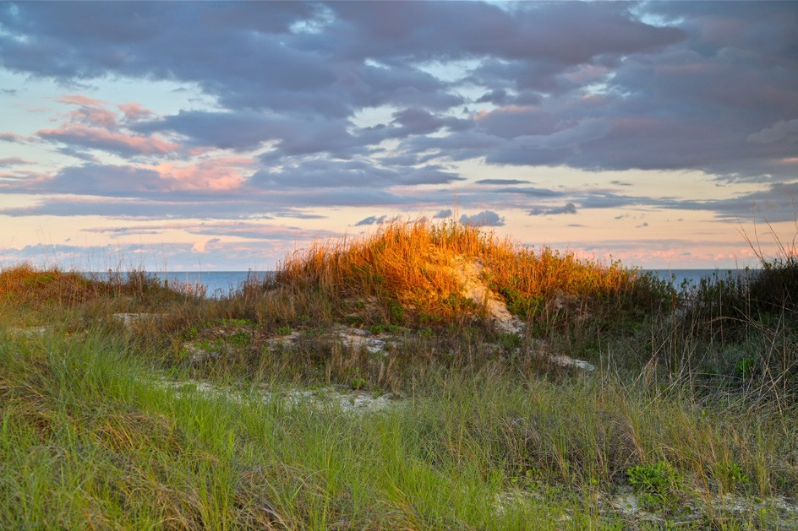

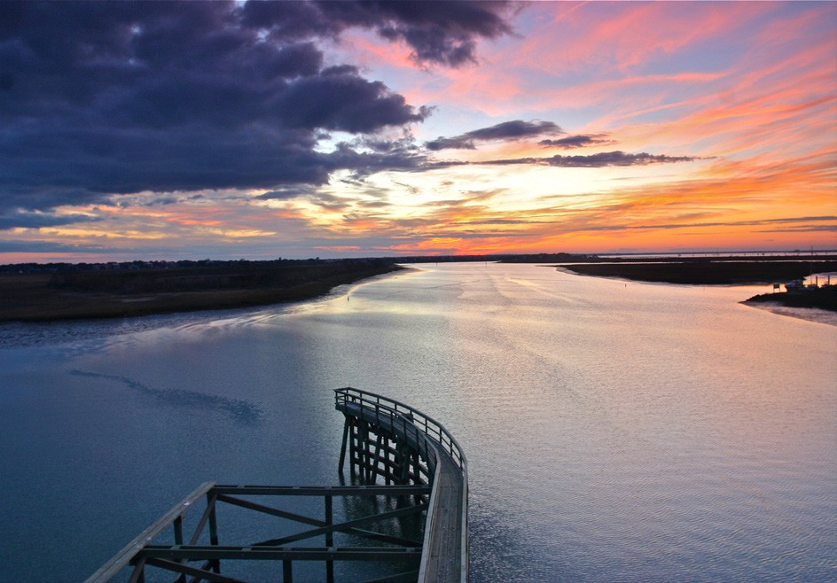

*Scenes of Sullivan’s Island - Photos Courtesy of Mark Howard*

1. *Brundtland Report Commission in 1987*
2. *Urban Land Institute: Building the Resilient City: https://uli.org/wp-content/uploads/ULI-Documents/BuildingtheResilientCity.pdf.*

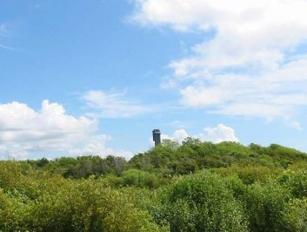

*The effect of salt spray on the Town’s Protected land*

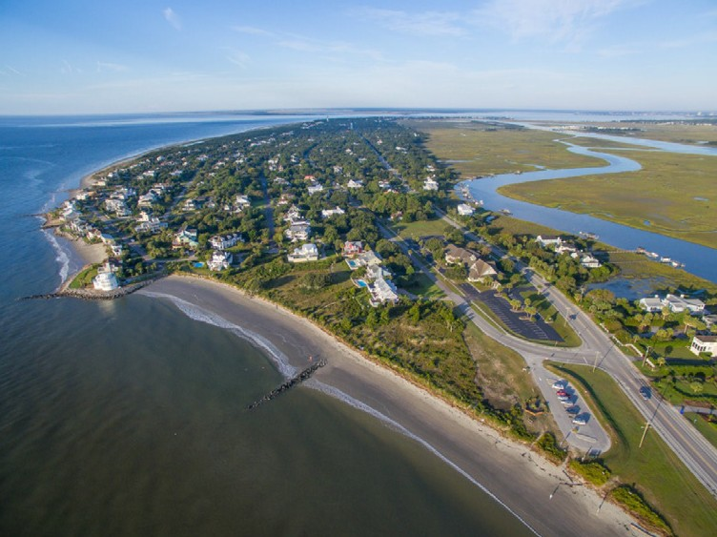

*Eastern end of Sullivan’s Island at Breach Inlet*

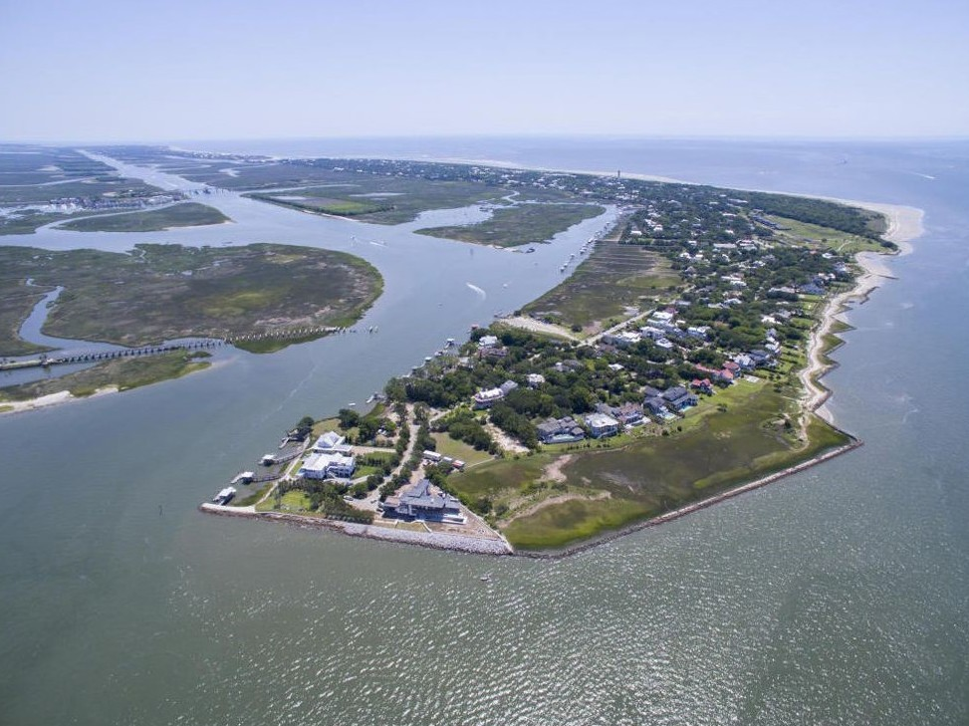

*Western end: View of Star of the West and the Protected Land*

## BARRIER ISLAND CHARACTERISTICS

Sullivan’s Island is a 3.8-mile-long barrier island located in the outer coastal plain, a geographically unique feature of the southeastern coastline. As a barrier island, it maintains an unusual orientation with most of its southern shoreline facing the Atlantic Ocean and its northern shoreline facing the Intracoastal waterway and marsh.

In geographic terms, the Island is rather young, having formed within the past 5,000 years. Sullivan’s Island is characterized by a beach and dune ridge system to its southern side, and tidal marsh along its northern side. There are approximately 190 acres of Town owned property that separates much of the residential area of the island from the active beaches; the property is mde up primarily of virgin maritime forests and scattered coastal wetlands and is most commonly referred to as the “accreted” or “protected” land.

When comparing Sullivan’s Island to other barrier islands in Charleston County, the Island has a unique orientation from east to west instead of north to south. This unusual orientation of the Island, along with the atypical flows of water around Breach Inlet, and the effects of the north jetty impeding the southwestern flow of sediment along the South Carolina coastline, has accumulated sand and grown the island’s beaches seaward along most of its shoreline. In contrast, Folly Beach, Isle of Palms and Edisto Island have experienced higher rates of erosion along their more eastern facing beaches.

The eastern end of the Island at Breach Inlet is experiencing regular rates of erosion while the middle and western end is stable and experiences regular accretion. The southwest facing end of the island is stabilized by the engineered structures, which would be experiencing erosion if the structures and accreted lands were not in place.

A comparison of Figure 9.1 *3* (mosaiced aerial photographs from 1941) and Figure 9.2 *4* (2017 aerial photographs) show the Island’s dramatic accretion over the past 75 years. The two highlighted areas in yellow show the western end (from Station 16 to Station 18) and central portion (from the Station 20 to Station 28) which in some areas has accreted more than 1,500 feet seaward. *5*

1. *Norm Levine, “Sullivan’s Island Maritime Forest Conservation Study,” College of Charleston 2006: 6.*
2. *Google Earth: 2017*
3. *Accreted Land Management Plan, Town of Sullivan’s Island (2010): 3*

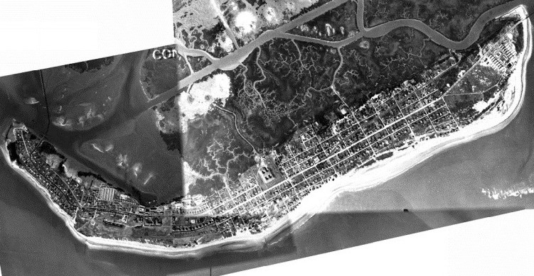

### FIGURE 9.1: SULLIVAN’S ISLAND - 1941 MOSAIC

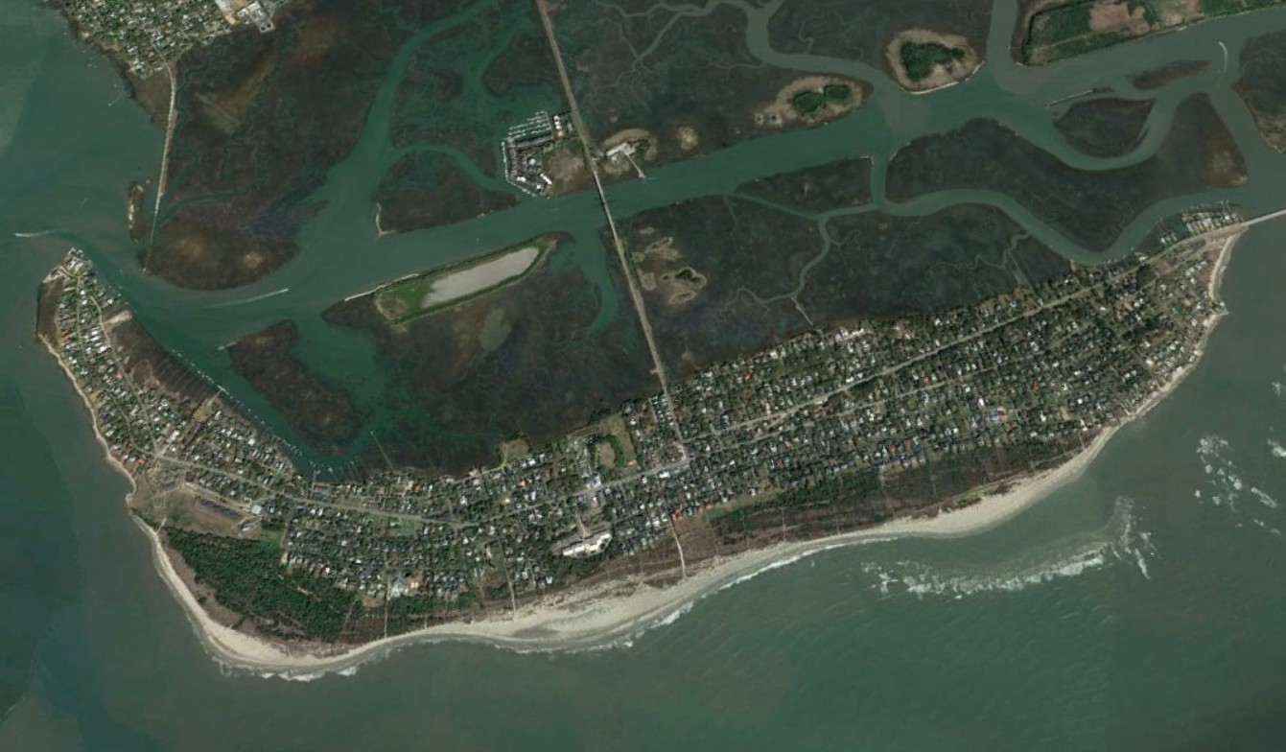

**FIGURE 9.2: 2017 AERIAL PHOTOGRAPH - GOOGLE EARTH**

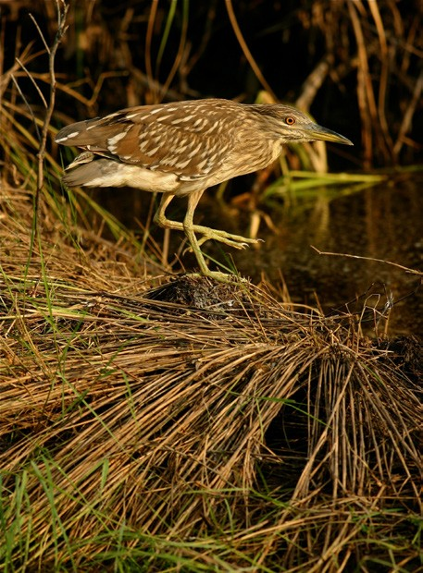

*A green heron pictured above. A variety of wildlife can be found in the Maritime Ecosystem, which constitutes most of Sullivan’s Island.*

This sand accretion has led to the formation of new dune ridges, which have gained significant elevation. Vegetation in this area has naturally adapted to poor soils, salt spray, and occasional flooding which is followed over time by a succession of land stabilization and other pioneering plant species. The new dune development has ultimately given way to a maritime forest. A diverse set of grass, shrub, and forest communities coexist within the accreted land and interior areas of Sullivan’s Island, providing ecological niches attractive to a wide range of plant and animal species. *6*

## BEACH AND MARSH ECOLOGICAL HABITATS

Sullivan’s Island has three distinct ecosystems, which are described below: (1) coastal marine, (2) maritime, and (3) estuarine *7*. Distinct geological, biological and botanical features characterize each ecosystem type. Factors such as wind, salt, tides, currents and soil nutrients control their geographic position across the Island. Figure 9.3 is a hypothetical transect of a barrier island and how each ecosystem transitions by physical characteristics and its vegetative and wildlife activity.

### FIGURE 9.3: CROSS-SECTION OF A BARRIER ISLAND TRANSECT

Meters

|  |  |  |
| --- | --- | --- |
| ESTUARINE ECOSYSTEM | MARITIME ECOSYSTEM | COASTAL MARINE ECOSYSTEM |
| Oyster beds, tidal marsh, mud falts (young fish and sealife) | Dune Community, transitional shrub zone, maritime forest (Decidous, coniferous, palmetto trees, sea oats) | From primary dune to 3 miles off shore (berm activity: sea turtle nesting, shorebirds) |



Spartina Marsh

Forest

Stable Dune

Shifting Dunes

Ocean Beach

Tidal

Creek

20

15

10

5

*Coastal Marine Ecosystem*

The coastal marine ecosystem extends from the seaward side of the primary dune to 3 miles offshore. Due to the physical factors characterizing this harsh environment (winds, currents, salt, tides, etc.), this area supports few terrestrial plants. Although this habitat provides a harsh environment for terrestrial vegetation, many faunal species are known to inhabit the area. Sea turtles use the dune area for nesting while feeding and mating occurs offshore. In addition, many birds (such as terns, skimmers, ducks, pelicans, gulls, and shorebirds) exploit the area’s food resources. *8*

1. *Norm Levine, “Sullivan’s Island Maritime Forest Conservation Study,” College of Charleston 2006: 33*
2. *Accreted Land Management Plan, Town of Sullivan’s Island (2010): 44*
3. *Accreted Land Management Plan, Town of Sullivan’s Island (2010): 45*

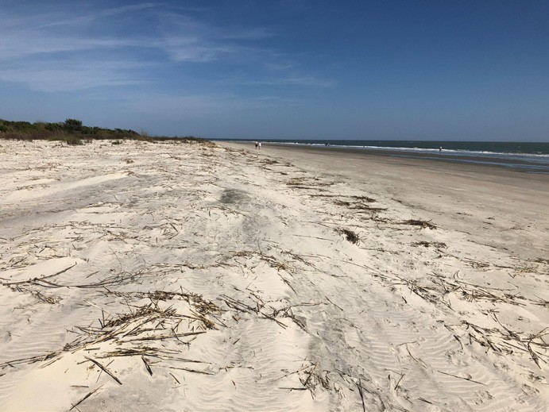

*Primary Dune*

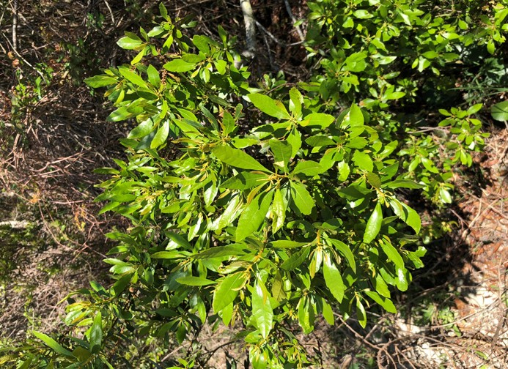

*Wax myrtles within the transitional shrub zone of the Town’s Protected Land.*

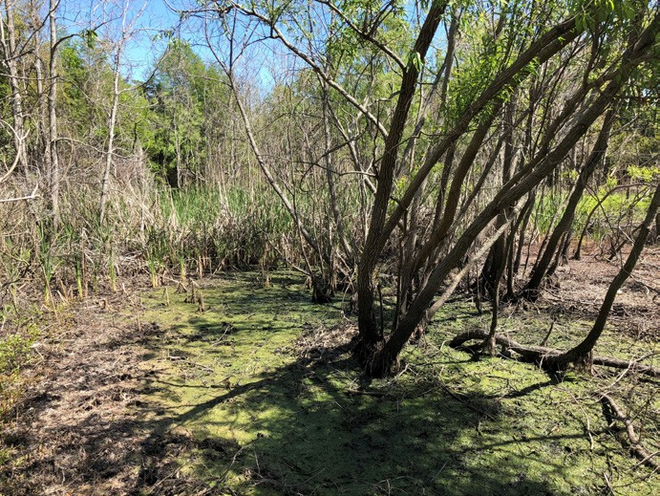

*Freshwater wetlands are scattered throughout the maritime forest.*

# Maritime Ecosystem

The Island’s residential areas and protected land occurs within this ecosystem and is bound by the primary oceanfront sand dune on the seaward side and extends to the mean high-tide mark on the bay side of the Island. The center of a barrier island is usually characterized by the presence of a dense forest made up of a mixture of pine, palmetto, and deciduous trees. As a result of tree preservation and residential property development, a mature urban forest has developed over the years.

The maritime ecosystem on Sullivan’s Island type is generally divided into three distinct sections: dune community, transitional shrub zone, and maritime forest, which each contain a range of flora and fauna species. *9*

* *The dune community is found from the primary dune to the transitional shrub zone. This area typically contains a variety of salt and wind tolerant species such as dune grasses and forbs, which account for the majority of primary productivity in this area. Avian species are the main fauna found here.*
* *The transitional shrub zone occurs between the dune community and the maritime forest. Due to the vegetation structure in this community, a high number of avian, mammalian and herpetofauna species can be found. Specific vegetation communities documented at Sullivan’s Island within the transitional shrub zone are maritime shrubland and manipulated maritime shrubland.*
* *The maritime forest occurs inland of the transitional shrub zone and extends across the barrier island to the transitional shrub zone which fronts the marsh.10*

# Estuarine Ecosystem

This ecosystem occurs between the upper reaches of saltwater influence on the bay side of the barrier island and the upper reaches of saltwater

influence on the mainland.*11* The importance of the back of the Island cannot be overlooked. Tidal salt marshes are very productive places, however are often the most vulnerable to sea level rise. They are the nursery for young fish and sea life, they assimilate runoff from the upland, and they assist in controlling flooding. These marshes accomplish these services due to the vegetation such as Spartina grasses and the micro-organisms that grow in these marshes.*12*

1. *U.S. Fish and Wildlife Service; Endangered Species.* [*https://www.f*](http://www.fws.gov/endangered/species/us-species.html)*ws.gov/*[*endangered/species/us-species.html*](http://www.fws.gov/endangered/species/us-species.html)
2. *Accreted Land Management Plan, Town of Sullivan’s Island (2010): 46*
3. *Norm Levine, “Sullivan’s Island Maritime Forest Conservation Study,” College of Charleston 2006: 33.*
4. *Accreted Land Management Plan, Town of Sullivan’s Island (2010): 46*

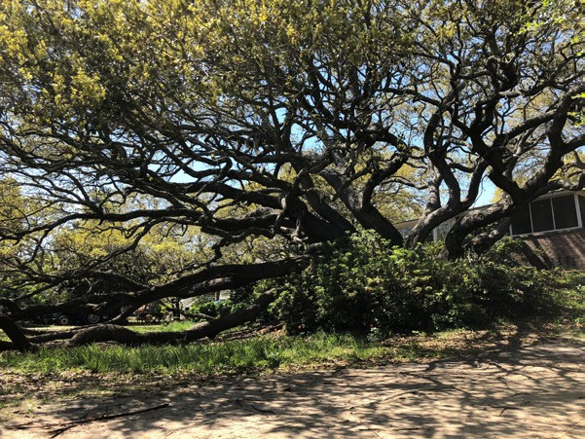

*Made famous by Edgar Allan Poe’s short story, the “Gold Bug Tree” on Goldbug Avenue is protected by the Town’s Tree Preservation Ordinance.*

**TABLE 9.1: ENDANGERED SPECIES**

*Animal and plant species having federal and state legal protection*

*endangered/species/us-species.html*

## WILDLIFE AND VEGETATION

The Island serves as a critical habitat to a variety of animal and plant species. The flora of the Island has adapted physiologically to thrive under the harsh conditions. For example, many salt-tolerant plants possess small, waxy, flexible leaves to resist the damaging effects of salt spray and wind conditions. In addition, many grass species have the ability to produce asexually by means of rhizomes or root runners, which is a characteristic of wax myrtles. This

vegetation also serves to stabilize and trap sand in oceanfront dunes making the wax myrtle a critical component of dune growth, particularly where dunes are fronted by a dry sand beach.

## TREE PRESERVATION

|  |  |  |
| --- | --- | --- |
| FEDERAL STATE COMMON NAME STATUS STATUS | | |
| Bald Eagle | Recovered | Recovered |
| Wood Stork | Endangered | Endangered |
| Kirtland’s Warbler | Endangered | Endangered |
| Least Tern | Not Listed | Threatened |
| Wilson’s Plover | Not Listed | Threatened |
| Piping Plover | Threatened | Threatened |
| Rafinesque’s Big-eared Bat | Not Listed | Endangered |
| Red Knot | Threatened | Threatened |
| Kemp's Ridley Sea Turtle | Endangered | Endangered |
| Leatherback Sea Turtle | Endangered | Endangered |
| Loggerhead Sea Turtle | Threatened | Threatened |
| Green Sea Turtle | Threatened | Threatened |
| Shortnose Sturgeon | Endangered | Endangered |

The Island’s first tree preservation ordinance was created in the early 1990s following the catastrophic loss of trees during Hurricane Hugo. Its purpose was to preserve the natural landscape by enhancing tree mass and canopy area throughout Island. The tree preservation ordinance is

codified in the Town’s Zoning Ordinance and is regulated by the Tree Commission and Town staff.

In addition to protecting their natural beauty, the ordinance protects trees to improve surface drainage and water quality and to prevent erosion, wind damage and to minimize flooding. Trees also serve to improve air quality, lessen air pollution, protect wildlife, and help to sustain property values island-wide.*13*

The Town’s ordinance cites four species: live oaks, southern magnolias, pecans, and eastern red cedars, along with sabal palmettos as prized species on the island; mitigation for removal of any of these species requires replacement with one of those four species, or like-kind replacement for the sabal palmettos.

## BIRDS

The dispersed wetlands and marshes provide a transition area which is an ideal habitat for nesting and roosting for many types of birds. Near-arctic migrant birds also use Sullivan’s Island as a resting and feeding point during their annual migration routes.

Table 9.1 presents a list of animal and plant species that have state or federal legal protection and are known to reside on Sullivan’s Island.*14*

1. *Town of Sullivan’s Island Zoning Ordinance, “Tree Commission” Article 17. 80.*
2. *U.S. Fish and Wildlife Service; Endangered Species.* [*https://www.f*](http://www.fws.gov/)*ws.gov/*

## SEA TURTLES

Sullivan’s Island is a nesting ground to a varying population of sea turtles each year. The nesting statistics in Table 9.2 *15* was generated from a centralized database which works to aggregate data from multiple sea turtle conservation organizations. Additionally, the South Carolina Department of Natural Resources Marine Turtle Conservation Program provides research, monitoring and education for all sea

turtles along the coast. The Town also supports the “Turtle Team,” a dedicated group of Sullivan’s Island and Isle of Palms volunteers who monitor the critical habitat and nesting of loggerhead turtles. They regularly provide advocacy services and outreach materials along with nesting information on their website.

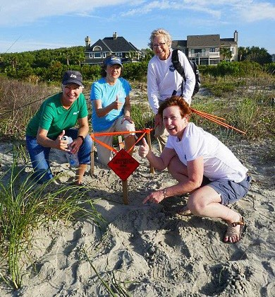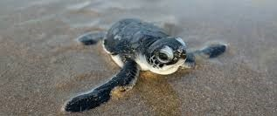

**TABLE 9.2 SEA TURTLE NESTING ON SULLIVAN’S ISLAND 2010-2017**

|  |  |  |  |  |  |  |  |  |
| --- | --- | --- | --- | --- | --- | --- | --- | --- |
| 2010 | | 2011 | 2012 | 2013 | 2014 | 2015 | 2016 | 2017 |
| Number of Nests | 2 | 4 | 6 | 3 | 6 | 5 | 15 | 8 |
| In Situ (not moved) | 0 | 3 | 1 | 1 | 2 | 3 | 5 | 3 |
| Nest Relocated | 2 | 1 | 5 | 2 | 4 | 2 | 10 | 5 |
| False Crawls | 1 | --- | 3 | 9 | 9 | 5 | 18 | 3 |
| Estimated Eggs | 155 | 335 | 730 | 408 | 642 | 252 | 1305 | 865 |
| Eggs Lost | 2 | 3 | 7 | 3 | 7 | 99 | 23 | 9 |
| Hatched Eggs | 113 | 201 | 657 | 377 | 602 | --- | 901 | 766 |
| Emerged Hatchlings | 108 | 190 | 616 | 350 | 576 | --- | 825 | 738 |

## PHYSIOGRAPHY AND TOPOGRAPHY

*Geology*

*Turtle Team members of Sullivan’s Island and IOP partner with the SC DNR biologists to track and document annual nesting trends.*

There are three types of geologic deposits located in the Town of Sullivan’s Island (Map 9.1). The newest deposit is artificial fill covering the center of the Island, made of sand and clay sand that is of diverse origin and ranges in depth from 3 to 10 feet. The original deposit of the Island is beach and barrier island sands from the Holocene

period made of quartz sand, which is very light gray, fine grained, well-sorted, shelly, and abundant with minerals. The deposits are less than ten thousand years old, and those on the surface are probably less than one thousand years old and range in depth from zero to 35 feet.

Portions of the Island are made up of tidal marsh deposits from the Holocene period, which are composed of clay and soft, organically-rich sand colored gray to black, dominated primarily by the mineral kaolinite. The deposits are zero to 10 feet thick and support marsh grasses. These deposits are most likely less than five thousand years old.

1. *South Carolina Department of Natural Resources: Marine Turtle Conservation Program, 2018* [*http://www.dnr.sc.gov/news/2017/may/may1_turtle.html*](http://www.dnr.sc.gov/news/2017/may/may1_turtle.html)

*Sullivan’s Island Comprehensive Plan 2018-2028: Natural Resources Element* 94

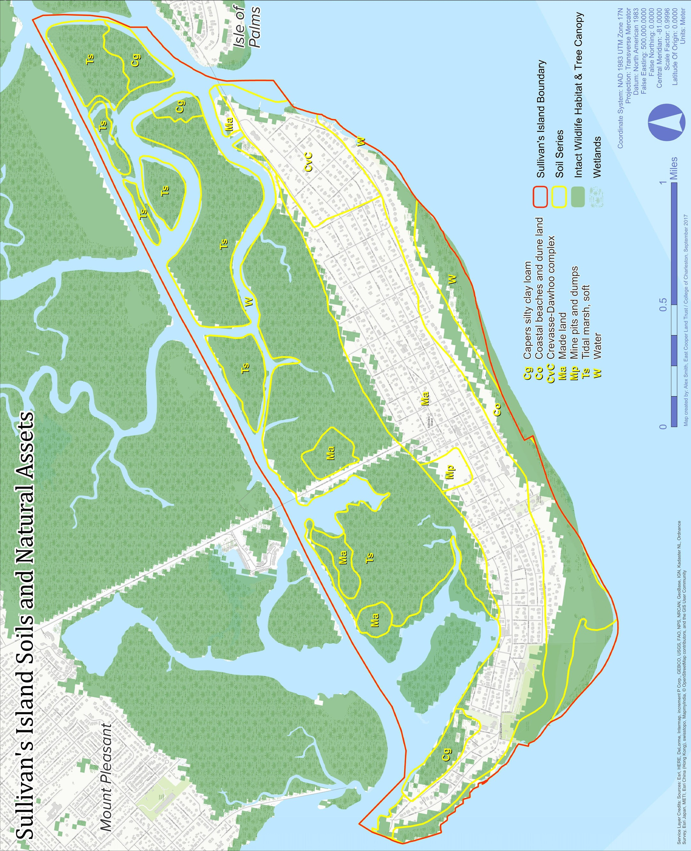

**MAP 9.1**

# Soils

Soil information given here is not for use on a site-specific basis and should only be used for planning on a community scale. Soil suitability assessments for individual sites require an independent, detailed soil survey.

While Sullivan’s Island’s soils are mainly classified as tidal marsh association soils, six different soil series have been identified. Since artificial fill is the predominant geologic formation on the island, ‘made land’ is the dominant soil series. Made land consists of variable amounts of sand, silt, and clay, or mixtures of these materials. New suitability assessments are important for this series because of the wide range of variation that can occur over time.

A small area located on the south side of the Island is characterized by the Capers series. Formed on tidal flats that are inundated with sea water once or more each month, these soils are very poorly drained and are saturated with salt water. The Capers series is well-suited for wildlife, and normally supports marsh grasses, but if drained, the soil becomes very acidic and can no longer support plant life. Coastal beaches and dune land make up the shoreline and dunes of Sullivan’s Island. The shoreline areas are nearly-level, fine sand beaches that are flooded twice daily by the tidal currents. The dunes formed by the wind are mounded areas of dry, loose, very pale brown to yellow sand. The sand is dry and there is sparse protective ground cover, leading to wind erosion of the dunes. The loss of this sand is a constant problem on the South Carolina coast, especially on the eastern end of Sullivan’s Island, which is battling natural erosional forces while the western end continues to accrete. In an effort to combat wind erosion, wind breaks of American Beach Grass and Sea Oats can be used to stabilize the dunes. Because of their instability, coastal beaches and dune lands are generally poorly suited for most kinds of development, though much of this area on Sullivan’s Island is zoned for recreation and conservation in an effort to restrict development in the area. Across most of the accreted lands, healthy dune ecosystems thrive with the bare sandy dunes beginning at the ocean and progressing to hearty vegetation such as wax myrtles that grow as large as many trees.

The eastern portion of the Island is made up of the Crevasse-Dawhoo soil complex. These soils occupy a ridge- and-trough landscape bordering the Atlantic Ocean. Crevasse soils are excessively-drained, sandy soils along the length of the long, narrow ridges, while Dawhoo soils are very poorly-drained, sandy soils that occupy the troughs between the ridges. Both soils have rapid infiltration and permeability, low available water capacity, low organic matter content, and low levels of inherent fertility, with the main difference between these two soils being that the Dawhoo soil has a high-water table for at least part of the year. Though much of this area is forested, neither of these soils is rich in nutrients, nor does either support cultivation.

The soil in the marsh is classified as tidal marsh, soft. This is a miscellaneous land type occurring on the coast and along tidal streams and rivers between the ocean and the uplands. It is in broad, level tidal flats that are covered by 6 to 24 inches of salt water at high tide.

## WATER QUALITY (HYDROLOGY)

Sullivan’s Island is located in the Ashley-Cooper Watershed, which is part of the larger Catawba-Santee Watershed Basin.

The Intracoastal Waterway (ICW) passes behind Sullivan’s Island, and maintains views of The Cove, Cove Creek, Inlet Creek, Swinton Creek, and Conch Creek. The Cove and Cove Creek feed into the Charleston Harbor, while Inlet Creek, Swinton Creek, and Conch Creek drain into the Atlantic Ocean through Breach Inlet.

Some of the waters surrounding Sullivan’s Island are approved for shellfish harvesting, some offer restricted harvesting, and some areas are closed to harvesting. The South Carolina Department of Health and Environmental Control (SCDHEC) regulate these waters depending on a host of factors pertaining to safety, seasonal conditions, and shellfish management. Current information on shellfish harvesting is available at:

[*http://www.scdhec.gov/FoodSafety/ShellfishMonitoring/.*](http://www.scdhec.gov/FoodSafety/ShellfishMonitoring/)

Urban runoff appears to have a significant impact on the lower portion of the watershed. A series of ditches carry stormwater directly into the ICW, together with spoil from containment areas, which discharge into the ICW and its tributaries (Conch Creek, Inlet Creek, and Swinton Creek) during storm events.

The Charleston Waterkeeper monitors and tests waters across the region and surrounding Sullivan’s Island to provide data supporting clean water advocacy, habitat restoration, and pollution reporting. In 2023 water quality testing along the beaches at Stations 18.5, 26, and 30 determined that those locations remained safe for swimming throughout the year, but the monitoring location on Cove Creek, near the old bridge site, revealed a bacterial spike in late September of 2023. This was the only instance of water quality issues at the site during 2023, and the bacterial spike in the water had subsided by the time of testing the following week. The Waterkeeper is also working with NOAA to monitor for pesticides and Polycyclic Aromatic Hydrocarbons (PHAs) in Cove Creek near the Station 16 outfall; this monitoring started over a year ago and is ongoing.

In order to implement a comprehensive and economical approach to prevent and control water resource impacts from non-point source pollution, the Town in 2007 partnered with Charleston County and other local jurisdictions. This partnership focuses on water monitoring, developing best management practices, education, public participation, and implementing solutions. The result of this program will ensure compliance with the Clean Water Act and provisions of the National Pollutant Discharge Elimination System (NPDES) Phase II requirements for the Town.

## CLIMATE AND PRECIPITATION

Sullivan’s Island has a year-round temperate climate that averages from 89 degrees Fahrenheit in July to 48 Fahrenheit in January. The Town’s average annual precipitation is 49.79 inches, however, for several years extreme rain events have skewed this figure.

Because of the Island’s proximity to the Atlantic Ocean, average monthly temperatures are mild in the summer and winter. Figure 9.4 illustrates the highest rate of rain fall corresponds with the hottest summer months.

90ºF

70ºF

50ºF

30ºF

**FIGURE 9.4: SULLIVAN’S ISLAND CLIMATE**

7 in.

6 in.



5 in.

4 in.

3 in.

2 in.

1 in.

0 in.

Low High Percipitation



*Source: US Climate Data*

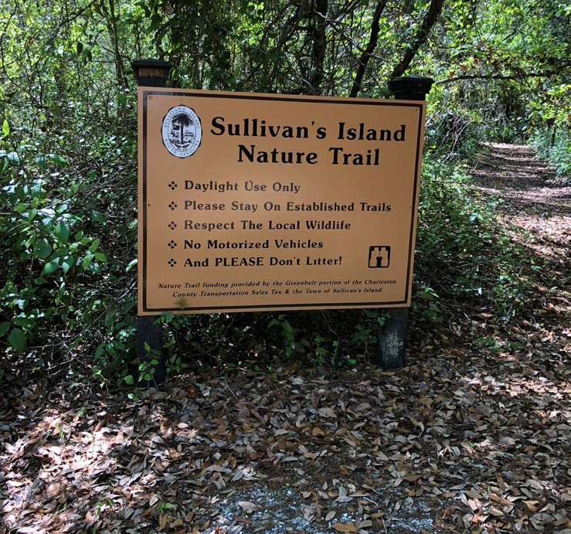

*The Sullivan’s Island Nature Trail was constructed in 2015 and is part of the management strategy for the Town’s Protected Land.*

## PREVIOUS PLANS, POLICIES AND INITIATIVES

Over the years, the Town has developed multiple standalone plans that are intended to provide long-range and short-range policy guidance for the protection and preservation of natural resources, conservation, public access and Town owned property. Some of these plans are listed below and are accessible at:

[*http://www.sullivansisland-sc.com/government/CURRENTTOWNPROJECTS.aspx.*](http://www.sullivansisland-sc.com/government/CURRENTTOWNPROJECTS.aspx)

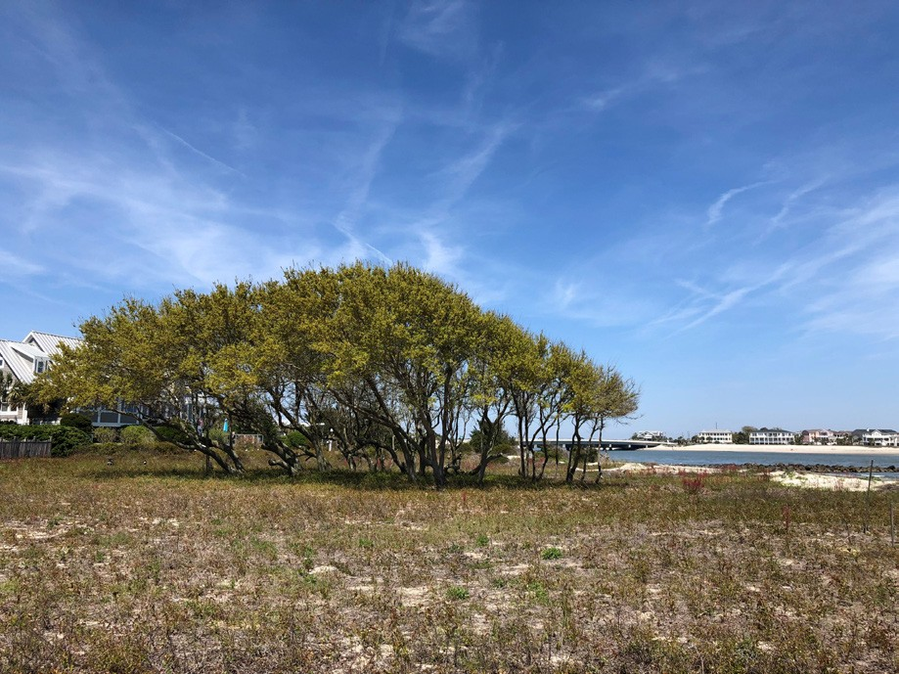

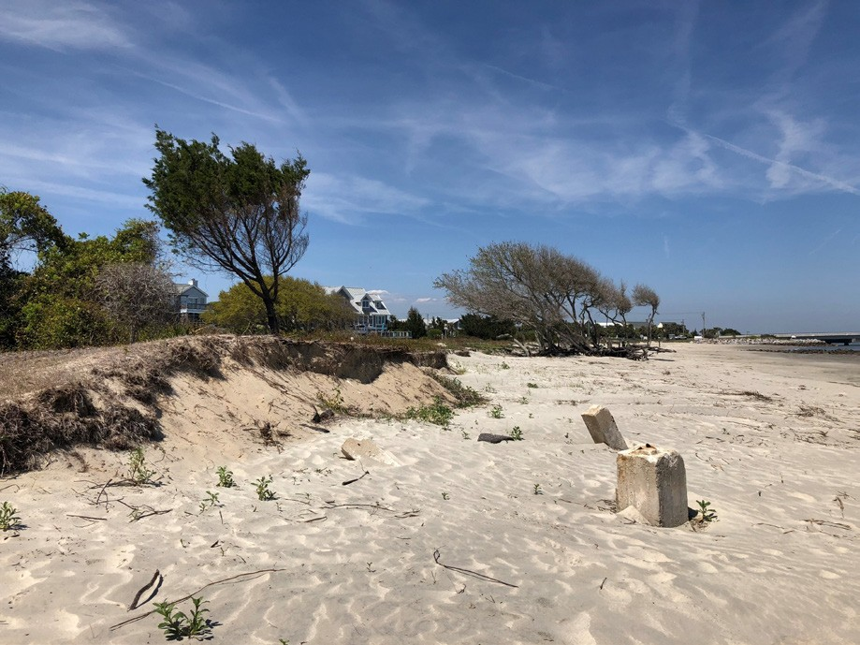

*Windswept native live oaks of the Town’s Protected Land are protected by way of zoning and deed restrictions.*

## TOWN PROTECTED LAND MANAGEMENT PLAN

A comprehensive land management plan was initiated by Town Council in 2007 to address the ongoing protection and maintenance of the 190 acres of oceanfront property (accreted land) located seaward of the Town’s residential district. This property has been protected by deed restrictions since 1991

when the Low Country Open Land Trust established prohibitions to commercial or residential development on the property.

This acreage includes beach, dunes, interdunal wetlands, shrublands, early successional maritime forest and maritime hardwood depression. Town Council regularly conducts public meetings to develop the long-term strategy for maintenance of the Town’s protected land.

## LOCAL COMPREHENSIVE BEACH MANAGEMENT PLAN

In accordance with the South Carolina Beachfront Management Act, the Town has maintained a local comprehensive beach management plan since 1992. This plan provides information relating to current beach profile data, structure inventory, and establishes a beach assess management strategy. The plan also outlines that zoning regulations, stormwater drainage and land use planning patterns are consistent with the Act. This Plan is reviewed and approved by SCDHEC-OCRM.

## GREEN INFRASTRUCTURE AND

**CONNECTED CONSERVATION PLAN**

In 2016 the Town collaborated with the East Cooper Land Trust and area municipalities to adopt a “green infrastructure” plan that identifies and maps connected natural systems, wildlife habitats, and passive recreational assets of the greater Charleston area. The goal of the plan was to identify core habitats by using an ArcGIS data model, which was then used to encourage connectivity of various regional pedestrian trails and local recreational assets. The plan was updated in 2023 and has an online GIS web application was created for use by the individual municipalities, which is located at:

https://scgiplan-gicinc.hub.arcgis.com/

# Single-Family Residential Conservation Easements

In October of 2015, the Planning Commission developed a Zoning Ordinance regulation that proactively incentivizes shoreline retreat from beachfront development by encouraging the removal of single-family homes from buildable Island properties. Approvable only as a special land use exception, the “conservation easement uses and structures” ordinance recognizes that all properties on Sullivan’s Island are part of a dynamic and ever- changing barrier island environment, which are predisposed to erosion, loss of critical dune vegetation and potential structural damage.

By creating the ordinance, the Town has provided an incentive to preserve environmentally sensitive properties zoned for residential purposes. A property owner (grantor) may now establish a permanent conservation easement on a beachfront parcel while still maintaining certain recreational uses and structures upon the property. These non-residential uses may include construction of a beach-side cabana, or other recreational use structure, with an agreement to retain and protect the natural or open-space values of the property. Specific development standards were created to ensure a low-scale and low-impact structure is built on the property. Currently, there is one conservation easement structure located on Marshall Boulevard.

Sullivan’s Island is the first beachfront municipality or community ever to provide this type of incentive to actively retreat from the beachfront area.

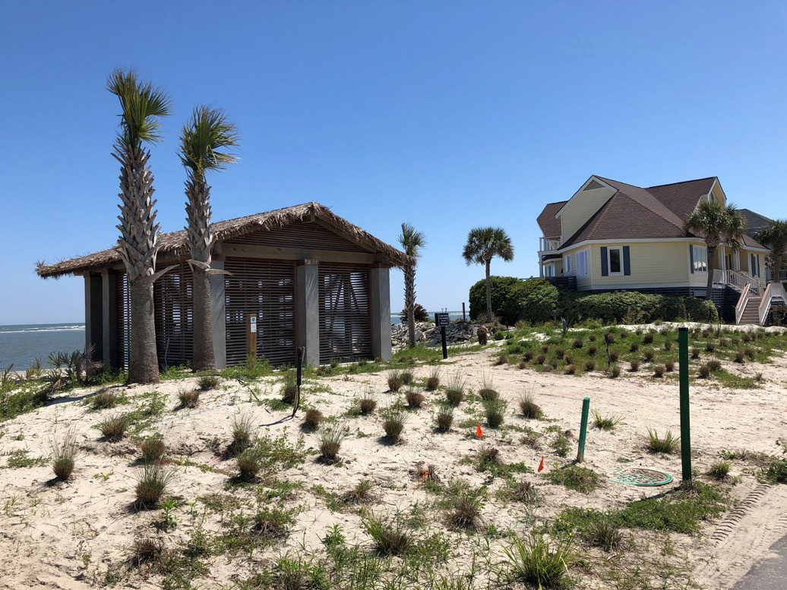 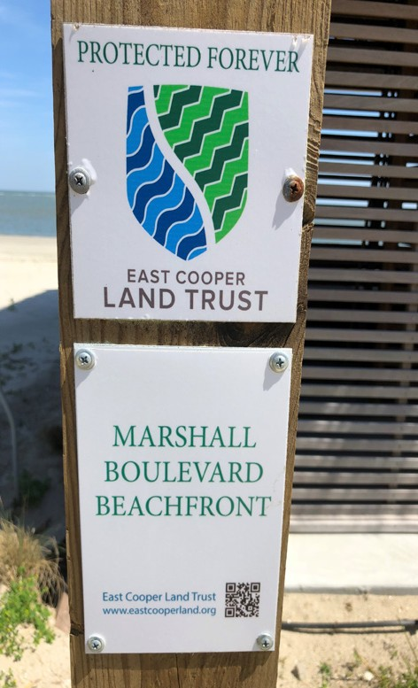 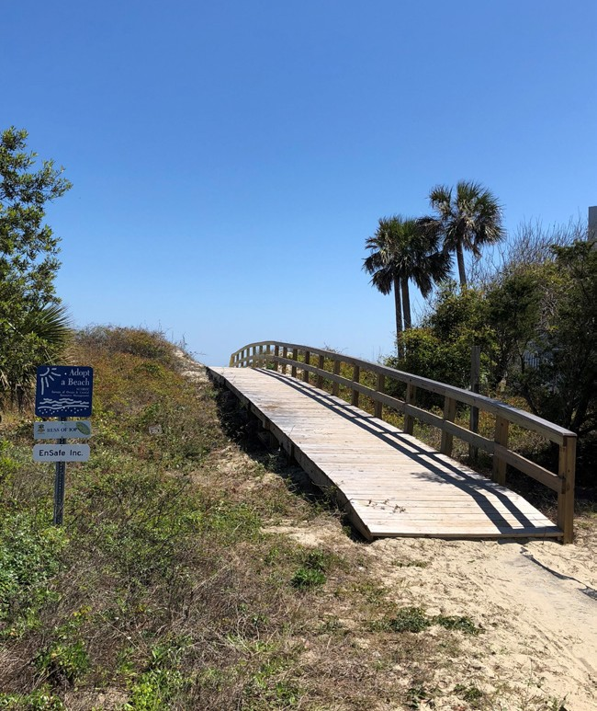

*Conservation easement structure on Marshall Boulevard Beach access is key feature of the Town’s Local Comprehensive Beach*

*Management Plan Boulevard*

# Trolley Bridge and Dump Properties

Both the trolley bridge and dump properties are held in a perpetual conservation easement through theLowcountry Land Trust. Both areas are open to the public as a scenic overlook and kayak and canoe launching site.