75 Sullivan’s Island Comprehensive Plan 2018-2028: Transportation Element

CHAPTER 8: LAND USE ELEMENT

HOW WE PLAN AHEAD

Sullivan’s Island Comprehensive Plan 2018-2028: Land Use Element 76

In the Land Use Element, research and analysis of existing growth and land use patterns guide the Town through the 20-year planning horizon established by the Comprehensive Plan. Even though the plan requires updates every five years, the 20-year planning horizon sets a standard for casting visionary goals and objectives, as well as sound projections.
Developing existing and future land use maps allows analysis of current land use patterns, which help illustrate predicted changes within the Town.

TOWN CHARACTER
The planning process identified four major points that define the character of Sullivan’s Island. These are:
- Informality
- Openness of the landscape
- Residential and family oriented in scale and nature
- Small commercial area.

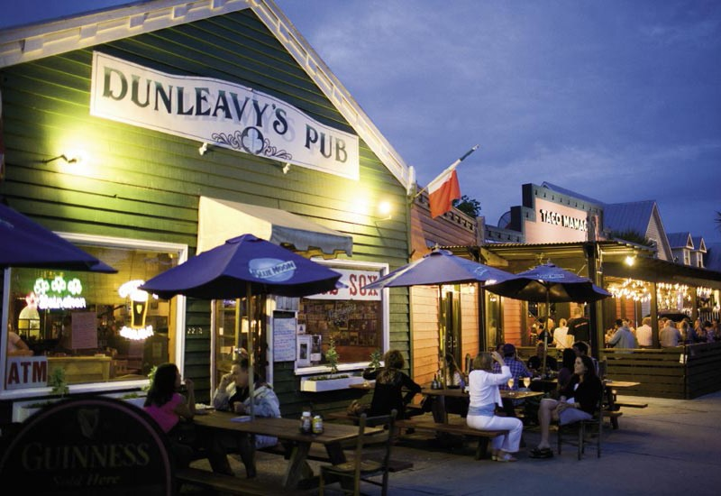
Source: Charleston Magazine
The importance of the informality of the Town has long been recognized by residents as well as Town officials. Some homes have a subtle landscape that utilizes native vegetation and wildflowers. The streetscape is informal, and there are only a few roads with curbs and sidewalks. In the older sections of the Island, which were not developed under the military regiments, many of the houses are set informally on large lots and do not line up along a common setback.
Related to this informality is the openness of the landscape on the Island. Many yards do not have tall hedges or tall fences common in some other island communities. The Island exhibits
a park-like appearance with expansive views and openness. In the past, the Sullivan’s Island’s landscape has been characterized by large expanses of spring and summer wildflowers on both public and private land. This feature added substantially to the concept of Sullivan’s Island’s special sense of place and informality.

Sullivan’s Island features a strong residential character. The Island’s activities and mainly single-family housing create a family-oriented atmosphere. The small commercial district , built at a pedestrian scale, does not diminish the residential atmosphere of the Island. In addition, Sullivan’s Island protects itself from the development of hotels, bed and breakfast businesses, timeshare and fractional ownership models, and short term rentals that would detract from the residential nature of the Island.
The small commercial district and the adjacent Sullivan’s Island J. Marshall Stith Park acts as a primary community focus. The commercial area is centrally located near the Ben Sawyer Bridge entrance to the Island. The Sullivan’s Island J. Marshall Stith Park is the location for many community events, as well as a nice recreational facility where residents can come together and visit with each other.

Currently, the Town is working on a plan to renovate and update the uses within Stith Park to better serve the needs of the community into the future
Removed existing LU map

Sullivan’s Island Comprehensive Plan 2018-2028: Land Use Element 78

EXISTING LAND USE
Since its transition from a military base to a residential island community more than sixty years ago, there has been little evolution of the Town’s various land uses. The currently existing land uses on the Island include (in alphabetical order): cemetery, church, commercial, conservation and recreation, government, multifamily residential, single-family residential, utility, and vacant land. Below is a breakdown of the land uses and what constitutes each use:

“Provide a zoning designation for Town-owned, non-residential property, as in
front of Poe Library, Battery Gadsden, and maybe Stith Park, that provides for public areas to include non- profit fundraising, etc. with Town permit.”
- Anonymous resident (providing feedback at the November Open House)
CEMETERY: There are two properties on Sullivan’s Island that are cemeteries.
CHURCH: Land that is used for religious activities, including a sanctuary and parish hall. Additionally, new churches are only allowed as a Single Family Residential (RS) District special exception, per the Town Zoning Ordinance.
COMMERCIAL: Commercial property is land designated for office, retail or service businesses in the defined Community Commercial (CC) District. These uses continue to be restricted mainly to the business district located on Middle Street, between Station 20 ½ and Station 22 ½. The CC-District consists of two Community Commercial Overlay Districts (1 & 2) that benefit Sullivan’s Island by:
(1) recognizing the unique nature of particular areas in the CC-District;
(2) allowing the Town to be very specific with regard to construction, design and other criteria; and
- clearly differentiate the areas from the balance of the Island with regard to subdivision and development.

RECREATION/CONSERVATION: Recognizes limited use of land, marshes, and creeks for recreational purposes, but otherwise envisions long-term preservation of the land without commercial activity or subdivision, with minimal impact on the view corridor. This land use pertains to both marsh and ocean front areas (RC1 and RC2) as well as Town parks dedicated for recreation.

GOVERNMENT: Government property covers a broad range of government, public, and institutional uses.
SINGLE-FAMILY RESIDENTIAL: Single-family residential land uses are defined as locations intended for occupants to live together as a single house-keeping unit. Single-family residential property is defined as a residentially-zoned parcel with only one dwelling unit, unless the property has been granted the Historic Accessory Dwelling Unit special exception, allowing a separate, second dwelling unit on the parcel.
MULTI-FAMILY RESIDENTIAL: Multi-family residential land use is defined as more than one dwelling unit located on the same parcel, typically in the same building or structure, creating a non-conforming use.
UTILITY: Property that is classified as utility is property with infrastructure uses on it. These include power substations and water pump stations.
More information pertaining to these terms can be found within the Town’s Zoning Ordinances.

TABLE 8.1: LAND USE BY PERCENT
In order to form the Existing Land Use Map, percentages of land used are determined in order to give a clear idea on how the Island is developing. Table 8.1 shows the breakdown, by percentage, of how much each land use takes up. The percentages have been compared with the 2013 and 2018 Comprehensive Plan data; there was reassessment of land uses on several parcels, and there were a couple of land use categories that were combined to make a more logical land use map, but as far as actual use of land, very little has changed.

 | 2013 | 2018 | % CHANGE
SINGLE FAMILY RESIDENTIAL | 21.4% | 21.5% | 0.5%
MULTI FAMILY RESIDENTIAL | 0.6% | 0.6% | 0.0%
COMMERCIAL | 0.3% | 0.4% | 33.3%
GOVERNMENT/INSTITUTIONAL | 5.0% | 4.9% | -2.0%
DEED RESTRICTED PROPERTY | 11.4% | 11.4% | 0.0%
CHURCH | 0.4% | 0.4% | 0.0%
CEMETERY | 0.1% | 0.2% | 100.0%
UTILITIES | 0.3% | 0.3% | 0.0%
VACANT | 1.6% | 1.5% | -6.3%
CONSERVATION/RECREATION | 58.8% | 58.8% | 0.0%

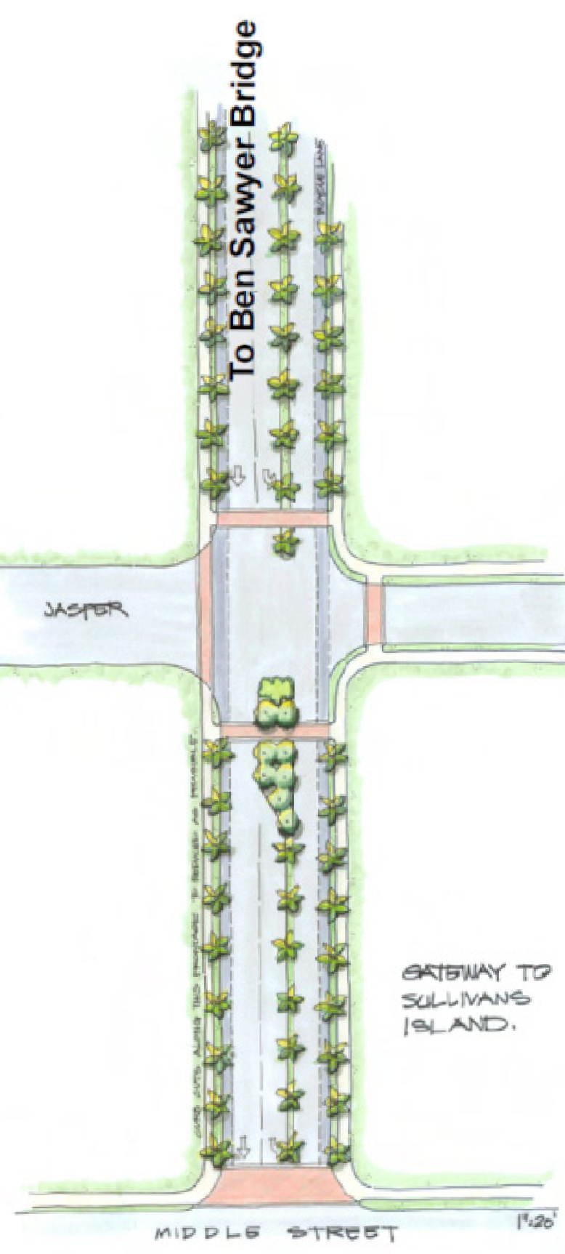
COMMERCIAL DISTRICT
The commercial land uses of the Town are lallocated to a small area on the Island. This area, which runs along Middle Street, consists of commercial businesses and office space for the benefit of Sullivan’s Island residents and visitors, alike.
In 2008, the Town of Sullivan’s Island and a team of consultants (Seamon Whiteside + Associates, LS3P Associates Ltd, and Kimley-Horn and Associates, Inc.) drafted and adopted the Sullivan’s Island Master Plan: Community Commercial District. As stated in the plan, the final goal statement is to “develop a master plan that promotes sustainable commercial activity while protecting the safety of residents and visitors, minimizing the impact of that activity on the surrounding residential neighborhoods and retaining the vernacular of island architecture.”
As a result of the 2008 design charrette, the plan proposed recommendations for the commercial district. These included:
  - Create a Commercial Area Overlay Zone District (2 commercial overlay districts have been created)
  - Allow parking on one side of I’On Street only (an island-wide parking plan has allocated only one side of I’On Avenue for parking)
  - Resident/Guest parking permits only on I’On, Jasper, Atlantic, and Myrtle after 8 p.m. (or other reasonable time) (residential parking permits have not been implemented)

  - Require shared parking provisions for off-street parking at office/retail businesses (no shared parking requirements have been enacted for the CC-District)
  - Institute a “Livability Court” to handle issues of litter, lack of maintenance, etc. (a Livability Court has not been created)
  - Develop guidelines for commercial parking, lot subdivision, height, massing and scale, and setbacks with Overlay District

  - (standards and guidelines for the commercial district were updated in 2012)
- Modify split zoning to allow parking to support existing businesses while limiting expansion of current commercial uses (commercial parking lot use has been added as a special exception in the CC-District)
- Explore options for increasing police presence/code enforcement in the commercial area (the police force has grown and continues to be a presence in the CC-District)
The master plan was set up to be a “conceptual design study,” which means that the design is very “broad brush” and all concepts would be subject to further design exploration at a later time. However, the master plan does reflect, in a purely illustrative manner, how the main tenets of design approach could be achieved.

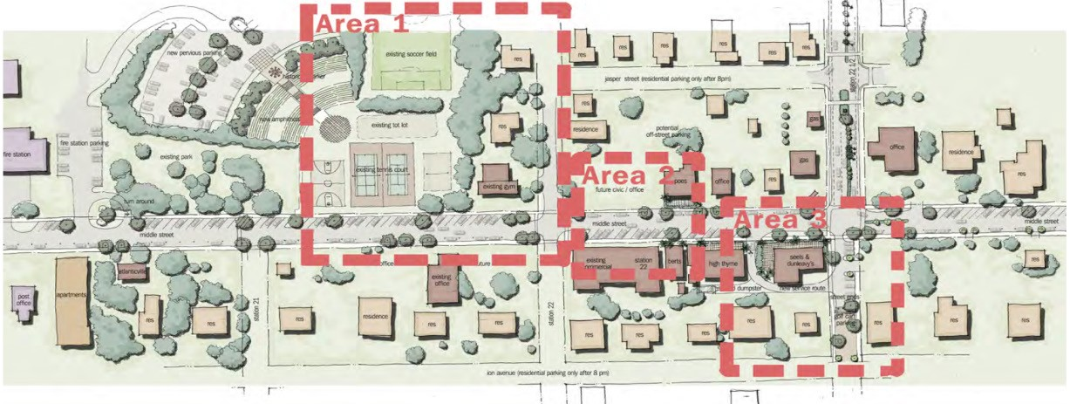
For more detailed information, the CCD plan is available on the Town’s website.

COMMUNITY COMMERCIAL OVERLAY DISTRICTS (CCOD)
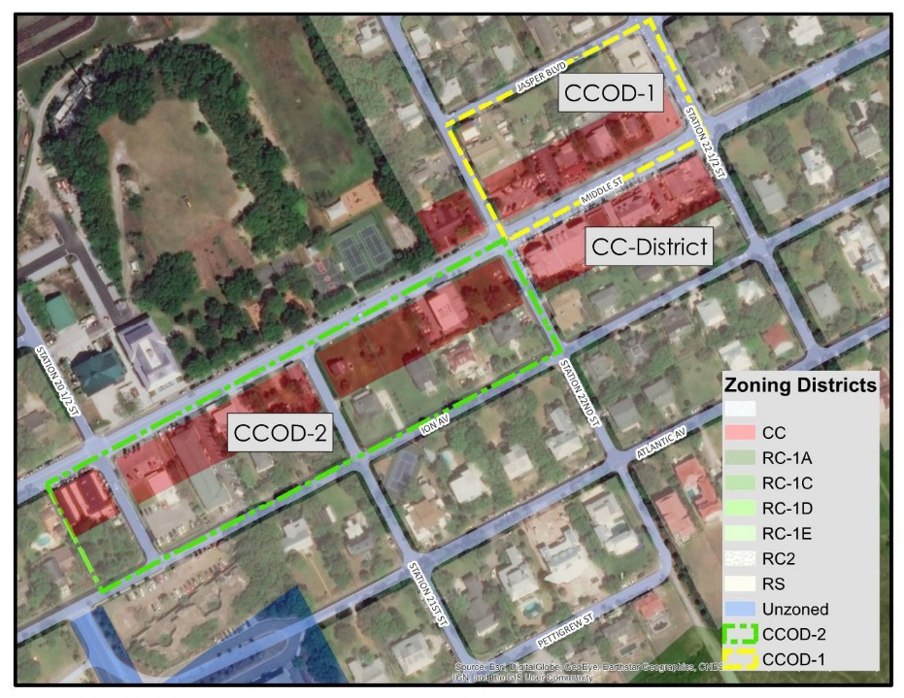
As a result from the recommendations from the Commercial District Master Plan, two Community Commercial Overlay Districts were created. An overlay district is a regulatory tool that creates a special zoning district, which identifies special regulations and guidelines that are applied in addition to or above and beyond those in the underlying base zoning district(s). Where differences in regulations exist between base zones and the overlay zones, the regulations on the overlay zone prevail.
CCODs #1 and #2 has a defined area along Jasper Boulevard and Middle Street, between the blocks of Station 22 ½ and 2019 Middle Street. CCOD #1 consists of lots between Middle Street and Jasper Boulevard, from Station 22 ½ to Station 22. CCOD #2 consists of lots between I’On Avenue and Middle Street from Station 22-
2019 Middle Street (currently Sullivan’s Restaurant and other businesses) to 2120 Middle Street.

RESIDENTIAL DISTRICT
Most of the Island is developed as single-family residential. Many destination beach areas face the threat of becoming commercial resort areas. In an effort to preserve the residential character of the Town, the permitted Residential District (RS) uses are limited to the following:
  - One single-family detached dwelling (other than manufactured homes such as trailers and mobile homes or industrialized facilities) per lot,
  - Publicly-owned facility or land, or
  - Non-commercial horticulture or agriculture, but not including the keeping of poultry or animals other than for family use or as ordinary pets.
Conditional uses include:
  - Customary home occupation meeting the requirements found in Section 21-141 of the Zoning Ordinance, and
  - Accessory uses such as garages or tool sheds in conjunction with a principal use
Special Exception uses (require approval from the BZA)include:
  - Conservation Easement Uses,
  - Historic cottages as accessory dwelling units,
  - Churches, and
  - public utility substations.
Prohibited uses include:
  - Residences of less than 1000 square feet,
  - Erosion control structures,
  - Rental of rooms is not allowed in either the residential or commercial zoning districts,
  - Mobile or manufactured homes, and
  - Vacation rentals.
Given the history of the Island, there are various non-residential structures that remain within the Residential District, such as old churches or fortifications. Some of these have been adaptively reused for housing or other types of spaces; one identified need that may be accommodated within a historic, non-residential property is that of a community center.
In 2004, a review of the Zoning Ordinance led to the creation of historic preservation overlay districts to protect properties that have been determined to be architecturally, archeologically, culturally and historically significant to the Town.

Historic District Overlays
In 2003, the Town of Sullivan’s Island established three (3) historic overlay districts in the Town. The three districts are: Moultrieville Historic District, Sullivan’s Island Historic District and the Atlanticville Historic District. These three distinct, separate areas comply with the Zoning Ordinance defining the district as, “architecturally, archaeologically, culturally, or historically significant to the Town of Sullivan’s Island.” Oversight of the historic districts is a task delegated to the Design Review Board, which guides new construction, alteration, demolition, moving and removal of structures within the historic overlay districts.

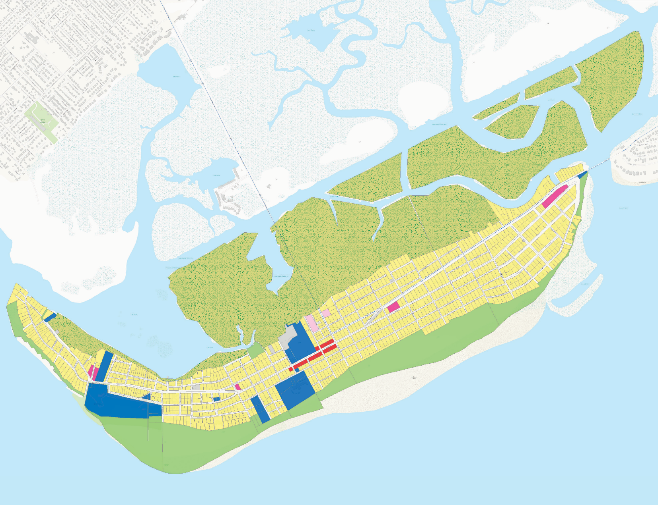
Sullivan's Island Comprehensive Plan Future Land Use Map
OP703
OP703
Residential
Commercial Government Church Cemetery
Conservation
±
Conservation/Recreation
Deed Restriction
0
0.5
1 Miles
Utility
Date of Map Creation: 4/03/2018

Data Path:W:\ProjectSpecific\Sulliv ansIsland_CompPlan\maps\FLU2018.mxd
Data Source:ESTI, 2018 BCDCOG and Ch arleston County GIS

FUTURE LAND USE
Given the Island’s desired character and geographical constraints, existing land uses for the foreseeable future will undergo incremental and small changes, as are necessary. Therefore, the Future Land Use map, illustrates a continuation of the established land uses set forth in the previous Comprehensive Plan.

LAND USE AND DEVELOPMENT STANDARDS
Zoning Ordinance
The Sullivan’s Island Zoning Ordinance aims to provide “a comfortable home at the beach, safe and friendly, where individuality and diversity are celebrated, neighborhoods are respected, Island resources are appreciated, history intertwined, and families and neighbors seek to thrive”, as stated in the publicly vetted vision statement crafted to capture the essence of the Island. This ordinance was a result of a substantial process of public involvement during 2002-2004, in response to residents’ growing concerns over the increasing amount of residential construction that was incompatible in scale and mass with existing Island development. The Town’s original ordinance was enacted in 1977.
Changes to the Zoning Ordinance occur as needed through a public process. One recent change to the zoning ordinance added a zoning classification for Government uses, the Public Facilities District, that was recommended in the 2018 plan.

Parking Plan/Ordinance
In an effort to promote public safety for Island residents and visitors alike, the Town of Sullivan’s Island created a new Parking Plan. This newly enacted plan allows vehicular parking on only one side of the street, which will allow a clear and unobstructed path to homes and beach accesses for emergency vehicles.

Sullivan’s Island Comprehensive Plan 2018-2028: Land Use Element 84

