39 Sullivan’s Island Comprehensive Plan 2018-2028: Community Facilities Element

CHAPTER 5: CULTURAL RESOURCES ELEMENT

OUR HISTORY

Sullivan’s Island Comprehensive Plan 2018-2028: Cultural Resources Element 40

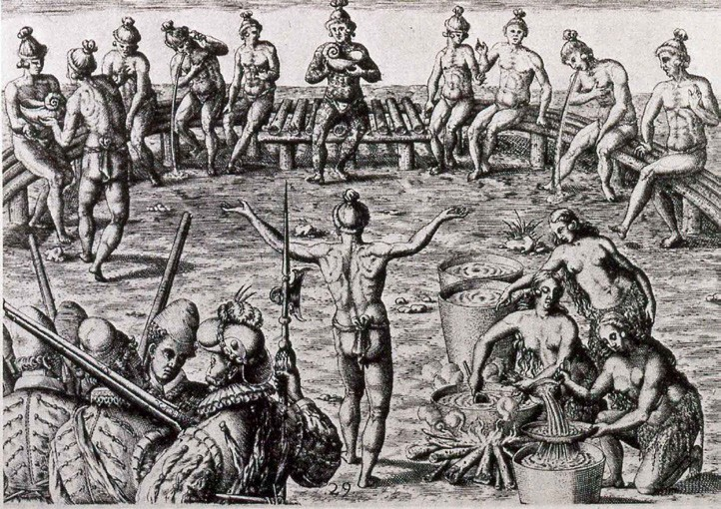
Early depiction of a “Black Drink Ceremony” common to Southeastern tribes such as the Sewee Indians of Sullivan’s Island

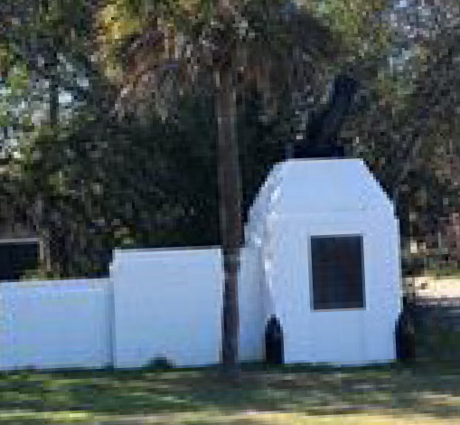
The restored Fort Moultrie Gates gives visitors a snapshot into the Island’s past.
Cultural resources can be broadly defined as the sites, structures and features within a community that have been given significant meaning or social value.1 Natural and human forces shape the Island’s culture and character. The following chapter details Island history, historical sites, national monuments, and cultural events which impact the Island’s unique sense of place.

HISTORY
Native American Settlement
Long before the arrival of white European settlers, Sullivan’s Island was a territorial stronghold of the Sewee, a Native American tribe found in the region between the Charleston Harbor and the Santee River.2 The name Sewee is thought to mean “islanders”, and the Sewee Indians were a semi-agrarian people that relied on harvesting crops as much as hunting and fishing. Although there is very little physical evidence of their life on the Island, it is believed that the Sewee would migrate to the barrier islands during the warm seasons for the exceptional fishing along the Island’s shallow waters and the reprieve the coastal breezes brought from the heat and mosquitos.
Historical accounts as early as 1670 describe that the Sewee offered an enthusiastic welcome to the first English settlers, offering food, trade and education in agricultural practices and customs. Sadly, in as little as 20 years, the Sewee all but vanished from the barrier islands , either escaping from or largely succumbing to the threats posed by war and disease.3

European Settlement and Revolutionary War
Throughout the late 1600s and early 1700s, the Island was inhabited by men serving as watchmen or scouts, whose primary duty was to guide ships through the treacherous waters at the mouth of the Charleston Harbor.
Some of the Island’s earliest buildings were the timber platforms and towers designed to keep the warning fires burning throughout the night. At that time, only a few rustic huts and a handful of people occupied the Island.
In 1674, an Irish settler named Captain Florence O’Sullivan was appointed as the colony’s first Surveyor-General and given the great responsibility of guarding the Charleston Harbor from attack by enemy vessels. Along with his new title, O’Sullivan was granted a large tract of land comprised of what is now the Old Village in Mount Pleasant and the small barrier island that would later be known as “O’Sullivan’s Island.”4

- Thomas F. King, A Companion to Cultural Resource Management (Cha. 24)
- Suzannah Smith Miles, The Islands Sullivan’s Island and Isle of Palms: An Illustrated History (12)
- Suzannah Smith Miles, The Islands Sullivan’s Island and Isle of Palms: An Illustrated History (15)
- Suzannah Smith Miles, “The Islands Sullivan’s Island and Isle of Palms: An Illustrated History” (22,29)

- Diamond, Jared, “Guns, Germs, and Steel”

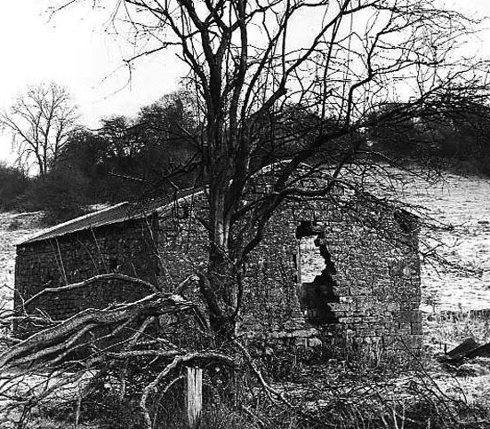
The Island’s pest houses were open-air structures made of brick and timber as exemplified by this English plague pest house from the mid-19th Century. deddingtonhistory. uk/buildings/pest house.

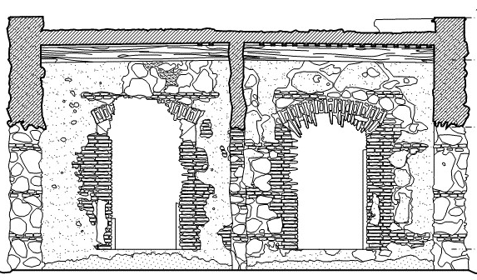
This cross-section details the methods of construction for a Spanish lazaretto in San Juan, Puerto Rico. nps.gov

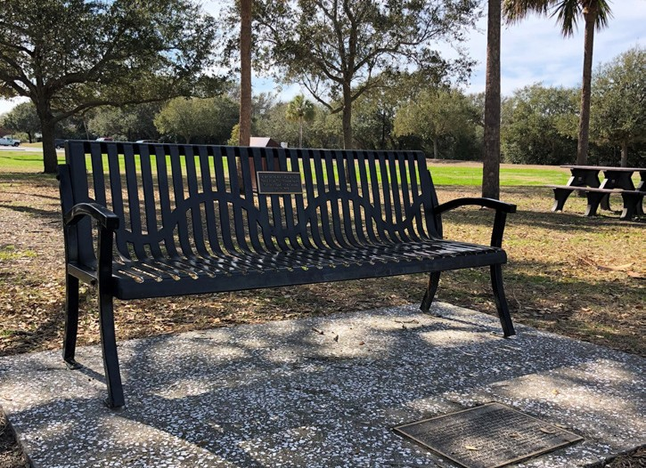
“Bench by the Road” is a memorial to honor enslaved Africans that spent time on Sullivan’s Island during the Middle Passage.

Pest Houses or Lazarettos
By the early 1700s the Carolina colony’s booming rice and indigo industry created a newfound demand for labor to help harvest the plantations of the Lowcountry. This new agricultural industry would come to rely heavily on the labor of enslaved Africans for the next 160 years. The importation of Africans and European immigrants would subsequently lead to frequent outbreaks of deadly diseases and epidemics documented throughout the history of Charles Town Colony.
Following the yellow fever epidemic of 1706, an act was passed to protect the colony from these foreign diseases by deeming the Island as
a quarantine station for incoming passengers who posed a potential risk for the spread of disease.5 Initially, four pest houses (lazarettos) were constructed of rustic brick and lacked finished walls, ceilings, or windows. Although their exact locations remain unknown, these
structures were likely located west of Fort Moultrie. If the ships containing enslaved Africans and immigrants showed signs of illness, the vessel
was either required to ride at anchor, be quarantined in a pest house or would occasionally be moored on boats anchored in what is now known as Cove Inlet. The pest houses remained on the Island until 1796 when Charlestonians petitioned to abandon the quarantine mandate and instead use the island as a summer retreat.
Much of the prevailing information from the National Park Service claims that “nearly half of all those of African descent in the US, had ancestors that passed through the quarantine structures on Sullivan’s Island.”6 This figure infers that most of the 200,000 enslaved Africans transported through the Charleston Harbor were actually quarantined on the island.
However, emerging historic research suggests that there may have been far fewer Africans quarantined on the Island than originally thought. One theory estimates that only 5,000 to 16,000 Africans were documented to have spent time on Sullivan’s Island during the time of the Middle Passage, accounting for approximately 5 to 15 percent of the 107,000 transported.7 This theory is based upon a chronicled timeline identifying three areas of historical research, 1) South Carolina’s quarantine laws, 2) the rise and fall of the pest houses in the Lowcountry, and 3) shipping documentation of African captives through Charleston Harbor.8
In acknowledgement of Sullivan’s Island’s role as an entry point for this population, a monument has been erected near Fort Moultrie to

- David Schneider, Historical Survey 1987
- National Park Service
- Wood, Mimi. “Challenging Sullivan’s History,” Island Eye News (Sullivan’s Island, SC) 2016
- Lucas, Jake. “Doubt cast on S.I. as slave landing point,” Moultrie News (Mt. Pleasant, SC) 2016

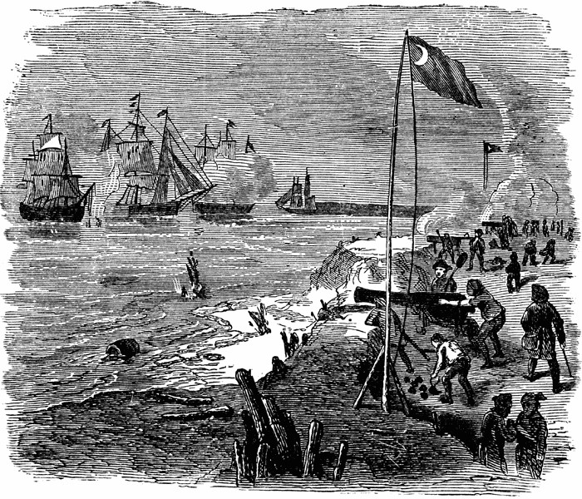

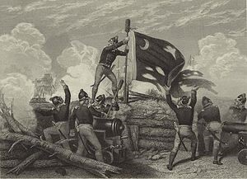
Sergeant William Jasper raises the Moultrie Flag toindicate the Americans were not surrendering , which rallied the American troops during the Battle of Sullivan’s Island.

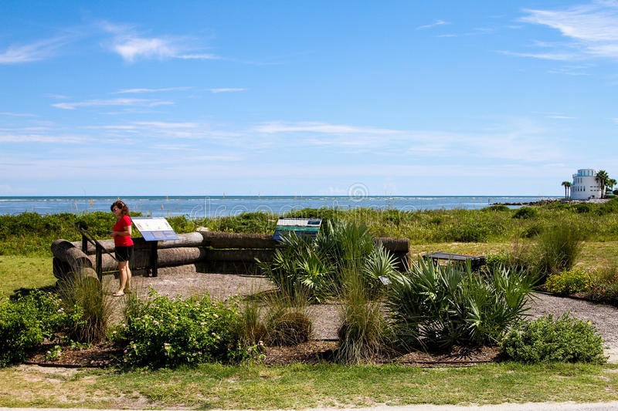
The Thompson Interpretive Park commemorates the American effort to stop the invading British from crossing Breezch Inlet on June 28, 1776.
commemorate the struggles, successes and contributions of these African captives.9 In addition, a memorial bench located near Cove Inlet at Fort Moultrie was dedicated to the memory of those Africans who passed through Sullivan’s Island during the quarantine period of 1707 to 1796.
From emancipation through the mid-1900s, Sullivan’s Island maintained a sizeable African American population who thrived as watermen, farmers, soldiers and various professionals and tradesmen. Some of these original families still reside on the Island today. Indeed, many African American Islanders helped build and maintain the historic structures that contribute to the uniqueness of the Island.

Revolutionary War
Prior to the Revolutionary War, Sullivan’s Island was rather sparsely populated, and Colonel William Moultrie identified the Island as ideally situated to protect Charleston Harbor from British naval invasion. Leading up to the First Siege of Charleston on June 28, 1776, Colonel Moultrie ordered the construction of Fort Sullivan, the Island’s first substantial military fortification. It consisted of sixteen-foot-thick palmetto log cribbing filled with sand, capable of absorbing the impact of British cannon fire. It was the fortress walls, made from the Island’s native sabal palmetto trees that enabled the Americans to fend off an armada of ten British warships; this fortification method also helped thwart an amphibious attack from the British attempting to cross Breach Inlet. The Battle of Sullivan’s Island would mark the first major victory over the British in the American Revolution.
As tribute to its historical significance, the Sabal Palmetto has been designated as South Carolina’s State Tree and is featured on the State Flag, State Seal, and gives South Carolina its nickname- “the Palmetto State.”10

Town Incorporation to Modern Era
In 1817, the Island was incorporated as Moultrieville. Almost immediately after incorporation, Moultrieville mandated that residents build proper houses and restricted building to one dwelling per half-acre lot. In 1850, the Moultrie House, the Island’s first grand hotel opened, further encouraging residents of downtown Charleston to escape the summer heat and diseases that flourished in the City. People traveled to and from the Island by boats that landed at a public boat dock located in “The Cove,” a small marsh creek to the north of the Island.
Sullivan’s Island also served as a critical defensive position for the Confederacy during the Civil War and served as a launching point for the H. L. Hunley (the Hunley), the first submarine to sink a warship.
Named for her inventor, Horace Lawson Hunley, the submarine was shipped

- Sullivan’s Island Plaque
- www.scstatehouse.gov

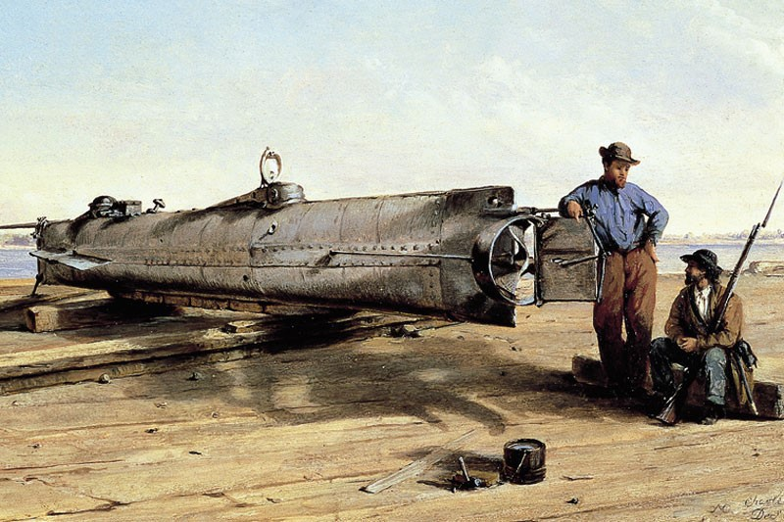

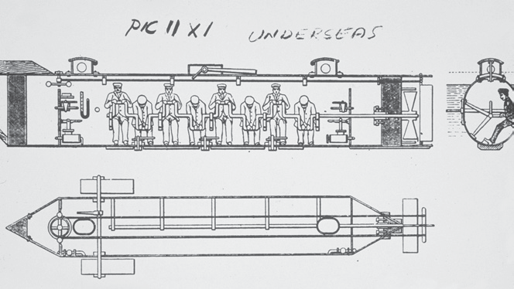
The H.L. Hunley: The first successful combat submarine vanished for over a century until it was discovered in 1995.

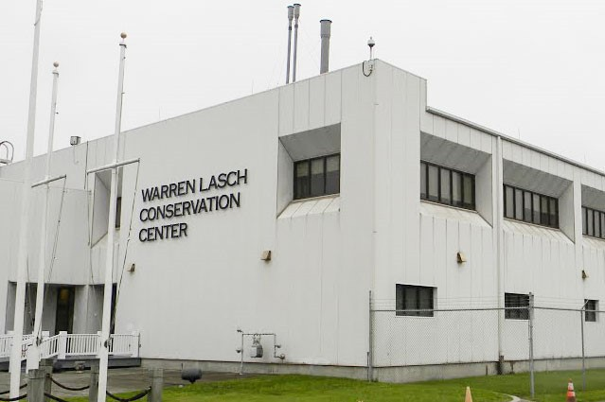
The Hunley is now exhibited at the Warren Lasch Conservation Center in North Charleston.
by rail from Mobile, Alabama to Charleston, SC in August 1863. For a time during the Civil War, the Hunley, was stationed on Sullivan’s Island in order to keep its development and existence a secret from the Union forces. The crew of the Hunley trained in Conch and Inlet Creeks behind Sullivan’s Island, and on February 17, 1864, the Hunley left the creeks behind Sulllivan’s Island through Breech Inlet, then attacked and sank the 1800-ton steam sloop USS Housatonic in Charleston harbor. During the attack, the Hunley sank off the coast of Sullivan’s Island, drowning all eight crewmen. More than 136
years later, on August 8, 2000, the wreck was recovered, and on April 17, 2004, the DNA-identified remains of the eight Hunley crewmen were interred in Charleston’s Magnolia Cemetery, with full military honors.
During the time from 1878 through 1895, the jetties were built just off of Sullivan’s Island in an effort keep the Charleston Harbor shipping channel open and to re-route the main channel into Charleston Harbor.
In the 1900’s the Island continued to be a summer resort and became accessible by a trolley-line that ran from Mt. Pleasant to Sullivan’s Island and then to the Isle of Palms. This original trolley service moved from west to east, and the stops or “stations” became the namesakes of most of the island’s north and south streets.
In 1989, the eye of Hurricane Hugo passed over Sullivan’s Island and the Charleston peninsula causing catastrophic damage to the Island’s
infrastructure. Estimates of wind speeds on Sullivan’s Island were in excess of 120 miles per hour. During the first year after the hurricane, more than
$15,700,000 in repairs occurred on Sullivan’s Island.
Although Sullivan’s Island was established as the Town of Moultrieville in 1817, formal incorporation did not occur through the South Carolina Legislature until 1975. One of the first tasks of the newly appointed Town Council was adoption of the Island’s first zoning ordinance in 1977. Today, many of these original zoning regulations still exist with the objective of separating land uses and preserving of historic structures, sites and significant archeological features throughout the Island. Of the approximately 992 residential structures, nearly 25% are deemed historically significant.
Town Council supports multiple events to commemorate the Island’s historical contributions, such as the annual Carolina Day Celebration. Additionally, the Battery Gadsden Cultural Center has compiled a comprehensive record of the recollections of long-time residents on the Island. This record continues to be a valuable resource for local historians studying the area.

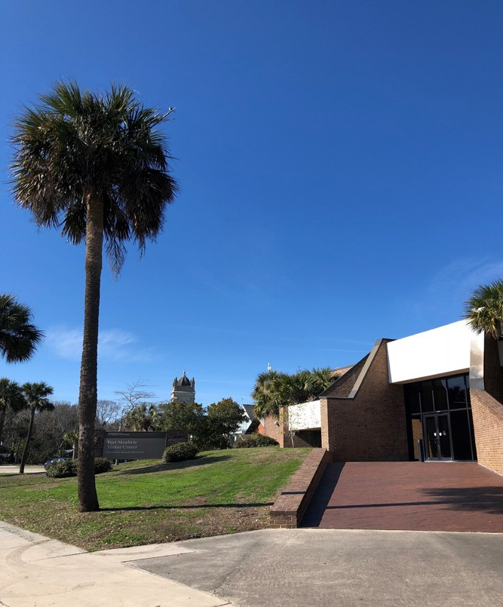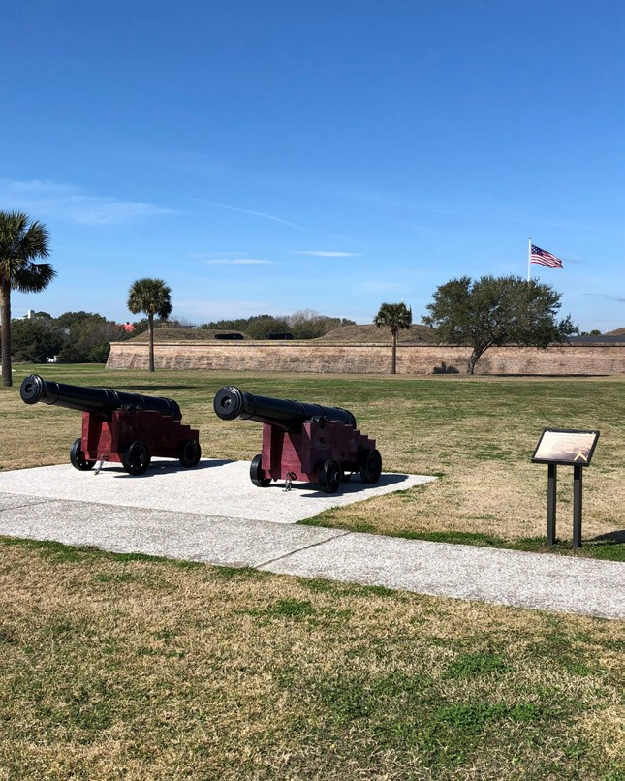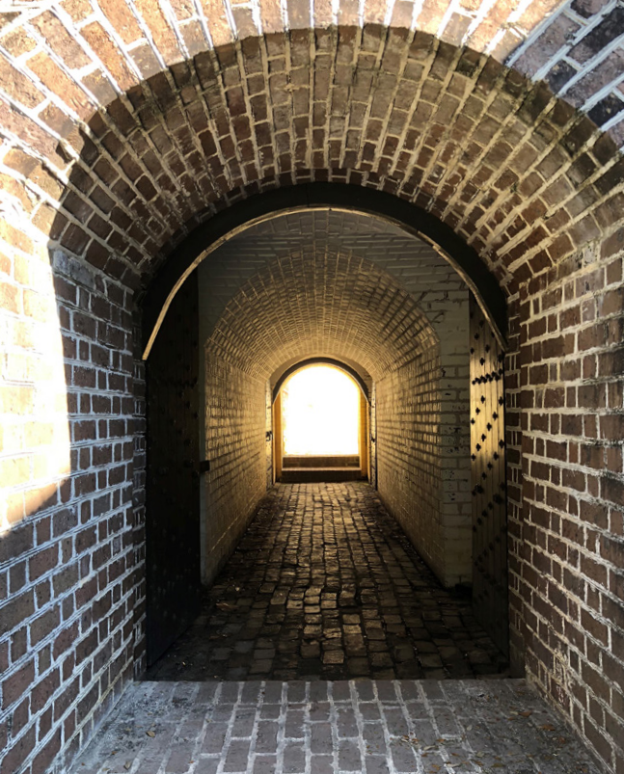
Fort Moultrie Visitors Center The seaward view of Fort Moultrie One of Fort Moultries many ground level
entrances

HISTORIC SITES AND NATIONAL MONUMENTS
Fort Moultrie National Monument
Fort Moultrie is part of the Fort Sumter National Monument, a unit of the National Park Service. The Fort and its visitor center museum, located at 1214 Middle Street, are open to visitors year-round. Because of its importance in American history, Fort Moultrie’s future protection is of the utmost importance to maintaining the cultural identity of Sullivan’s Island.
Following World War II, 1n 1947 the fort was decommissioned as a military base by the Department of Defense, and in 1960, South Carolina transferred ownership of the Fort to the federal government and the National Park Service. In 1976, renovations and archeological studies were completed for the nation’s bicentennial, which resulted in funding for the new visitor’s center. At that time, there were plans to have boat trips from the park property to Fort Sumter; however, Island residents expressed concern about additional traffic onto the Island resulting in an abandonment of the idea.
Access to Fort Sumter now originates in downtown Charleston and Mount Pleasant.
Fort Sumter National Monument has completed a long-range plan, which includes Fort Moultrie and the Charles Pinckney National Historic Site in Mount Pleasant.
From 2009 to 2017, Fort Moultrie attracted an average of 95,000 visitors per year, and in 2022, the combined attendance for the Fort Sumter and Fort Moultrie National Historical Park was 385,472 visitors; the park’s website states that about 300 visitors come to Fort Moultrie per day. Entry fees to visit the Fort have risen to $10 for adults over 16 years, and they are valid for one week; children under 16 years are free.
The National Park Service offers special programs throughout the year and allows educational and community groups to rent the park facilities. Additional information about Fort Moultrie has been provided in the Community Facilities Element.

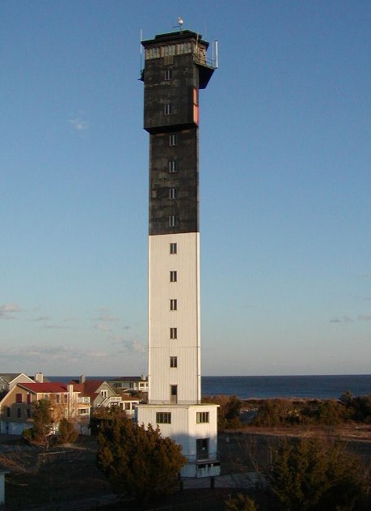
TABLE 5.1

BATTERY NAME | CONSTRUCTION DATE | ADDRESS
Capron-Butler | 1898-1942 | 2056 Middle St
Jasper | 1898-1942 | 1201 Poe Ave
Thomson | 1906-1945 | 2051 I’On Ave
Gadsden | 1906-1917 | 1921 I’On Ave
Logan | 1899-1904 | 1515 Poe Ave
Bingham | 1899-1919 | Fort Moultrie
McCorkle | 1901-1920 | Fort Moultrie
Lord | 1890s | Removed
Fort Marshall Batteries 1-3 | 1930-1944 | 3004-3031  Brownell Ave
Sullivan’s Island Light House circa 1962 Endicott Program Batteries of Fort Moultrie and Fort Marshall.

Sullivan’s Island Light House and U.S. Coast Guard District
Constructed on June 15, 1962, the Sullivan’s Island Lighthouse, affectionately known as the Charleston Light, was the last functional lighthouse built by the United States federal government. In 2008, the lighthouse conveyed ownership from the U.S. Coast Guard to the National Park Service, becoming a part of the Fort Sumter National Monument, incorporated with the US Life Saving Service, a precursor to the US Coast Guard.11 The US Lifesaving Station on Sullivan’s Island was constructed in 1894. Then lighthouse is best known for its unusual triangular shape and unique architectural features. Due to its unique design, the lighthouse can withstand wind gusts up to 125 miles per hour. Additionally, it was once touted as the second most powerful lighthouse in the western hemisphere with a 28-million candlepower, which was later reduced to 1.5-million to accommodate Island residents. The lighthouse is located at 1815 I’On Avenue and has become a widely recognized symbol of the Island, and its preservation is critical to maintaining the character of the Island.

Postbellum and Endicott Period Fortifications
Some of the more distinctive characteristics of the Island’s built environment are the various military batteries and fortifications scattered throughout the Island. These batteries, armories and ammunition storage fortifications were constructed during two major periods of the military’s occupancy of the Island: 1890 to 1910 during the Endicott Period and the Harbor and coastal defense improvements during World War II. The U.S. Army remained on Sullivan’s Island until the decommissioning of Fort Moultrie in 1947.12 Table 5.1 lists the Endicott Program batteries of Fort Moultrie and the Marshall Reservation armaments constructed in the 1940s.

- National Park Service Website https://www.nps.gov/fosu/learn/news/lighthouse-transfer.htm
- https://www.sciway.net/sc-photos/charleston-county/battery-gadsden.html

HISTORIC DISTRICTS
The historic districts of Sullivan’s Island are located in the central and western portions of the Island. Their location primarily corresponds with the residential and support facilities of Fort Moultrie. There are three (3) Local Historic Districts which encompass the four (4) National Register Historic Districts (NRHD) noted below:
- Moultrieville NRHD
- Sullivan’s Island NRHD
- Fort Moultrie Quartermaster and Support Facilities NRHD
- Atlanticville NRHD
Map 5.1 provides an overview of local historic districts with their underlying National Register Historic District (NRHDs) boundaries. Also included in this section, is a brief description of the characteristics within each district and an inventory of prominent historic resources.
A “local historic district” is a type of zoning overlay district that applies to entire neighborhoods or individual properties which give the Town police protectionary powers over demolition and appearance; they are authorized by the Town’s zoning ordinance as historic preservation overlay districts. A NRHD provides no regulatory protections; however, the designation may qualify a structure or property for state or federal preservation incentives.
The Sullivan’s Island Design Review Board (DRB) serves as the overseeing authority of the Town’s Local Historic Districts and is charged with the protection of all designated properties within or outside of the Historic Preservation Overlays. The DRB duties and powers include reviewing and approving projects within all local historic districts and individually designated properties. The DRB also approves contemporary infill construction within a given historic district. Ensuring the proper size, scale and location of newly constructed homes within historic districts is of the utmost importance to the Town. Combined, there are approximately 240 historic properties Island-wide, accounting for roughly 25% of the houses on Sullivan’s Island.

MAP 5.1

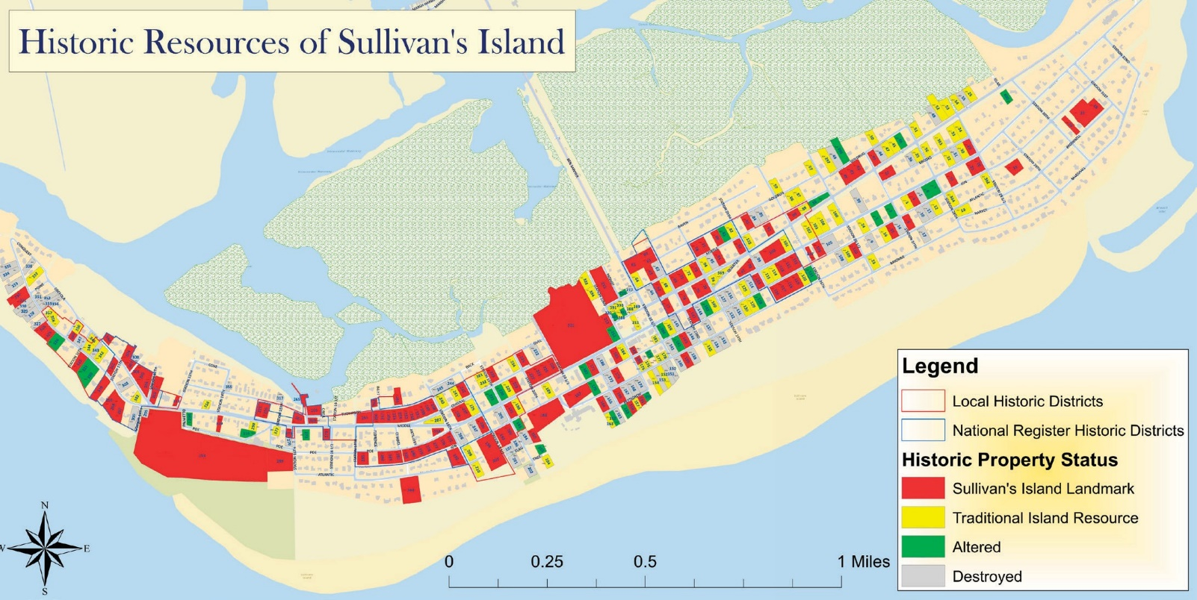

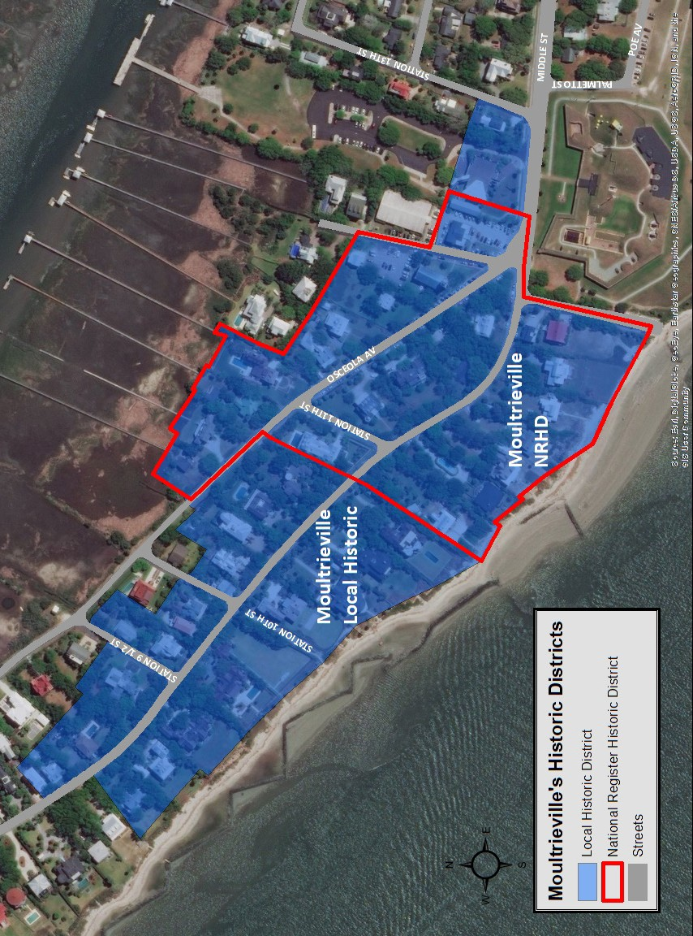

Sullivan’s Island Comprehensive Plan 2018-2028: Cultural Resources Element 48

Moultrieville Historic District
The Moultrieville Historic District, located on the west end of the Island, is composed of a relatively small collection of Island houses. These homes were approximately constructed between 1830 through 1930 and consist of the earliest period of resort housing on the Island. The most notable nonresidential historic resource within the district is the Stella Maris Church, which is located at 1204 Middle Street.
Originally constructed around 1873, Stella Maris has sustained structural damage multiple times over the years, including the earthquake of 1886 and the hurricane of 1893. The church was said to have been rebuilt with the rubble of Fort Moultrie in 1873.
The Moultrieville Historic District is located just to the west of Fort Moultrie and includes the historic Fort Moultrie Torpedo Storehouse, located between the Stella Maris Church and the Fort Moultrie Visitor Center. The Torpedo Storehouse was constructed in 1902 and was part of a cluster of buildings constructed by the US Army to support the minefields protecting Charleston Harbor. The Torpedo Storehouse is the only one of those buildings that survives today, and the National Park Service utilizes the facility as the administrative headquarters for the Fort Sumter and Fort Moultrie National Historical Park and the Charles Pinckney National Historic Site. 13
The Moultrieville area also contains many modestly sized summer cottages and homes, many of which are not contributing to the district. A row of eleven small cottages that served as the homes for the fort’s non-
commissioned officers lies just outside the district’s boundary. Although these homes were built in 1910, they were either poorly altered over the years with nontraditional construction materials or damaged significantly during Hurricane Hugo.

- 13. National Park Service Website https://www.nps.gov/fosu/learn/news/lighthouse-transfer.htm

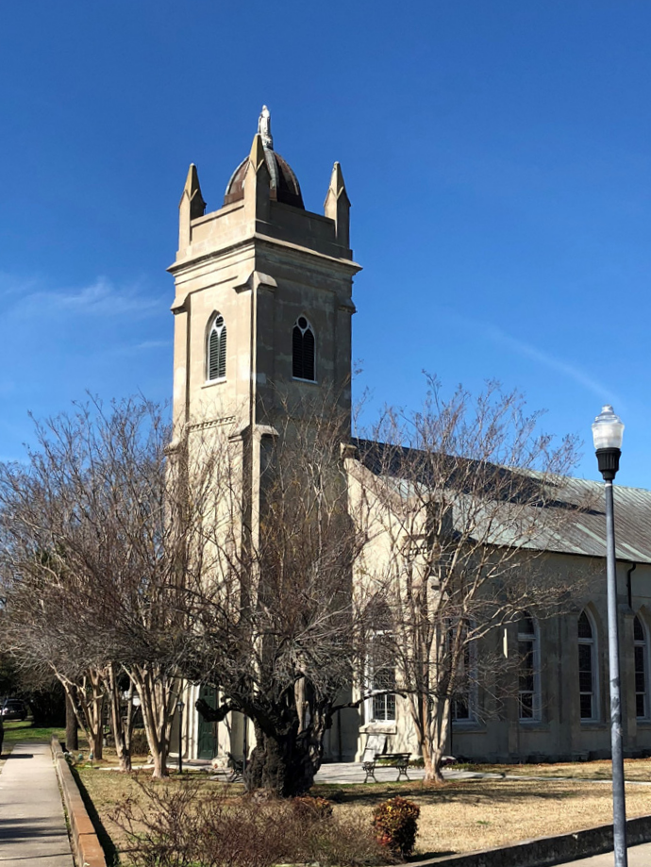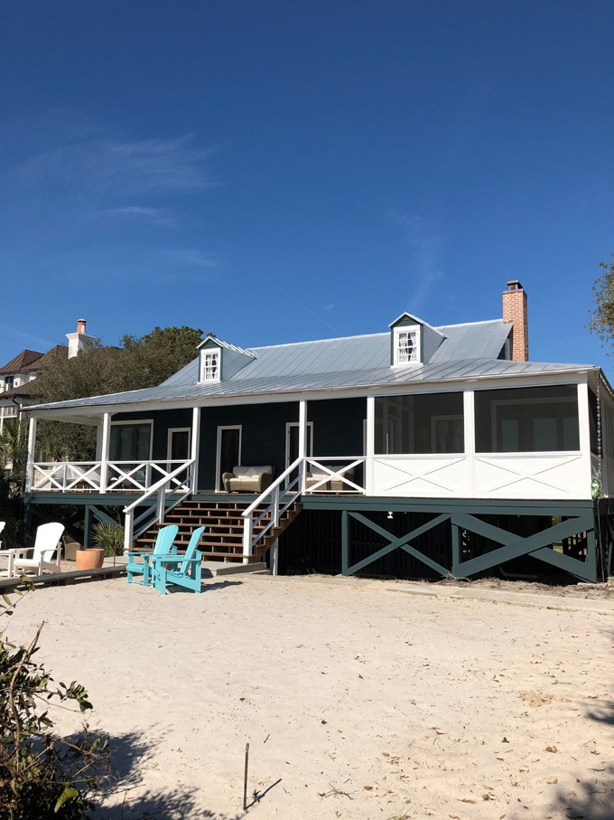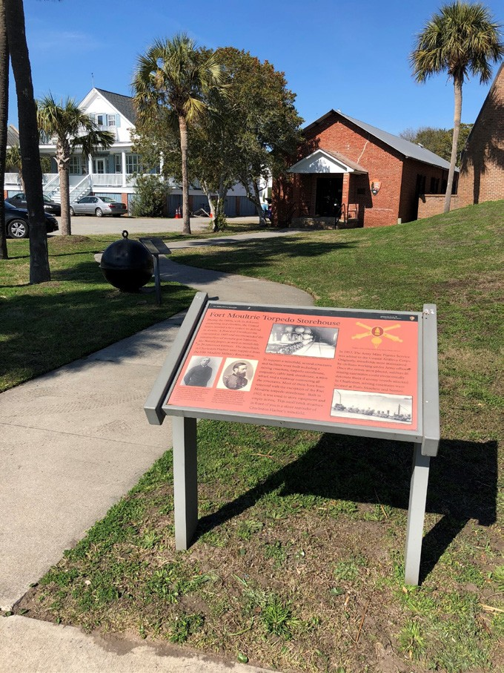

Stella Maris Church, circa 1873 The Nathaniel Barnwell home at 1023 Middle Street exemplifies the vernacular
summer cottages of the island
The Torpedo Storehouse of Moultrieville

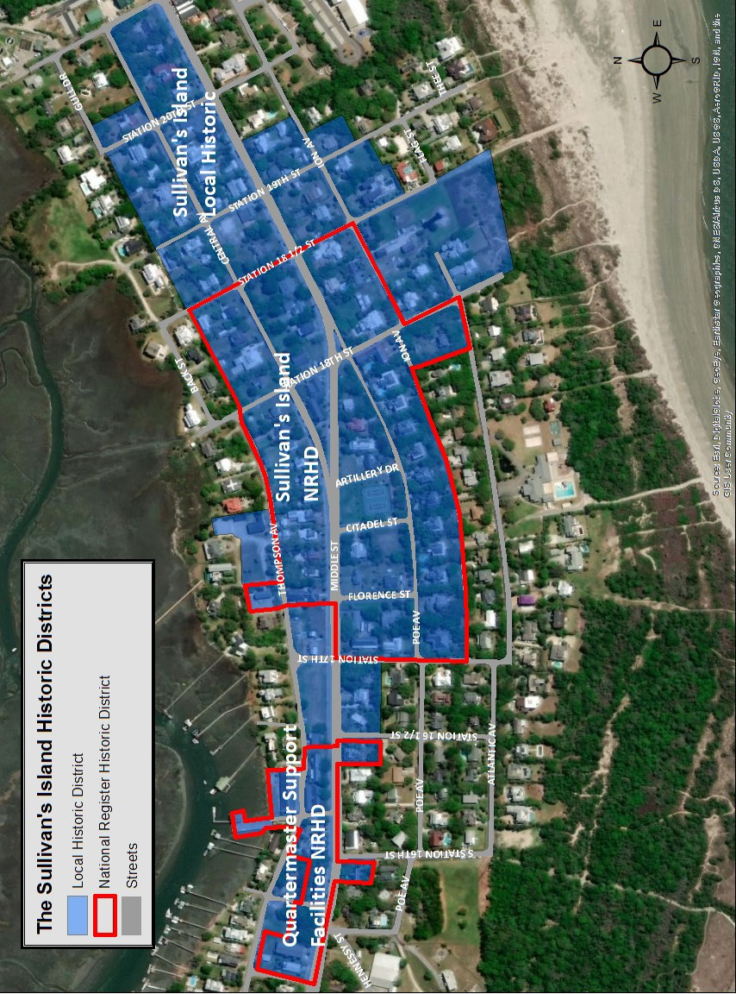

Sullivan’s Island Comprehensive Plan 2018-2028: Cultural Resources Element 50

Sullivan’s Island Local Historic District
The Sullivan’s Island Local Historic District contains the Fort Moultrie Quartermaster Support Facilities NRDH and the Sullivan’s Island NRHD. Sullivan’s Island Local Historic District is generally located on Middle Street, Thompson Avenue and I’On Avenue, between Station 14½ and 18½.

Fort Moultrie Quartermaster and Support NRHD
Developed between 1900 and 1930, the Quartermaster Support Facilities District consists of ten (10) nonresidential military buildings intended to serve as facilities for Fort Moultrie. Many of these buildings included entertainment venues, shopping facilities, and recreational opportunities, which improved the quality of life for soldiers and their families on what was previously a sparsely populated military outpost. Nearly all of the buildings are visible from Middle Street and are within walking distance of most residential neighborhoods.
In the years following the Civil War, Fort Moultrie fell into disrepair and was largely abandoned until the United States Congress passed the Fortifications Bill of 1871. Only minor repairs were performed on the base until William Endicott began implementation of the Plan for Coastal Defenses in 1885. This base expansion included the Non-Commissioned Officers’ Club, the Post Theater, Commissary Storehouse, a Barracks, Ordnance Storage and Office, two Quartermaster Warehouses, Dispensary/Provost Marshall’s Office, Quartermaster’s Office, and the Quartermaster’s Dock.

The Sullivan’s Island NRHD
The Sullivan’s Island NRHD is located east of the Fort Moultrie Support Facilities NRHD. The district was intended to serve as the core administrative and residential area for commissioned and non-commissioned officers stationed at Fort Moultrie. Distinctive features of this district include the single-family military dwellings constructed around 1900 to 1905. These dwellings can be divided into three styles that corresponded with the military rank of the occupants. There were the Senior Officer’s Quarters, the Junior Officer’s Quarters, and multi-family Bachelor’s Officer’s Quarters.
The Senior Officer’s Quarters (circa 1905) also known as “Officer’s Row” is located along I’On Avenue and includes the famous “Commandant’s House” at the far west end of I’On Avenue. These homes showcase an Antebellum-Georgian architectural style with two-storied wrap around porches. The Junior Officer’s Quarters are located along Middle Street and Central Avenue and include ten (10) similarly constructed structures with two-tiered porches on brick foundations. The district also includes the multifamily Bachelor’s Officer’s Quarters, the Administrative Building, a Post Exchange, and the electric shop on Thompson Avenue.

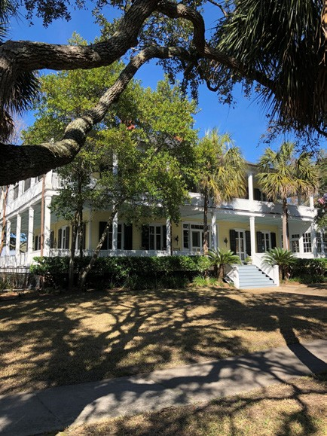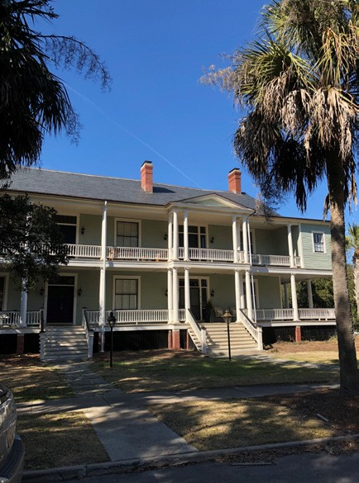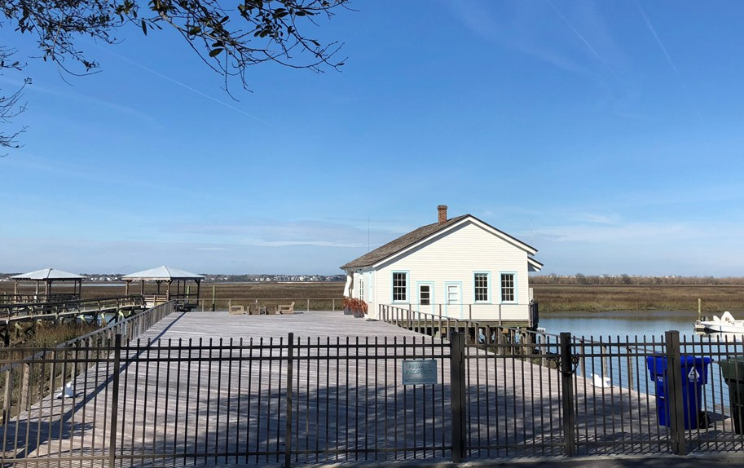

The Commandant’s House of Officer’s Row
Bachelor’s Officer’s Quarters
The Quartermaster’s Dock, a support facility, was fully restored in 2015 by private owners.

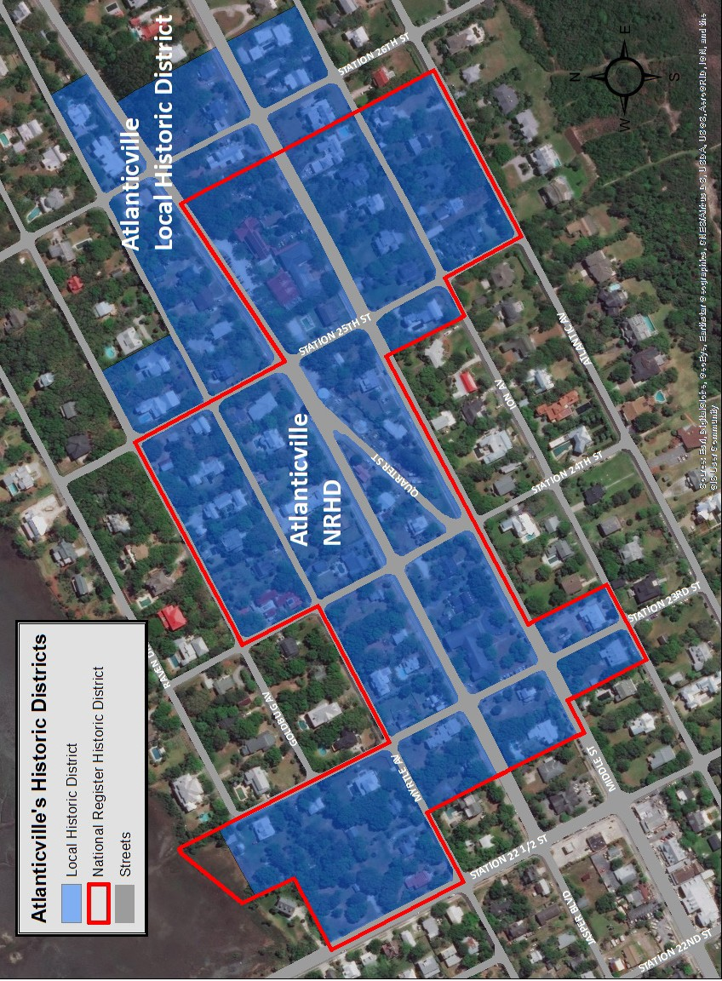

Sullivan’s Island Comprehensive Plan 2018-2028: Cultural Resources Element 52

Atlanticville Historic Districts
The Atlanticville Local Historic District contains the Atlanticville NRHD. The District is located east of the island’s commercial area and was developed as part of a civilian resort development of the late 19th and early 20th centuries.
The neighborhoods of Atlanticville once included boarding houses, several luxurious hotels, a post office, and two churches. The homes were typically smaller vacation cottages that were serviced by the trolley, which would deliver goods and services to the seasonal visitors and soldiers of Fort Moultrie.
Perhaps the most notable structure within the Atlanticville Historic District is the Sullivan’s Island Graded School, which was built in 1925 and later became the Presbyterian Church. This structure was converted to multifamily dwellings in 1977 and underwent a full historic restoration in 2018. Unlike the western portion of the Island, many of the historic homes within Atlanticville sustained severe damage during Hurricane Hugo leaving only fifty-six (56) contributing structures.

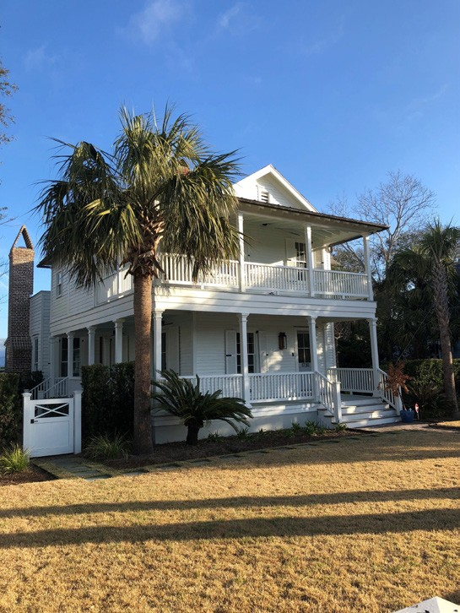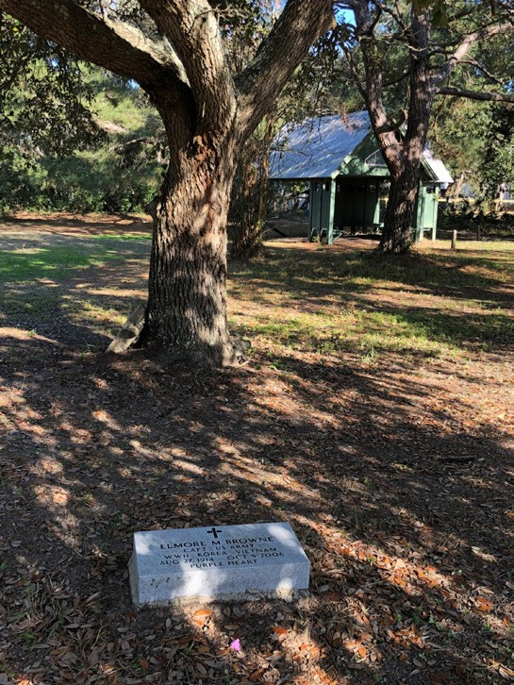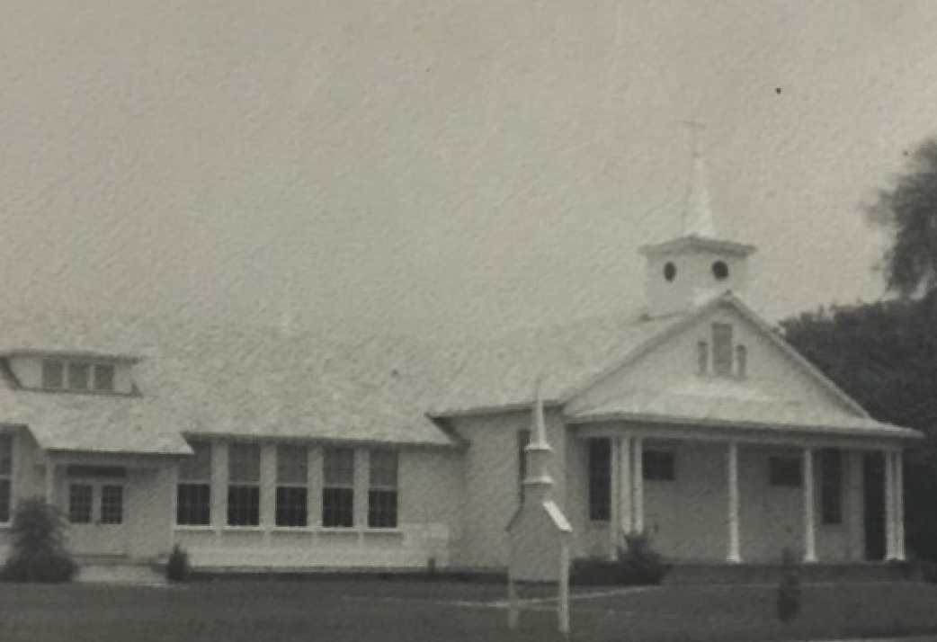

Junior Officer’s Quarters African-American Cemetery located in the Atlanticville Historic
District.
The Sullivan’s Island Graded School circa 1925, later became Sunrise Presbyterian Church.

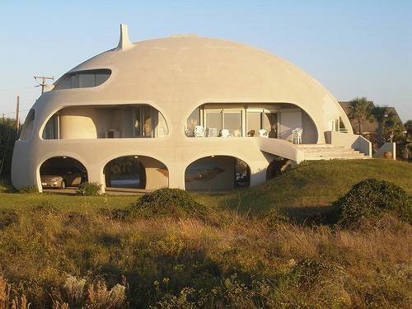
Unique architecture can be found scattered throughout the Island

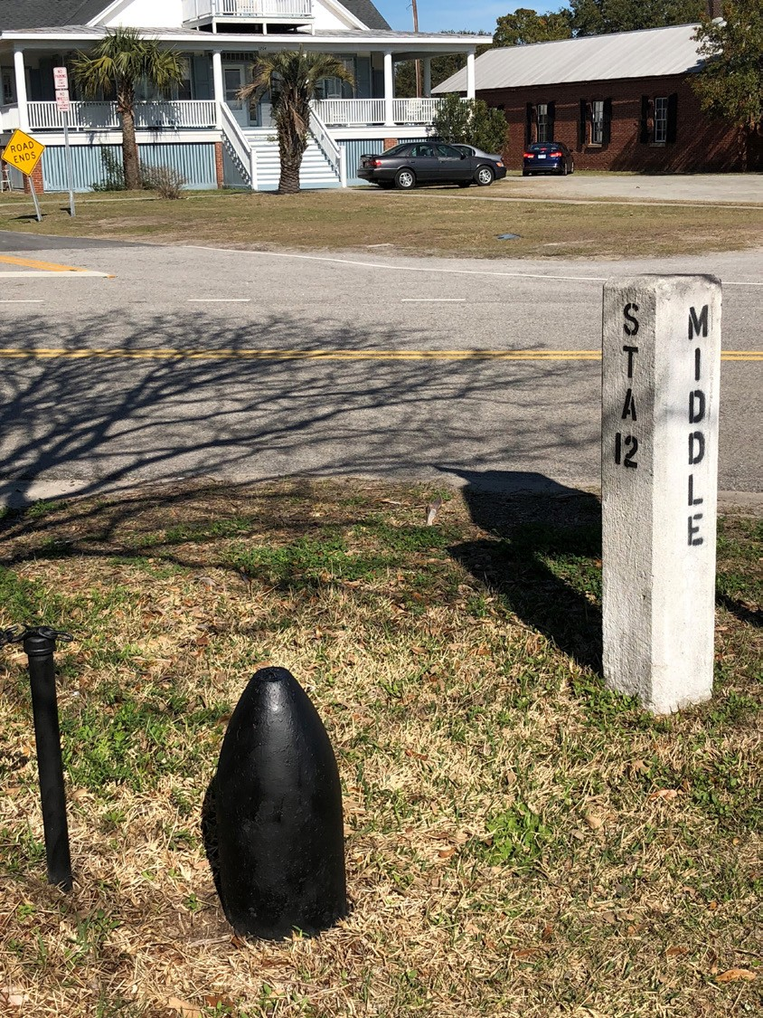
Historic trolley station markers

OTHER ISLAND CULTURAL RESOURCES
Because of the Island’s long military history and early use as a resort for downtown Charlestonians, there still remains many interesting architectural styles and cultural features. Some of these sites are listed individually below.

RESIDENTIAL AREAS
Most of Sullivan’s Island consists of historic residential neighborhoods, however, there is a constant flow of new residential infill construction taking place. Midcentury and modern contemporary architecture can be found in most neighborhoods, which express the eclectic culture of the Island.
- UNIQUE ARCHITECTURE: Dome and cylindrical shaped houses can be found on the front beach along Marshall Boulevard. These homes were built after Hurricane Hugo and are constructed to be more tolerant of high winds from tropical storms and hurricanes.
- HISTORIC POST STATION MARKERS: From the 1890s until the mid-1930s, the trolley was the primary method of transportation to Sullivan’s Island, linking travelers from Mount Pleasant to Sullivan’s Island and the Isle of Palms. The station stops became the unofficial street names for most of the Island, being designated the official street names in 1968. It is believed that the original stations were marked in the early 1900s by the same style concrete markers that now identify the Town’s major intersections. Although not officially on the National Historic Register, these concrete posts are a part of the Island’s history.
- CEMETERY, STATION 22½: Few grave markers remain on this site that was used until the mid-1900s primarily for those of African American descent. Many of those interred were from
nearby Mount Zion A.M.E. or the Stella Maris Catholic Church. The cemetery was significantly damaged during Hurricane Hugo, but recent efforts have been made to update records and maintain the site. A historic marker was erected in 2004 to commemorate the site and the contributions of those buried there.
- CEMETERY, STATION 22 AND MYRTLE STREET: Similar to the cemetery located at Station 22½, few grave markers remain on the site, but some are still legible.

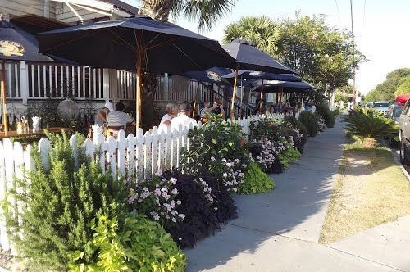
Restaurants and offices along Middle Street

COMMERCIAL AREA
There is only one commercial node on Sullivan’s Island; the commercial district is small area, comprised of only eighteen parcels that run along Middle Street, between Station 22½ to just beyond Station 20½. The commercial district abuts the Town’s showcase park, Stith Park, and the Town Hall complex, creating a unique and walkable community center for Sullivan’s Island residents and visitors. While the commercial district is a bustling area with lots of pedestrian and vehicular activity, it isstill best known for its quaint and low-key sea-side village vibe.

NATURAL AND SCENIC AREAS
Sullivan’s Island is known for its ubiquitous natural and scenic areas. Its location affords plentiful sunrise and sunset views. There are the expansive ocean views, marsh views, views of Charleston Harbor, the Charleston Peninsula, and Breach Inlet. The following is a listing of some of the unique natural and scenic areas that are available to all residents and visitors to the Island.
- BREACH INLET: Broad views of the ocean, Isle of Palms, and features Thomson Park, a small arrangement of interpretive sign boards describing the Battle of Breach Inlet during the Revolutionary War.

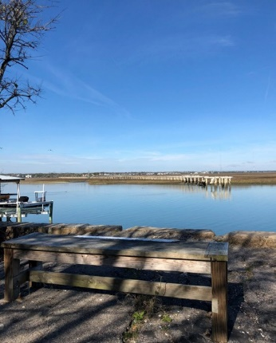
The Ravenel Bridge
from Star of the West, or Hagerty’s Point.
The Old Trolley Bridge
Overlook provides views of the old bridge, Cove Creek and Ben Sawyer Bridge.
  - THE OLD TROLLEY BRIDGE OVERLOOK: Used as a fishing pier and scenic overlook of Cove Inlet.
  - BATTERY CAPRON (THE MOUND): The highest point on Sullivan’s Island which provides expansive views of the Charleston Harbor, Arthur Ravenel Bridge, Atlantic Ocean and the marsh. (Large scale renovation plans are underway for both the Old Trolley Bridge Overlook and Stith Park, which including Battery Capron.)
  - THE OLD DUMP: Serves as a public canoe and kayak launching area to Cove Creek and the marsh.

  - THE BEACHES OF SULLIVAN'S ISLAND: Four miles of public beaches, with 30 public access points across the Island, provide access to the Atlantic Ocean and to views of Breach Inlet, the Atlantic Ocean and the Charleston Harbor.

RELIGIOUS SITES
There are several churches on the Island. Some of them have a long history, while others are relatively new. Many of the community’s churches function both as places of worship and as outposts for community events, thus contributing to the array of various community facilities available to Sullivan’s Island residents.
  - CHURCH OF THE HOLY CROSS: The Episcopal Church built the stone church at 1401 Middle Street near Fort Moultrie in 1891. The Army immediately decided to expand the reservation and acquired the building for $6,000 as the Post Chapel. The Episcopal Church was then moved to its present location at 2520 Middle Street. A large new church and parish hall were constructed in 2006. When Fort Moultrie was decommissioned, the Lutheran

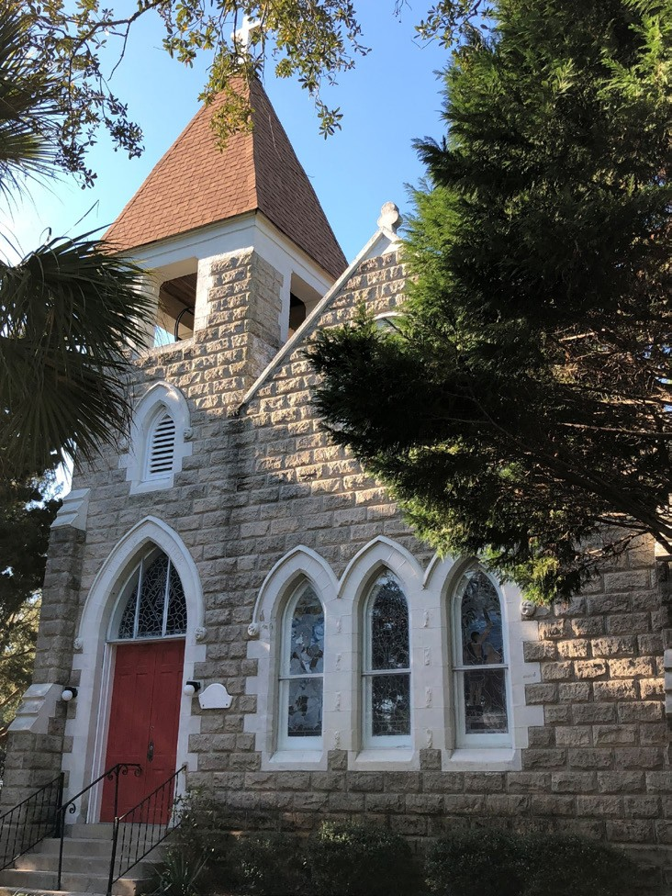
Chapel of the Holy Cross: Circa 1907

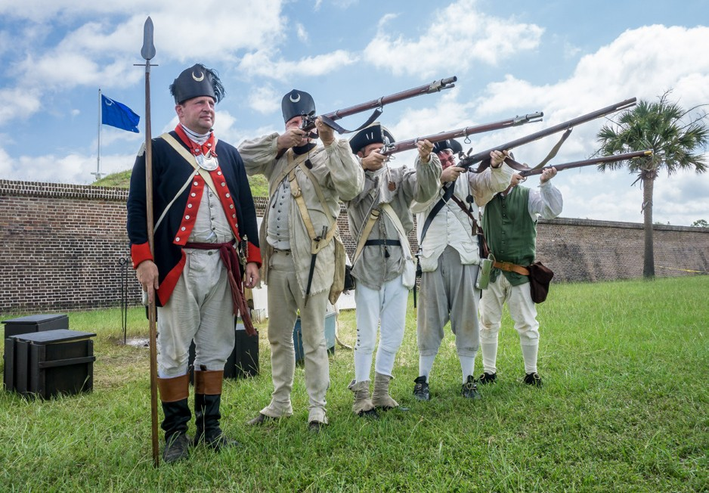
Carolina Day -Steve Rosamilia

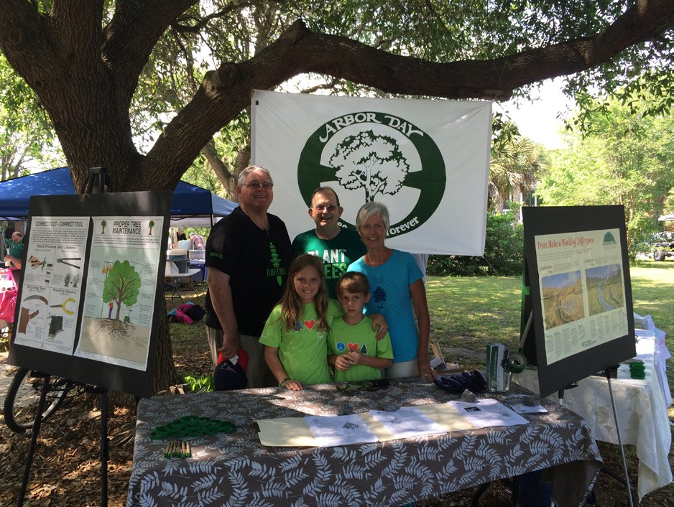
Annual Arbor Day Celebration. The Town was awarded Tree City USA Status in 2016.
congregation acquired the original building. The original granite building, located on Middle Street, is now a private residence.
- SUNRISE PRESBYTERIAN CHURCH: The Presbyterian Church was originally located at 2302 Middle Street within the historic Sullivan’s Island Graded School from 1957 to 1977. Sunrise Presbyterian is now located at 3222 Middle Street.
- STELLA MARIS CATHOLIC CHURCH: Located at 1204 Middle Street in the Moultrieville Historic District, the church is the most notable nonresidential historic resource in the district.
- SULLIVAN’S ISLAND BAPTIST CHURCH: The Sullivan’s Island Baptist Church occupies an old fort chapel near the former gates of Fort Moultrie at Station 18.

ENTERTAINMENT AND COMMUNITY ACTIVITIES
Sullivan’s Island offers many types of recreational activities for its residents and visitors. These events and resident participation are important to the social vitality of the community, as they offer opportunities for getting to know the members of the community and foster community interaction. The following is a listing of some of the activities offered on Sullivan’s Island.
- SULLIVAN’S ISLAND VOLUNTEER FIRE DEPARTMENT OYSTER ROAST AND FISH FRY: These yearly fundraisers, which occur in the fall, winter and summer, attract residents from the Town and surrounding area. The fire department has constructed a large shelter near Fort Moultrie to accommodate large events.
- ARBOR DAY: Sullivan’s Island was awarded Tree City USA status in 2016 and has held regular Arbor Day celebrations and tree giveaway events at Stith Park.
- CAROLINA DAY: On June 28th each year, the Island commemorates the defeat of the British attempting to occupy Charleston in the early days of the American Revolutionary War. The day is commemorated in several ways around
the community including a reenactment and a parade downtown.
- J. MARSHALL STITH PARK: J. Marshall Stith Park is a community gathering place and is the location for many community concerts and festivals. This park is located on

A featured junior vendor at the Island’s Farmers Market.

The market hosts an array of local vendors and activities including produce vendors, local crafts, live acoustic music, food trucks, and educational opportunities. -Steve Rosamilia
Middle Street in the commercial district of Town. The park contains a large open field for public use and two separate playgrounds, one for children under the age of six and one for older children. The historic Fort Moultrie bandstand provides shade for picnics and a site for entertainers to perform during various community activities. The Sullivan's Island Park Foundation is an active group of Island residents who raise money to provide landscape improvements, resurfacing of basketball and tennis courts, and also hosts several fundraising events throughout the year.
- SULLIVAN’S ISLAND COMMUNITY ACTIVITIES: Town Council routinely organizes family-oriented events for most major holidays. These events include the annual park lighting and fireworks festivities during the December holidays, St. Patrick’s Day Children’s Fest, and a fireworks display on Independence Day. These events take place at the J. Marshall Stith Park.
- FORT MOULTRIE: The Fort’s historic status combined with its preserved location on the coast make the site an ideal place to visit. Annually the National Park Service hosts multiple events.
- STATION 26 KAYAK & CANOE LAUNCHING AREA: The landing was restored by the Town in 2016 as a small-scale boat launching area for non-motorized boats. Provides direct marsh access.
- TOWN BOAT LANDING: The Town offers a boat landing for Sullivan’s Island residents and non-residents for a fee.

St. Patrick’s Day Children’s Festival -Steve Rosamilia

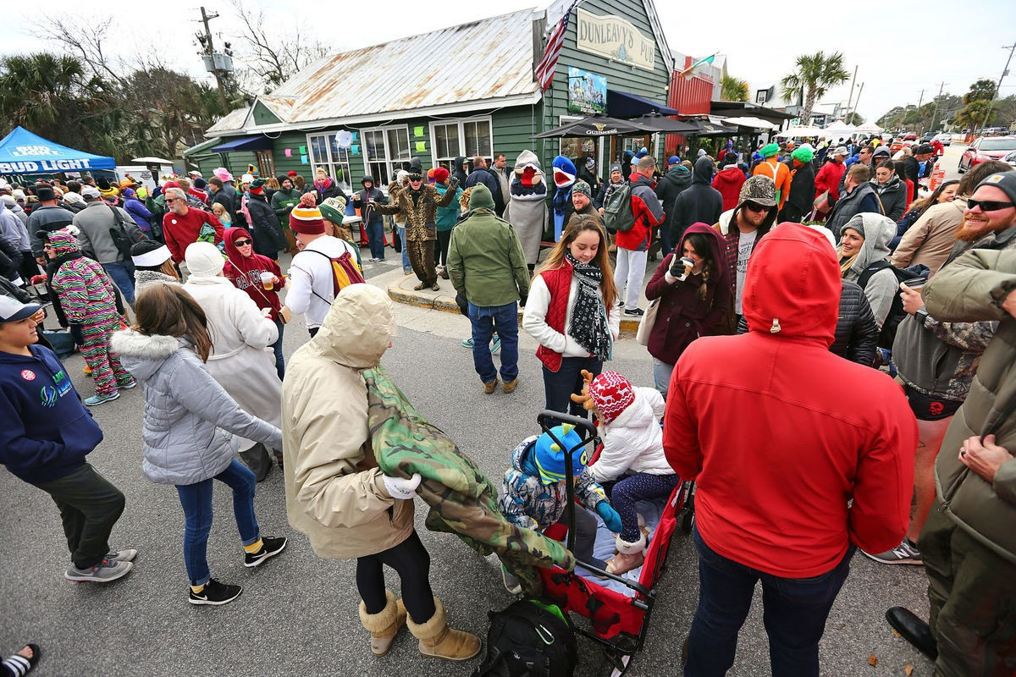
New Year’s Day Polar Plunge - Post and Courier
  - NEW YEAR’S DAY POLAR PLUNGE: Although not a Town sponsored event, the New Year’s Day Polar Plunge is a fundraiser for the Special Olympics that attracts thousands of visitors to the Island each year.
  - WALK DOGS ON BEACH: Residents walking their dogs at the appropriate hours to promote community interaction and exercise.

