The Community Facilities element describes the services, activities, programs, and amenities that contribute to and enhance the overall high quality of life on Sullivan’s Island. This chapter will summarize the function of Town government, including emergency services, public works and water and sewer infrastructure. Other community assets such as libraries, parks and educational facilities will be incorporated as well. Evaluating the current state of Town services and local public facilities and infrastructure is critical in addressing existing needs for services and how those services will be provided to meet future needs.
Town Government and Departments

The Town’s municipal complex is located in the center of the Island and serves as the epicenter of Town government operations.
The campus, located at 2056 Middle Street, includes Town Hall, the Fire Station, Water and Sewer facilities, and Stith Park. Town Hall is a 10,000-square foot facility that houses the Town’s administrative departments, municipal court, Police Department and serves as the meeting venue for all regularly held community councils, boards and commissions.
Town Council
Town Council serves as the governing body for the Town of Sullivan’s Island. Operating under the council-administrator form of government, the Town’s system of governance combines the political leadership of an elected mayor and council members with the managerial experience of a professionally trained administrator who oversees the day-to-day delivery of public services. The Council is a seven-member elected body, including a voting mayor. Each council member serves a staggered four-year term with regularly held meetings a minimum of twice a month at Town Hall.
Town Administration

The Town Administrator serves as the chief executive officer for all Town business and works toward implementing the various policies and decisions adopted by Town Council. The Administration Department includes the Town Administrator, Deputy Administrator/Comptroller, Assistant to the Town Administrator/Personnel Administrator, Town Clerk, Accounting Clerk, Town attorney, and several other administrative support positions.

Building and Planning Department
The Building and Planning Department, located in Town Hall, is comprised of a Building Official, Director of Planning and Zoning, and one permitting and licensing specialist. These professionals manage all planning and development related services.
The department’s primary responsibilities are handling the day-to-day building and permitting activities such as issuing building permits, business licenses, performing plan review, and performing zoning and building code enforcement.
Additionally, the Building and Planning Department is responsible for all long-range planning activities which include writing zoning text amendments, implementation of special projects, and management of long-range planning studies such as the Comprehensive Plan, Beachfront Management Plan, Island-wide Parking Plan and assisting Town Council with the crafting of other relevant policies.

Court Services
The Sullivan’s Island Municipal Court system is comprised of a Town Council appointed municipal judge, one part-time substitute judge and is staffed by the Clerk of Court. The Town retains the services of a part-time prosecuting attorney for professional legal assistance with various court proceedings. Court is held in Town Hall twice a month.

Public Safety & Emergency Services
Public Safety services are offered through the Police and Fire Departments. The Police Department maintains animal control, fleet management, beach patrol services, and parking enforcement. The Fire Department includes full-time firefighters on permanent rotating shifts and public works personnel, who handle Island-wide maintenance activities. The Fire Department also maintains a large volunteer firefighting force of more than 50 individuals.
Police Department
The increasing popularity of the Island’s beaches can be attributed to both the explosive population growth of the Charleston region and the area’s limited access to public beaches. What was once a seasonal increase of beachgoers has now become a year-round presence of visitors to the Island’s beaches, restaurant district, and other cultural attractions such as Fort Moultrie. The year-round impact of traffic congestion and other law enforcement activities has subsequently led to a need for both seasonal beach security and parking enforcement personnel, as well as regular patrol officers. In the fall of 2016, a public parking plan was implemented by the Town, which increased the Department’s need for additional technical equipment, patrol vehicles, and all-terrain vehicles.
As of 2023, the department is comprised of 12 full-time uniformed officers, 1 full-time animal control officer (fleet manager) and 4 to 7 part-time seasonal beach services officers. The uniformed officers, which consist of a Police Chief, an Assistant Chief, 4 sergeants, and
4 patrol officers, typically work 12-hour shifts. The Department occasionally uses reserve officers and constables during the peak of tourist season.
The Department has also attempted to keep up-to-date on technological advancements in the field of law enforcement through the acquisition of updated Police vehicles adapted with Geographic Information Systems (GIS), guided laptop computers and updated radio equipment.
Body cameras, tasers, and body armor, now considered standard issue for local government law enforcement, will now require ongoing maintenance and regular replacement. Table 4.1 identifies the various projects and capital improvements for the Police Department.
Fire Department
The Fire Department holds the responsibility of providing two separate and distinct public services: 1) Fire protection and emergency first responders 2) Public works and facility maintenance.
The Sullivan’s Island Fire and Rescue Department consists of eleven
- (11) paid full-time shift firefighters: one (1) chief, one (1) assistant chief &

training officer, two (2) captains, three (3) lieutenants, one (1) engineer and three (3) firefighters. The full-time staff is supported by 43 on-call volunteer fire fighters who are available for structure fires, as well as disaster recovery
from emergency weather events. The Department provides emergency first response to all areas of Sullivan’s Island and provides fire protection for the Fort Sumter National Park and associated structures. Assistance is provided from the Town of Mt. Pleasant and the City of Isle of Palms by way of a consolidated 911 dispatch service operated by Charleston County. Fire hydrants are maintained regularly by the department and are available throughout the Town.
The Town’s fire station is located at the corner of Station 20 ½ and Middle Street and is a cornerstone of the Town’s municipal complex. Constructed in the aftermath of Hurricane Hugo, it serves as part of the Island’s Municipal Emergency Operations Center (MEOC) for emergency storm events.
The facility is fully-equipped with phone and fiber optic connections that serve as an emergency support facility to Town Hall with the capacity and space to house all emergency response operations. Currently, the building houses the Town’s Fire and Rescue and Public Works Departments.
In 2016, the Fire Department received the highest possible protection rating of Class 1, which is determined by the Insurance Service Office (ISO). The ISO is a nationally recognized entity that evaluates a community’s firefighting preparedness on a scale of 1 to 10.

Additionally, the fire department operates a boat landing at Station 9 and Osceola Avenue for emergency water rescue purposes. Membership is sold to Town residents and non-residents, with residents’ fees being less than half of what non-residents pay. The fire department also operates and maintains a training center at Battery Thompson, which is used by Mt. Pleasant and the Isle of Palms Fire Departments.
Table 4.2 lists the various departmental needs within a 10-year planning horizon. Being a coastal community, the Sullivan’s Island Fire and Rescue Department is not only charged with fire protection, but also water rescue. An offshore fire rescue boat was purchased in 2014, which dispatches to water emergencies adjacent to the beaches, tidal marshes and inlets of Sullivan’s Island.

Public Works (Maintenance Department)
The Public Works Division is managed by the Fire Department and is charged with assisting with the regular maintenance of public parks and rights-of-ways. The staff consists of one (1) full-time supervisor and three (3) full-time maintenance workers. Seasonal part-time employees are retained as needed.
With increased building and development in the past 10 years, there has been an increased citizen demand for park maintenance, recreational courts and availability of open spaces for special events. This increased demand in facilities and services has led to more frequent use of Public Works equipment by departmental staff with an increased demand on maintenance staff. The Public Works Division currently lacks a permanent facility for storage of maintenance equipment and operation of personnel. A new facility, and most likely an increase in staffing, will be needed in the coming years.

Emergency Operations Center
As a barrier island, Sullivan’s Island shares a unique set of challenges when beset with emergency storm events. It is essential that community residents and visitors understand that the entire Island is located within a flood hazard area and is prone to catastrophic damage and loss of life if confronted with extreme weather events.
Town government must continually stress the importance of evacuation plans if confronted with tropical storms, hurricanes, tsunamis, floods and fires.
The primary Municipal Emergency Operations Center (MEOC) is located within Town Hall at 2056 Middle Street and is equipped with an elevated generator capable of sustaining operations in the event of a power outage.
Town Hall also maintains all phone, radio and internet communications necessary to handle the function of Town government.
Emergency services have greatly expanded for the Island in the past 10 years. In 2011 the Sullivan’s Island Remote Emergency Notification System (SIRENS) was implemented and is comprised of two (2) sirens located at Station 24 and Station 15. This audio notification will activate should residents become unresponsive to telephone, mobile
devices, and internet. The Town also manages an emergency alert system through “Nixle,” (www.nixle.com), which allows residents to register phones and mobile devices to receive text messages and e-mails from the Police and Administration Departments.
Annually, the Town participates in the Charleston County Emergency Operations Plan and the Charleston County Hurricane Preparedness Guide in addition to the Town’s Hurricane Plan.

Emergency Medical

Services (EMS)
The Fire and Rescue Department has long provided first responder services to the Island since its founding in 1948. Initially organized as a volunteer fire department, today’s firefighters are cross-trained in emergency first responder care and work 24-hour shifts. Additional emergency first responders are provided through the Charleston County 911 Consolidated dispatch service consisting of a nine (9) member intergovernmental agreement, of which Sullivan’s Island, IOP and Mount Pleasant are a part.
In 2016, Town Council also initiated an agreement with Air MedCare Network (Meducare) to provide citizens and Town employees with air ambulance service. Any insured resident of Sullivan’s Island may receive paid air medical transport, if they are within Charleston County.

Water and Sewer Department
Drinking water supply and wastewater treatment are managed under the Town’s Water and Sewer Department. The Department consists of 8 full-time employees, including one departmental manager and one full-time billing clerk who operates from Town Hall. There are 7 licensed water and sewer operators holding South Carolina Department of Health and Environmental Control (DHEC) certifications in the area of water treatment, water distribution and wastewater treatment. All employee certifications are maintained through continuing education, training and are geared to meet the facility’s state permitting requirements.
Water Supply
Following Hurricane Hugo in 1989 and the widespread water quality problems in the early 1990s, the Town began purchasing water from Charleston Water System (CWS), the primary water distribution agency for the greater Charleston area. CWS currently supplies water to Sullivan’s Island, the Isle of Palms Water and Sewer Commission, and Mt. Pleasant Waterworks through a water line that runs under the Charleston Harbor to the western tip of Sullivan’s Island. This water main runs along the Middle Street right-of-way for the entire length of the Island, as seen on Map X.
Beginning in 2004, the ongoing water line replacement program has completed the replacement of approximately 20,000 feet of pipe, 45 valves and 20 hydrants. The work that has been completed thus far has resulted in successful mitigation of the discolored water issue identified in the late 1990’s and early 2000’s and helped with the long overdue need of replacing aged and failing water pipes. These efforts have also increased fire flow to all hydrants island-wide, resulting in better insurance rates for homeowners and increased public safety. In 201X, the Department approved a new 32-year water line replacement plan. The Water Distribution System Pipe Replacement map shows the Department’s five-year focus area, as of 2023.
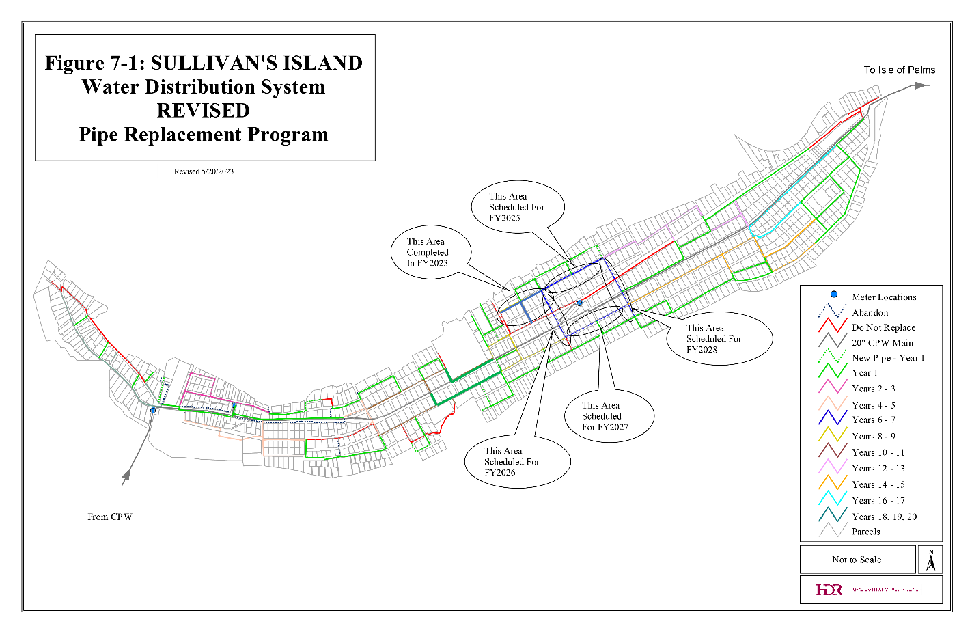
The Town’s current contract with CWS provides a limit of 750,000 gallons of water per day for Sullivan’s Island’s use. However, the Island maintains an emergency water agreement with the Isle of Palms Water and Sewer Commission and Mt Pleasant Waterworks in the event of a CWS failure from the Charleston Harbor pipeline. Additionally, the Town maintains two (2) deep wells for water pressure in the event of an emergency.
Residents’ water usage data is collected and maintained by a touch-read computerized meter reading system that allows meters to be accessed easily and downloaded for automatic billing. The Town uses a progressive rate structure, meaning that the unit cost of water increases as more water is used. Current water and sewer rates and fees are passed by Council via resolution. Water testing is accomplished on a regular basis in accordance with DHEC standards. Annually, a report is mailed to all users summarizing the water tests and results in compliance with regulations.
Wastewater
The Town owns and operates a wastewater treatment facility (WWTP) and its associated gravity collection system. This collection system consists of nearly 80,000 linear feet of gravity collection mains, 25,000 feet of service lateral lines, over 325 manholes, and 6 pump stations. In 2021, the WWTP and associated infrastructure and facilities were upgraded to improve efficiency and resiliency. However, despite these upgrades, the design capacity of the plant remains unchanged at 0.57 million gallons per day (MGD). Furthermore, the daily average flow has dropped from 0.58 MGD in 2020 to 0.47 MGD in 2022, which meets current DHEC operating and discharge standards. Located on Gull Drive, the plant has a permitted effluent discharge point into the Intercoastal Waterway (ICWW) via an unnamed tributary.
Perhaps the most significant concern for the Town’s wastewater system relates to the occurrence of inflow and infiltration (I&I). I&I occurs when groundwater and stormwater enter the sanitary sewer system through a variety of ways. Inflow refers to water that enters through improper connections, such as downspouts and groundwater sump pumps and infiltration is ground water that enters the system through damaged or leaking pipes. In 2015, the Town completed the first phase of their I&I reduction program, resulting in a 36% reduction of I&I with the second phase having been completed in 2020. This process included the grouting of thousands of feet of sewer lines within the existing system. Furthermore, these projects provided the Water and Sewer Department with a road map for future sewer collection system rehab repairs and replacements. Any future repairs and replacements will now coincide with the annual water line replacements as needed.
Water and Sewer Planning Reports & Projects
The following list of projects and planning reports have been developed by various consultants and the Town’s Water and Sewer Manager as part of the 2018-2022 Water and Sewer Capital Improvement Program (CIP). This program considers the current and projected water and wastewater needs for the Town.
Project Status | Water and Sewer Planning Reports and Projects
Ongoing | Water Line Replacement Program:  Continuation of 2004 study to replace remaining unlined cast iron pipe, valves, and hydrants
Complete | Wastewater Treatment Facility Replacement:  In 2017, Town Council approved a plan to reconstruct existing oxidation ditch, treatment plant headworks, treatment plant generator, drying beds, and other associated accessory structures.
Complete | Pump Station Improvements:  Retrofit all 6 pump stations to become submersible pumps which will make them flood proof
Complete | Poe Avenue Sewer Replacement:  Relocate 1,400 linear feet of 8-inch pope and install 5 new manholes in the Poe Ave right-of-way
Complete | Station 17 to Citadel Sewer Replacement:  Relocate 382 linear feet of 8-inch pipe and install 2 new manholes in the Middle Street right-of-way
Complete | Inflow and Infiltration (I&I) Rehabilitation Project:  A grouting project that consisted of cleaning CCTV subsection 5 and 6 of the sewer collection system. The success of this project resulted in a 32% reduction in I&I to the system and led to Phase II.

Stormwater Management

In 2007, the Town entered into an intergovernmental agreement with Charleston County to administer and enforce all Island stormwater utility regulations. These regulations are codified under Chapter 25, Sections 1-12 of the Town Code of Ordinances. In addition to serving as the regulatory authority for enforcement, billing and collecting the Town’s stormwater fees, the Charleston County Stormwater Management Division is charged with conducting regular maintenance of all inlets, conduits, manholes, channels, ditches, waterways and infiltration facilities.
Although the Town does not operate its own stormwater utility, Town officials have taken great strides to lessen the impact of stormwater inundation during rain events by implementing various policy and regulatory initiatives. Many of these stormwater management initiatives are part of the larger strategy for mitigating the future effects of sea-level rise and are discussed in greater detail in Chapter 10, Resiliency and Sea Level Rise.
In response to the catastrophic flooding events of 2015 (Hurricane Joaquin), the Planning Commission performed a detailed study of the effects of Island development at the neighborhood scale and subsequently created a Zoning Ordinance regulation requiring an onsite stormwater management system for any residential or nonresidential development. This regulation can be found in Section 21-17 of the Zoning Ordinance and mandates that a plan be developed with any substantial construction project that prevents adverse impacts to adjacent or downstream properties. This plan must be developed by a professional engineer or landscape architect.
Stormwater Management and Resiliency Projects
To implement many of the established goals and objectives related to sea level rise, resiliency and island wide flooding, multiple planning initiatives and infrastructure projects are either underway or in the process of approval. Since the adoption of the Comprehensive Plan in 2018, the Town has begun stormwater improvement projects within eight watershed areas across the island, and has begun three major planning initiatives funded by either Town, state, and federal funding sources. These projects and project areas are listed below:
Planning Initiatives
Stormwater Master Plan: A federally funded grant project to be completed in 2025, focuses on developing an island wide stormwater master plan to systematically inspect and catalog existing drainage infrastructure, investigate drainage deficiencies and develop a sound comprehensive strategy to address flooding experienced on the island today, while also preparing for tomorrow’s changing coastal environment.
Resilience & Sea Level Rise Adaptation Plan: The plan will produce clear strategies to identify, assess and plan for potential impacts of sea level rise, storm events, and other environmental hazards, which will serve as a framework for guiding local investments in flood mitigation projects and policies.
Stith Park Master Plan: A Town funded park redevelopment plan geared to improving stormwater drainage not only for Stith Park but also the surrounding municipal complex and its surrounding facilities (Town Hall, Fire Station, Wastewater Treatment Plant).
Stormwater Infrastructure Improvements
South Carolina Infrastructure Improvement Program (SCIIP): A state and federally funded grant of $10 million to study and improve infrastructure conveyance within the following watersheds while improving outfalls along the marsh
Station 16 Watershed - ±48 acres of service area. Intended to mitigate existing flooding along Middle Street and Station 16 (considerable impacts seen between Poe and Atlantic Ave). Project includes upgrading the mainline to 24-to-36-inch pipes along Middle Street to the outfall, adding new inlets, piping throughout the service area, and incorporating check values and manufactured treatment devices (MTD) where needed.
Station 25 watershed- ±53 acres of service area; Project includes 1,940 linear feet of piping, 16 inlets with manhole structures, one check valve and one MTD. The existing 18-inch mainline from Raven Drive to Atlantic Avenue will be upgraded to significantly larger pipes; 18-inch to 48-inch at the outfall; to 18-inch to 30-inch piping near Atlantic Avenue.
Station 28.5 watershed- ±89 acres of service area. Includes upgrades to the existing outfall and mainline along Station 28.5 increasing diameter from 18-inch to 42-inch in addition to upgrading most of the connecting upstream and adjacent drainage system. Additional improvements will take place with most undersized pipes and small open ditches along I’On Avenue and Atlantic Avenue.
Station 31 watershed- ±83 acres of service area; Represents the largest low-lying depressional area and includes 3,245 linear feet of piping, 19, inlets and/or manhole structures, two check valves, and two MTDs. Includes upgrading the existing outfall piping beneath Jasper Boulevard, existing culvert beneath Middle Street, existing pipe along Middle Street and Station 31 and new piping along Station 30 and 31. All new piping will require upgrades to drainage inlets and check valves and MTDs will be installed at the Jasper Boulevard outfall to prevent backflow of tidal waters.
Station 18 to Station 19 via a FEMA Hazard Mitigation Grant (HMGP): Approved in 2017 to study the existent stormwater drainage deficiencies from Station 18 to Station 19 along with improvements to all drainage infrastructure to the marsh outfall, one of the worst areas affected during heavy rain events.
Outfalls at Station 19 & Station 25 via a FEMA Hazard Mitigation Grant (HMGP): Outfall improvements include upgrading all necessary drainage systems along from Station 18 ½ to Station 19 and Station 25. Tide check valves area proposed at each outfall. This work will take place concurrently with other stormwater improvement projects.
Osceola Avenue Outfall Improvements: Will improve drainage throughout the western end of the Island by cleaning infrastructure and pipes and upgrading Tide check valves area proposed at each outfall
Commercial District watershed improvements from Station 22 to Station 22.5: Improvement of insufficient pipe sizes and flow to
The map shown in Figure XX illustrates the various project areas slated for infrastructure improvements.
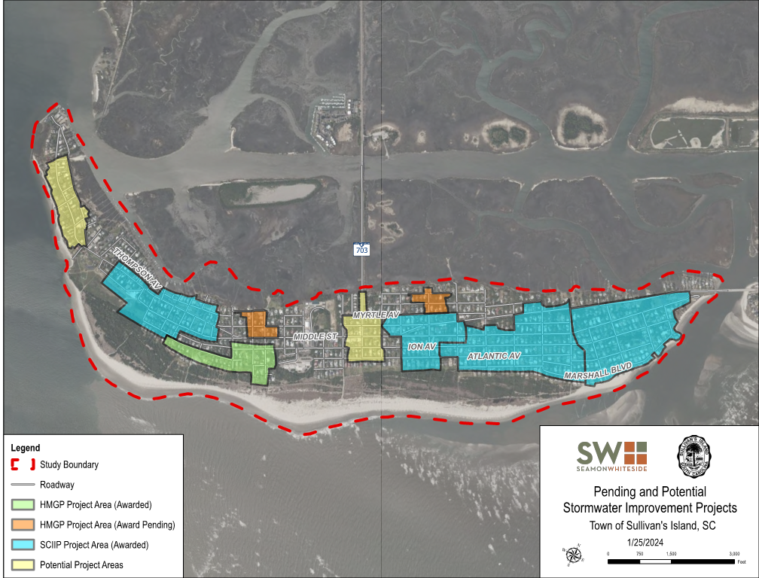
Although stormwater conveyance and drainage systems are owned by SCDOT, Town staff and County officials continue performing regular maintenance of ditches and providing jet-vac services and other excavation equipment on an as needed basis.
Other Utilities
Electric
Electric power and tree pruning maintenance (when trees affect power distribution) is provided by Dominion Energy. Natural gas is unavailable to Island residents and must be purchased from private vendors.
Phone, Cable and Internet Services
Primary cable and internet service providers are AT&T U-verse, Comcast Xfinity, Dish network, Direct TV and Verizon.
The Town has also considered the merits of establishing a municipal wireless network, which would offer broadband services to Island residents. This type of system would require multiple Wi-Fi access points throughout the Town.
Solid Waste
Sullivan’s Island contracts with a private third party to provide weekly solid waste collection. This service includes household trash and garbage collection via roll container, bulk waste (large furniture, appliances, carpet, mattresses, etc.) and yard waste. During the three summer months, when beach traffic and rentals are at their highest levels, the regular household trash is picked up twice a week and bulk trash/yard debris once per week. The refuse is taken to the Charleston County landfill.
In 2015, Charleston County Environmental Management Department (CCEMD) began providing all-in-one (single-stream) residential recycling services to the Island. This allows the convenience of placing all recycled materials into one container instead of pre-sorting. Recyclables are picked up once every two weeks by way of 55-gallon roll carts.
Emergency debris collection from major storms and extreme flooding events has long been a critically important issue for Island residents. Because the Town does not operate its own solid waste collection authority, debris collection following these events must be retained by private contractors, which is often seen as an unfunded liability from a budgetary standpoint. The Town must rely on Federal Emergency Management Agency (FEMA) reimbursements for these expenditures and assistance from CCEMD.
Traffic and Security Cameras
Two traffic cameras were installed in 2017 providing live video streaming of traffic flow conditions on both the Sullivan’s Island side of the Ben Sawyer Boulevard (Highway 703) and Mount Pleasant sides of the Causeway. This feed can be viewed from a smart phone or other mobile device at http://www.511sc.org/. Security cameras may also be added to the right-of-way to monitor the flow of vehicles onto the Island. This data can be used to aid the Police Department in decision making and for law enforcement purposes.
Health Care
There is one primary care facility on Sullivan’s Island offering a wide range of family care services including pediatric, adolescent and adult medicine. Additional primary care facilities are located in Mt. Pleasant, Isle of Palms, and downtown Charleston. Three major hospitals are easily accessible from the Island including East Cooper Regional Medical Center, Roper Saint Francis Hospital, and Medical University of South Carolina (MUSC) East Cooper facility, all located within 10 miles of Sullivan’s Island..
Parks and Recreation Facilities
Both passive and active recreational opportunities are found throughout Sullivan’s Island. Passive recreation is generally defined as an undeveloped space or environmentally sensitive area that requires minimal development and varying levels of maintenance. Active recreation, on the other hand, includes structured or organized recreational activities, most often associated with developed sports fields, playgrounds, and boat landings. The recreational activities on Sullivan’s Island can be divided into these two distinct areas of recreation. Map 2.2 illustrates several passive recreational areas which includes kayak launching areas, walking trails and beach access points.
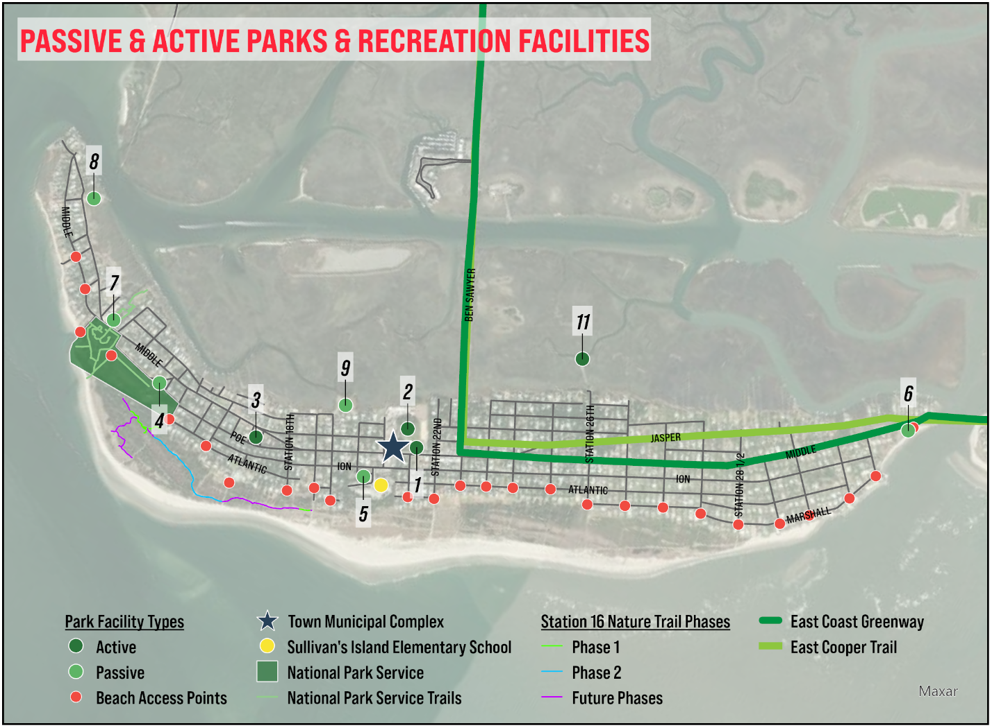
Active Recreation Areas: Parks, Sporting Facilities
- Town Hall Municipal Campus: The Town Hall municipal campus is a host to multiple recreational opportunities:
- J. Marshall Stith Park (1): Located in the heart of Town, the park includes three (3) tennis courts (one practice court), one (1) full basketball court, younger and older children’s playground and historic bandstand (community gathering place).
- Fishing Pier: Located behind the water treatment facility, this small pier extends 160’ into the creek and is open to the public.
- Multipurpose Sports Fields: Used year-round for general public use, soccer, lacrosse and other organized sports.
- Battery Capron/Butler (2): Better known as “the mound,” this hill top is the highest elevation on Sullivan’s Island. Battery Capron/Butler is located behind Stith Park and was originally an Endicott Period military fortification that was filled for being a danger to public safety due to its forty-foot deep mortar pits. Occasionally, special events are held on the grass plateau atop the mound and is well known for its “bamboo forest,” growing on the eastern face of the mound. In 2017 Town Council established a maintenance program for re-grading the hill facing Stith Park and containing the proliferation of bamboo to just the eastern face of the mound.
- Poe Park (3): Located on Middle Street between Artillery Drive and Citadel Street, Poe Park underwent multiple renovations in 2016 and 2017, including resurfacing of two (2) tennis courts, adding new fencing, adding one (1) basketball goal and installing new playground equipment.
- Fish Fry Shack: Used as a training and fundraising facility for the Sullivan’s Island Volunteer Fire and Rescue organization.
- Island Club (4): Used as a venue for various community events.
- Battery Gadsden Cultural Center (5): The Battery Gadsden Cultural Center is a local organization comprised of residents and nonresidents, who host an array of community and civic events annually:
- Farmers Market: On hiatus since the beginning of the COVID pandemic.
- Arbor Day: Sullivan’s Island was awarded Tree City USA status in 2016 and has held regular Arbor Day celebrations and tree giveaway events at Battery Gadsden.
- Thomson Park Interpretive Memorial (6): The memorial is a small interpretive pocket park at Breach Inlet on Middle Street, initially dedicated in June 2011. The Park’s purpose is to commemorate a historic military event that occurred at Breach Inlet during the Battle of Sullivan’s Island during the American Revolution on June 28, 1776 (Carolina Day). Primarily, private funds developed and currently maintain the Park, but it is available to the public for free.
- Fort Sumter and Fort Moultrie National Historical Park Visitor’s Center and Fishing Pier (7): Located at 1214 Middle Street, Fort Moultrie is a historic National Monument site with various recreational activities. Touring the monument is primarily self-guided through the various interpretive wayside exhibits, however, daily tours and programs are available depending upon the season. A fishing pier and open space with picnic shelters are open to the public year-round.
- Benke-lowe landing (8): Owned and maintained by the Fire Department, this landing provides water access for boats, kayaks, and canoes. Membership is sold to Sullivan’s Island property owners and non-residents. Boat Landing Memberships are issued annually beginning on March 1st and can be purchased at the Fire Department located at 2050 Middle Street.
Passive Recreation Areas:
- Old Dump Kayak Launch (9): The old dump is a deed restricted property located at Station 19, which now serves as an open space for general public use. Mainly serving as a wildlife viewing area and canoe and kayak access to Cove Creek, this property is held in a perpetual conservation easement through the East Cooper Land Trust.
- Old Trolley Bridge (10):
The trolley bridge predates the Revolutionary War and served as Sullivan’s Island’s only connection to the mainland. Also held in a perpetual conservation easement through the East Cooper Land Trust the remnants of the bridge are open to the public and accessible by a short trail that opens to a scenic overlook of the Charleston Harbor, Mount Pleasant, and Cove Inlet.
- Beach, Access Paths & Town Protected Land: There are 26 public access paths to the Island’s beaches, of which, there are seven (7) ADA-accessible and 10 emergency access enabled paths. Two (2) beach wheelchairs are available at the Fire Department and may be used for beach access throughout the day.
- Station 16 Nature Trail: The trailhead is located off of the Station 16 beach access. Opened in June 2015, the 650-foot nature trail offers two (2) observation decks and benches along a partially elevated boardwalk. Phase 2 of the SI Nature Trail is in engineering and once constructed will provide trail access through the maritime forest between the Lighthouse and Fort Moultrie.
Station 26 kayak & Canoe Launching Area (11): The landing was restored by the Town in 2016 as a small-scale boat launching area for non-motorized boats. Provides direct marsh access.
Educational Facilities
Schools
Sullivan’s Island Elementary School is a public-school facility located off of I’On Avenue in Sullivan’s Island and is part of the Charleston County School District (CCSD). Serving the residents of Sullivan’s Island and Ise of Palms, the school maintains an annual enrollment of approximately 500 students and is consistently ranked one of the top public elementary schools in South Carolina. Other public schools that serve Sullivan’s Island students include Moultrie Middle School for grades 6, 7 and 8, and Wando High School for grades 9, 10, 11 and 12. There are also several county-wide magnet schools which Sullivan’s Island residents may attend, including Academic Magnet School, School of the Arts, and Military Magnet School.
Libraries
The Edgar Allan Poe/Sullivan’s Island Library, located in Battery Gadsden, is a branch of the Charleston County Public Library (CCPL) system. The library is located at 1921 I’On Avenue (directly adjacent to Sullivan’s Island Elementary School) in the renovated military installation dating to the Spanish-American War. The library is named for author Edgar Allan Poe, who was stationed on Sullivan’s Island as a private in the United States Army in 1827 and 1828, and who used the Island setting as the background for his famous story, “The Gold Bug.”
The 2,000-square foot branch houses a collection of more than 6,800 materials, including fiction and non-fiction, juvenile and young adult books, periodicals, books on CD and DVDs. Library cardholders also have access to downloadable materials including e-books, audiobooks, magazines, music and more and can request more than 250,000 additional titles from other branches. The branch circulated 25,919 materials in FY 2017 and provides its visitors with four internet-connected computers and free Wi-Fi. The branch also hosts hundreds of educational and entertaining programs throughout the year. In 2017, more than 9,000 attended nearly 500 sponsored events, which included children’s programs, lectures, games, writing groups, book club discussions, and crafts.

