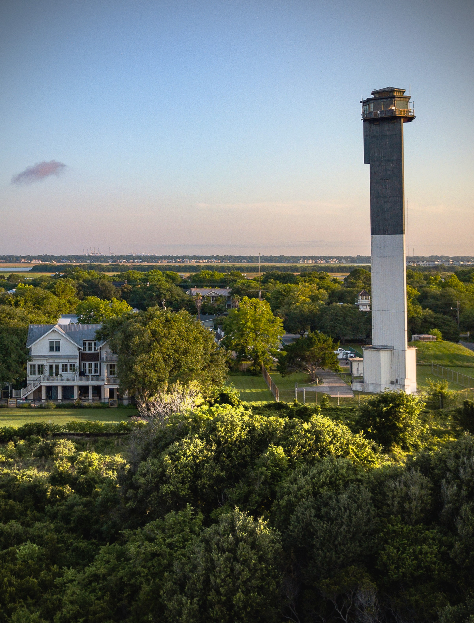

109 Sullivan’s Island Comprehensive Plan 2018-2028: Resiliency Element

CHAPTER 11: PRIORITY INVESTMENT ELEMENT

HOW WE PRIORITIZE

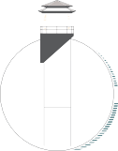

Sullivan’s Island Comprehensive Plan 2018-2028: Priority Investment Element 110

South Carolina Priority Investment Act
“South Carolina Priority Investment Act by amending section 6-29-510, relating to comprehensive plans of local planning commissions, so as to amend the housing element and to
provide for transportation and priority investment elements of comprehensive plans; to amend section 6-29-720, relating to regulation of zoning districts, so as to allow local governments to develop market-based incentives and elimination of nonessential housing regulatory requirements to encourage private development, traditional neighborhood design, and affordable housing in priority investment areas;
to amend section 6-29-1110, relating to definitions, so as to defined “affordable housing”, “market based incentives”,
“traditional neighborhood design”, and “nonessential housing regulatory requirements”; to amend section
6-29-1130, relating to regulations of a local governing body governing the development of land upon the
recommendation of the local planning commission, so as to further provide for the content of these regulations relating to land development; and to provide that local governments amend their comprehensive plans to comply with these provisions.”
The purpose of this element is to enhance coordination of local government and public service planning in the Town of Sullivan’s Island. The Town can synchronize public and private investment in land and infrastructure if they are able to think strategically about how those improvements will affect the Island. Increased coordination between the Town and other jurisdictions will help
conserve culturally and environmentally sensitive resources as well. This element also serves to show what local revenues are collected and why the Town must work to find other revenue streams to invest in large, impactful projects.
The Priority Investment Act legislation requires an additional comprehensive planning element, which instructs local government entities to analyze the likely federal, state and local funds available for public infrastructure and facilities during the next ten years.
These entities are encouraged to prioritize projects for expenditure of those funds during the next ten years for needed public infrastructure and facilities such as water, sewer, roads and schools. Local government agencies should coordinate with adjacent and relevant jurisdictions such as counties, municipalities, public and private utilities, school districts, transportation agencies and other public entities affected by or that have planning authority over the public project. Town Staff is responsible for seeking and monitoring aid, grants, and other opportunities that arise.

FINANCIAL PORTFOLIO
To better understand how priority investments may occur, the Town can outlay revenues and potential financial opportunities. Revenues consist of the total operating budget and can be tracked and monitored closely in the Town’s annual budget process. Financial opportunities are contingencies that occur like grants or regional, state, or federal assistance programs. Financial opportunities may occur at random intervals or on scheduled occurrences.

REVENUES

The Town of Sullivan’s Island annual budget provides a funding timeline for public facility improvements including public safety, culture/recreation, general government, and public service. These projects include maintenance for fire and police stations, Town parks and other supporting facilities. An annual budget is prepared by the Town and the process is open and transparent for the citizens through public notice and public meetings. This section is only a snapshot of the budget and more in-depth information can be found at the Town’s website:

https://sullivansisland.sc.gov/government/financial-reports

FIGURE 11.1 SULLIVAN'S ISLAND REVENUE SOURCE
1.6%
0.4% 7.1%
50.4%
11.8%
24.1%
4.6%

Property Tax
Local Option Sales Tax Licenses
Permits and Fees Accommodations Hospitality
Misc. Revenue
The Town’s fiscal year runs from July 1st to June 30th, which means that a budget
must be prepared and approved by Town Council before July 1st. The budget process begins in January and it is a time in which priority expenditures should be made.
Figure 11.1 shows an approximate snapshot of the Town’s 2022/2023 annual revenue stream. It should be pointed out, that the Town should continue its efforts to obtain regional, state and federal grant/funding sources for many of the 10-year capital improvement, infrastructure and Town facility projects, because of the nature of the Town’s land use and business structure.

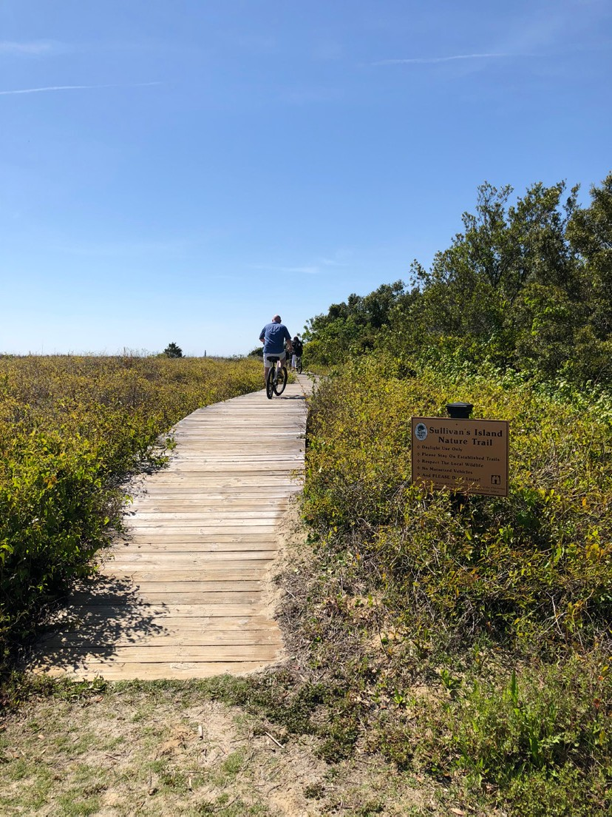
Station 16 – Nature Trail, Sullivan’s Island
Sullivan’s Island is considered a bedroom community with the preponderance of the Town’s land zoned for single-family residential use. Business activity is limited to a two-block Community Commercial District and a handful of allowed home-based business uses. As a beach community close to the City of Charleston, which is a nationally-ranked tourist destination, Sullivan’s Island could potentially generate more traditional tourism and hospitality business revenue streams, such as hotel and vacation rental accommodations; restaurant or nightlife activities; front beach business; and Island festivals and events. Sullivan’s Island, however, receives nominal revenues from accommodations and hospitality taxes, in part due to the vacation rental ban the island enacted in 2005. This makes the Town different from other coastal communities in the area, such as Folly Beach and the Isle of Palms that have incubated vacation rental activities in their residential districts; now only 40 vacation rentals remain on the island. Another factor that keeps the revenues from the accommodations and hospitality taxes low is prohibition in the Community Commercial District on both hotels and restaurants. Although revenues are very low from accommodations and hospitality taxes, the Island maintains a strong tax base
due to higher median property values when compared to the region. These higher property values are in part due to the Island’s unique sense of place that has developed over time as a community of
year-round residences. It is therefore crucial that the prohibition of vacation rentals be continued and closely monitored by Town Staff. As a result, accommodations revenue accounted for only slightly more than one (1) percent (1.3%) of the Town’s annual revenues in FY2023. Likewise, there are only ten
(10) food and beverage establishments in the town and hospitality revenue only accounts for approximately 5.8% of the Town's governmental funds.
Additionally, the Town continues its historical focus on natural resource conservation, specifically by deed restricting and zoning the 190+/- acre maritime forest along the front beach and the 100+/- acre front beach to recreation-conservation space use only, with a prohibition on any business activity on the beach. As such, the Town does not receive

revenue from the typical business activity often found on popular beaches: equipment rentals, photography, refreshment sales, beach sports lessons and/or fitness camps, to name a few.

EXPENSES
Towns that are largely residential incur high service costs that are only offset by property taxes or special use taxes paid by the residents. Sullivan’s Island receives visitors daily to its beaches, with soaring numbers during the summer months; these visitors come for both local day trips and for vacation while lodging in acoomocations located elsewhere in the Charleston region. While these visitors enjoy the Island, they are also protected by the services that the the Town provides including emergency rescue as aprimary example, but the Town does not pass along these expenses related to heavy tourism to its visitors, and it receives nominal to no funding offsets from Charleston County or the State of South Carolina.

FINANCIAL OPPORTUNITIES
In an effort to prioritize how investments are made, financial opportunities should be presented so that Town staff can explore them as they arise. The Town should explore all opportunities to fund facilities and larger infrastructure projects.

Charleston County Funding
CHARLESTON COUNTY TRANSPORTATION COMMITTEE (CCTC): CCTC selects projects on an annual basis to fund within Charleston County. The funds are derived from 2.66 cents per gallon of the state user fee, which is allocated into a County Transportation Fund. The CCTC consists of members who are appointed by the State Legislation. 80% to 90% of the funds go toward preservation, rehabilitation, and reconstruction of the current
network. Up to 10% may be awarded to new projects. The Town received $20,000 from the CCTC for Crosswalks in 2018. More information can be found at http://charlestonctc.org/. okay-jh
TRANSPORTATION SALES TAX (TST): TST is a funding source that is obtained by Charleston County successfully holding a referendum. Charleston County Transportation Development plans, programs, and administers the transportation projects throughout the County. In 2022 and 2023 TST provided funding for traffic control improvements at Station 22 ½ and Middle Street and road pavement work at Conquest Avenue. More information can be found at https://roads.charlestoncounty. org/index.php.
URBAN GREENBELT FUNDING: Urban Greenbelt Funding is provided by Charleston County and can be used to conserve and protect the natural environment. Sullivan’s Island was able to secure funds from Charleston County to build the Station 16 Nature Trail and has now assisted in reconstruction of four beach access boardwalks: Station 18, Station 26 ½ ,Station 27, and ADA accessible boardwalks at Sullivan’s Island Elementary School. More information on Greenbelt Funding can be obtained from www. charlestoncounty.org.

Regional Funding
Berkeley-Charleston-Dorchester Council of Governments (BCDCOG) – BCDCOG is one of ten regional planning councils in South Carolina. BCDCOG primarily assists local governments develop local and regional plans within the tri-county region, as well as providing local governments with planning and technical support to improve

the quality of life in the region. Funding opportunities exist through partnerships with BCDCOG in grants. More information can be located at www.bcdcog.com.
CHARLESTON AREA TRANSPORTATION STUDY (CHATS): CHATS is the Metropolitan Planning Organization (MPO) for the urbanized areas of Berkeley, Charleston, and Dorchester counties. Funding opportunities exist through:
  - Guideshare Funding – Federal dollars used for transportation improvements
  - Transportation Alternatives – Federal dollars used to help fund bicycle and pedestrian projects
More information regarding CHATS can be found at: www.bcdcog. com/transportation-planning/

State Funding
COASTAL ACCESS IMPROVEMENT GRANTS: The South Carolina
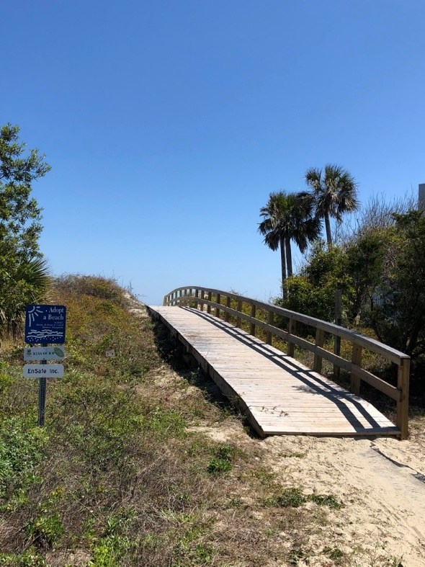
Department of Health and Environmental Controls (DHEC) Ocean and Coastal Resource Management (OCRM) division offers opportunities to improve ADA accessibility to beach access points. These are pass- through Federal funds that are managed by the OCRM division.
Sullivan’s Island was awarded funding for Station 29 (pictured) beach access improvements in 2015. More information regarding funding opportunities can be located at
http://www.scdhec.gov/HomeAndEnvironment/Water/ CoastalManagement/.

SOUTH CAROLINA DEPARTMENT OF PARKS, RECREATION AND
TOURISM (SCPRT): SCPRT offers opportunities to local jurisdictions through a Parks and Recreation Development Fund (PARD). PARD is State funding that can be used for the development for new park and recreation trails or facilities, or an enhancement of existing facilities.
The Town has used PARD grants for projects ranging from historic bandstand renovation to beach access boardwalk enhancements; in 2022 the Town received a PARD grant to engineer and construct phase 2 of the Sullivan’s Island Nature Trails that winds through the maritime forest between Fort Moiultrie and the Sullivan’s Island Lighthouse. More information can be found at www.scprt.com.

SOUTH CAROLINA RURAL INFRASTRUCTURE AUTHORITY: The
State offers a Basic Infrastructure Grant Program, which helps to offset

infrastructure projects such as drainage repair or enhancements. More information can be obtained from https://www.ria.sc.gov/.

MUNICIPAL ASSOCIATION OF SOUTH CAROLINA (MASC): MASC is
a non-profit organization that offers funding to participating members. The money can be used for safety related items such as police protective gear or safety cones. More information regarding MASC and the opportunities can be viewed from www.masc.sc.
SOUTH CAROLINA FORESTRY COMMISSION: The South Carolina
Forestry Commission offers an Urban/Community Forestry Grant to local jurisdictions. The grant can be used to improve Geographical Information System (GIS) studies, tree surveys, and environmental protection projects. In February 2024 the Town received an award from SCFC in partnership with GIC ( (the Green Infrastructure Center) to create a tree canopy map for the entire island; the only match required of the Town will be participation and coordination with the GIC. More information regarding the grant can be located at www.state.sc.us/forest.
Image: Station 29 Sullivan’s Island

Federal Funding

FEDERAL EMERGENCY MANAGEMENT AGENCY (FEMA) HAZARD MITIGATION GRANT (HMGP): FEMA helps
communities declare disaster relief and provides guidance with hazard mitigation measures in an effort to get communities back on track after major events. FEMA also helps individual property owners with elevating of noncompliant/non-elevated homes to protect against flooding. In the unfortunate event of a natural disaster, FEMA will have opportunities for the Town to receive federal funds.

More recently, the Town has received funding opportunities through FEMA’s Hazard Mitigation Grant program for stormwater mitigation. A list of the Town’s awarded grant projects can be found in the Community Facilities Element under Stormwater Management.

More information can be found atwww.fema.gov.
US ARMY CORPS (USACE): Opportunities exist that could help fund beach re-nourishment projects. The Town has been awarded 1.7 million cubic yards of sand to be placed on the beach near Breach Inlet and spread along the beachfront of the eastern corner of the island from the USACE as it works to widen and deepen the channel of the Intercoastal Waterway at its Breach Inlet confluence. Please visit www.usace.army.mil for more information. Okay-jh
RECREATION TRAILS PROGRAM (RTP): Federal funding that is administered through the State of South Carolina’s Parks, Recreation and Tourism (SCPRT) Department. The funds can be used for parks or vehicular/multi-modal trails. More information on the RTP program can be found at www.scprt.com.
COORDINATION
To achieve the goals of this Comprehensive Plan Element, the Town of Sullivan’s Island should facilitate communication between public service and infrastructure providers. The Town of Sullivan’s Island’s Planning Staff should provide written notification to relevant jurisdictions and public service authorities to coordinate the
municipal approval of significant project proposals including emergency and wastewater services. The purpose of this notification process is to increase government efficiency and remove avoidable duplication of tasks.
The Town of Sullivan’s Island’s Planning Staff should facilitate a yearly review of service planning coordination with representatives from utility providers, school districts, SCDOT, SCE&G, CARTA and other entities. This meeting
will facilitate an increased level of dialogue, reduce administrative overlap and ultimately increase efficiency throughout all levels of the municipal approval structure. The Town continues to work in conjunction with Charleston County to provide a 911-consolidated dispatch program to serve the residents and visitors of the Island.
Sullivan’s Island continues to evaluate its current essential services for maximum efficiency and value to the residents: garbage collection, water and wastewater treatment, fire suppression and law enforcement. All services remain a function of Town services with individual departments and staff with one exception, waste collection.
Council deemed the most economical way to provide residential garbage collection is by contracting these services with a garbage collection vendor. Town Council and Staff will continue seeking opportunities to serve on regional and statewide boards to improve Town services.
The Mayor and Council members serve on agency boards providing regional services: CARTA, CHATS, and BCDCOG. Sullivan’s Island and neighboring coastal communities, like Folly Beach and Isle of Palms, hold annual mayor/administrator meetings to discuss and strategize shared solutions to mutually-shared issues unique to area coastal communities.
Town Staff are members of regional and statewide industry related groups, such as SC City County Manager’s Association, the Urban Land Institute (ULI), and various affiliate groups with the Municipal Association of South Carolina (MASC).

Transportation Coordination
The Town of Sullivan’s Island, through coordination with Charleston County and SCDOT, should continually review and analyze existing and alternative funding sources for transportation infrastructure improvements. The municipal boundaries of the Town of Sullivan’s Island, Isle of Palms, and the Town of Mt. Pleasant are closely tied thus further necessitating inter-governmental coordination.
The Town of Sullivan’s Island is also a member of the Charleston Area Transportation Study (CHATS) and participated in the composition of the CHATS Long Range Transportation Plan (LRTP) for the Berkeley-Charleston- Dorchester Region, in order to prioritize regionally significant transportation projects. The CHATS LRTP schedules road construction and enhancement projects with subsequent funding sources. Scheduled transportation projects with corresponding funding sources are identified on the region’s Transportation Improvements Program (TIP). Federal funds for transportation infrastructure improvements are channeled through CHATS.

Sullivan’s Island Comprehensive Plan 2018-2028: Priority Investment Element
116

