99 Sullivan’s Island Comprehensive Plan 2018-2028: Natural Resources Element

CHAPTER 10: RESILIENCY & SEA LEVEL RISE ELEMENT

HOW WE RESPOND

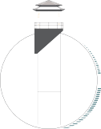

Sullivan’s Island Comprehensive Plan 2018-2028: Resiliency Element 100

RESILIENCY PLANNING…
- Collaboration
- Coordination
- Community engagement

Sustainability- “meeting the needs of the present without compromising the ability of future generations to meet their own needs.”
~Our Common Future

Community Resilience- “the ability to prepare and plan for, absorb, recover from, and more successfully adapt to adverse events.”
~Urban Land Institute

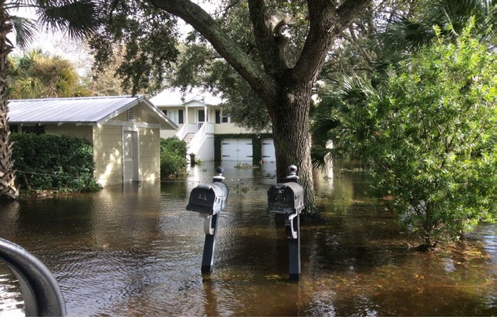
Hurricane Matthew 2016

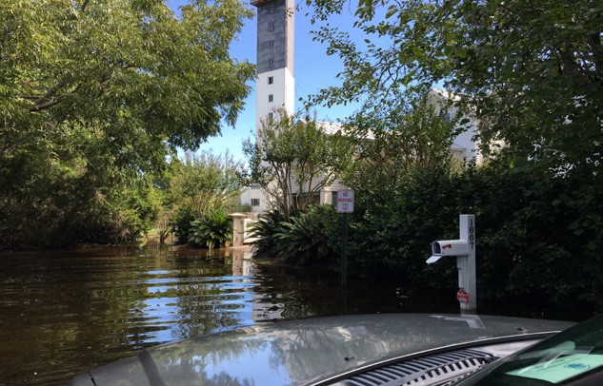
Hurricane Irma 2017

RESILIENCE PLANNING AND ADAPTATION TO SEA-LEVEL RISE
Since the adoption of the 2008 Comprehensive Plan, Sullivan’s Island has taken great strides in promoting sustainable planning initiatives as a means of protecting its natural resources and the quality of life of residents and visitors. The Town began considering local impacts of sea level rise in
the summer of 2010 by participating in a series of discussions to identify management challenges associated with adopting hazard mitigation policy. Although few local policy decisions were made, these discussions brought together a collaborative group of organizations and Town decision makers, including National Oceanic and Atmospheric Administration (NOAA), South Carolina Sea Grant, the Social Environmental Research Institute (SERI).
This section of the Comprehensive Plan is intended to revive a robust public engagement process to develop a series of adaptation actions that will produce two overarching goals: 1) develop mitigation strategies to prepare for future hazards associated with sea level rise; and, 2) align these strategies with existing local and regional plans to enable eligibility of future federal and state grant opportunities (for capital improvement projects: drainage, water/ sewer, renourishment, etc.).
It is important to note that these recommendations and actions are not intended to produce a complete vulnerability and risk assessment or contain an exhaustive list of all potential risks for Sullivan’s Island. Instead, it is geared toward providing an initial strategy and guiding framework for producing a future comprehensive sea-level rise adaptation plan.
These recommendations will also provide a planning projection for accommodating a 2-foot sea level rise within the next fifty years and provide a process for prioritizing these mitigation actions.

LOCAL CHALLENGES
Sea level rise can impact not only homes and private property but also local streets, public utilities, beaches, wetlands, and community facilities, potentially increasing risk to the public’s health and safety. Since 2015, there have been several major weather events that have caused severe and prolonged island-wide flooding. Each of these events has served as a stark reminder of the low-lying topography of the Island and the imminent dangers of sea-level rise. These events include the extreme rain event from the remnants of Hurricane Juaquin in October 2015; Hurricane Matthew in September 2016; and Hurricane Irma in October 2017.
Damage assessments conducted after these events estimated private property impacts of just under $3 million dollars. In addition to the impacts of private property owners, local roads, stormwater infrastructure, water and sewer utilities and public open spaces were affected. Some of these impacts included:

  - Tidal backup of stormwater drainage systems in low-lying areas; saltwater intrusion and flooding of neighborhoods, roads and yards;
  - Increased coastal erosion in the Marshall Boulevard area, however major erosion in all areas of the active beach;
  - Hurricane Irma’s peak wind speeds occurred at high tide creating saltwater intrusion on the western portion of the Island from Station 18 and Thompson Avenue to Star of the West. Massive amounts of debris washed across the western 1/3 of the Island;
  - Roads flooded and were impassable in areas most severely affected.

Over the ensuing five years the Island has continued to feel the effects of extreme weather events; in the 2023 hurricane season, Hurricane Idalia past through the area as a tropical storm, but it brought large-scale flooding and beach erosion to the Island. More recently, on December 17, 2023, a Nor’easter blew through bringing the highest non-tropical system related tide to the area in recorded history; the 9.96-foot tide was the 4th highest ever on record, and it caused the waves on the beach to overwash the primary dune in many places along the Sullivan’s Island coast resulting in salt intrusion that has devasted patches of the maritime forest.

SULLIVAN’S ISLAND NEEDS ASSESSMENT

Table 10.1 reflects a 2019 study that was funded and published by NOAA and the NPS, in which the data are showing a growth curve in the number of annual flooding events occurring in the Charleston Harbor. The 2019 data point of 77 observed flood events was far higher than the estimated 50 events and the observed total from the previous year of 39 flood events. The nearly exponential growth is predicted to continue, and the study suggests that 1.4% of the total hours during the years of 2012-2017 flood waters were at nuisance level, and the projection is for nuisance flooding to occur 7.8% of the time by 2050.
According to the City of Charleston Sea Level Rise Strategy, tidal flooding in the Charleston area averaged two (2) times per year in the 1970s and increased to eleven (11) times per year in the 2000s. This number has increased exponentially to 50 tidal floods in 2015. The NOAA report also describes that these observed and projected increases of nuisance flooding, are reliable indicators of local sea level rise.
NOAA also makes the startling projection that up to 180 tidal floods per year will occur within the Charleston area by 2045. Additionally, long-range scientific predictions indicate that “sea level may rise two (2) to seven (7) feet in the next 100 years.”2

TABLE 10.1

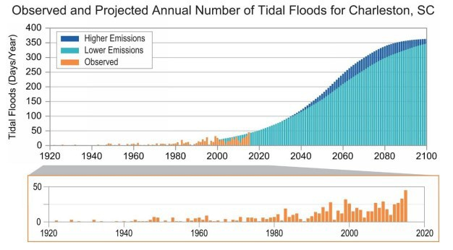

- Folly Beach Sea Level Rise Adaptation Report, March 2017: 6. NOAA, Sea Level Rise and Nuisance Flood Frequency Changes around the US, Technical Report NOS CO-OPS 073. 2014
- “City of Charleston Sea Level Rise Strategy” (2015): 1-5

MAPPING SEA LEVEL RISE
It is clear that sea level rise increases the potential damage and level of risk to stormwater systems, the wastewater system, public streets and private property. Sullivan’s Island maintains an average upland elevation of 7.9 feet (mean high water) with multiple manmade earthen structures that exceed well over 30 feet in height, according to current GIS topographical data.3 Because of the Island’s low-lying elevation and its proximity to the ocean and marsh, homes and nonresidential structures of the Island have historically adapted to the rising waters of major storm events and king tides by elevating their first stories 2 to 4 feet from natural grade as depicted in the photographs.
Until recently, FEMA base flood elevation mapping regulations require homes to be elevated, on average, 6 to 10 feet from grade; however under the updated mapping,adopted in 2021, homes on the Island are not required elevate to that extent anymore, with the regulations typically requiring first floor elevations of only 1 to 4 feet above grade. Regardless of the reduced requirement, most new home construction has continued to provide 8-9 feet from grade to the first story, but a sole reliance on elevating homes cannot be the Town’s only strategy for addressing sea level rise.
A multifaceted approach should be taken when preparing for long-term rising sea levels inclusive of home design (regulatory compliance), public and private stormwater improvements, and right-of-way improvements.
NOAA’s Sea level Rise Viewer application allows the depiction of various scenarios of rising water levels, which can then be used to conduct a visual assessment of areas on the Island that may be impacted by king tides and localized flooding.
Figure 10.1 shows a potential tidal flood impact under a 2-foot sea level rise. This model would severely damage private properties, public roads, and pump stations along the marsh side of the Island and along Marshall Boulevard. Severe saltwater inundation would also be felt across much of the western portion of the Island; from Middle Street to Osceola Avenue, from Star of the West to Station 13. The latest data estimates predict the sea level along the South Carolina coast will rise over 16.5 inches by 2050; the conservative end of the range for the sea level rise is just over 7 inches, and the more dramatic side of the range indicates a rise of up to 21.5 inches. 2

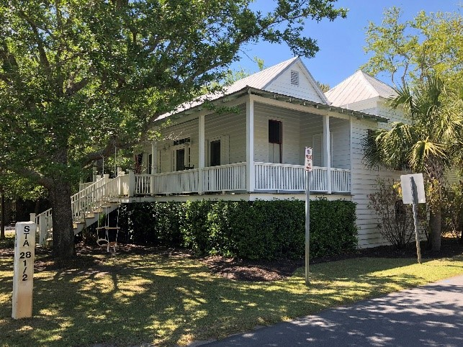
Historic homes were commonly elevated to avoid rising waters from king tides and storm events.

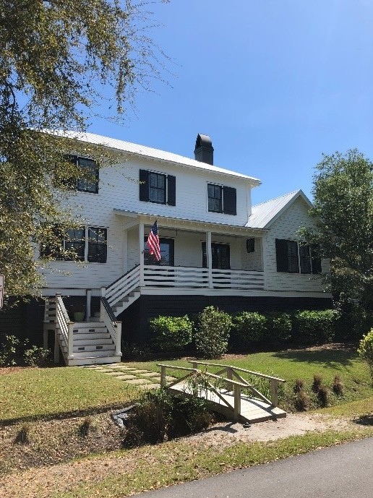
New construction is required to be elevated over the flood elevation.

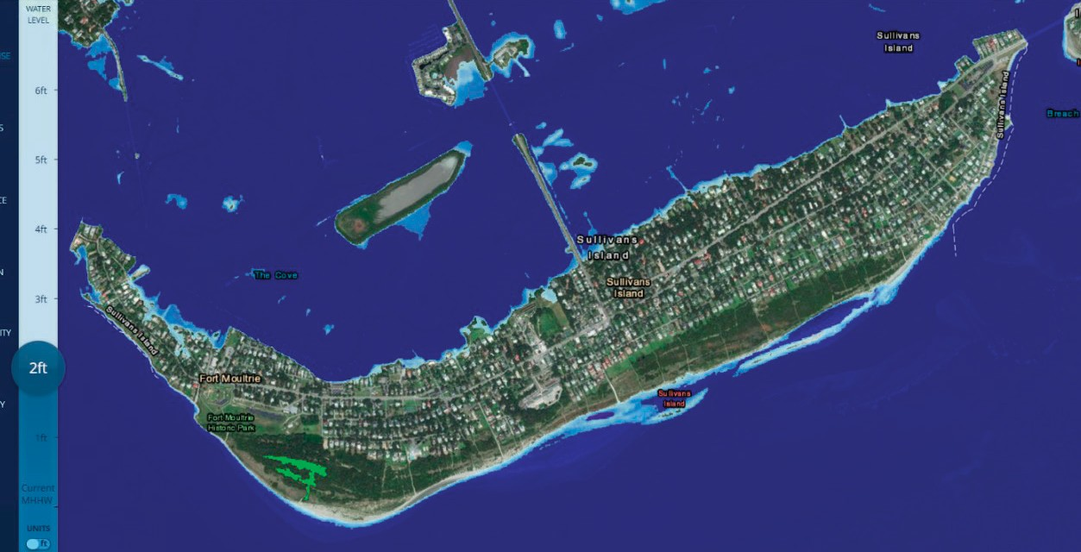
FIGURE 10.1
TWO (2) FOOT SCENARIO

- FEMA’s CRS Data: Provided in GIS format: https://www.fema.gov/faq-details/GIS-Data

2 South Carolina’s Sea Level Is Rising, and It’s Costing over $2 Billion. www.sealevelrise.org/states/south-carolina/

ADAPTATION STRATEGY
Building a resilience framework for Sullivan’s Island should be coordinated, planned and integrated among all Town Departments and across other agencies, and communities in the region.4 A multifaceted strategy should include the following adaptation actions for addressing rising waters:
  - ACTION 1: Stormwater infrastructure improvements
  - ACTION 2: Drainage outfall improvements
  - ACTION 3: Regulatory compliance with SI Floodplain Ordinance
× Residential stormwater plans (SWP)
× Deed restrictions – Non-conversion Agreements
  - ACTION 4: Outreach and community engagement (Community Rating System)

Action 1: Stormwater Infrastructure Improvements

One of most effective strategies for community resilience will involve investment and planning for physical infrastructure improvements. In the next fifty years, the Town should commit to prioritizing stormwater drainage improvement projects to enhance drainage and protect against sea-level rise and flooding. The Town has begun the process of identifying where these island-wide stormwater collection deficiencies are located by working with a local engineering firm. This project is intended to identify critical areas of the Island that experience decreased stormwater drainage for lack of maintenance or a complete lack stormwater conveyance facilities. Major areas identified are the facilities and outfall of the Station 18 and Station 28 watershed basins. Assessments have been made regarding the existing conditions of the stormwater conveyance systems on the Island. The Town has partnered with an engineering firm to map and assess the conditions of the stormwater infrastructure in 2 of the 3 main drainage basins on the island. Details related to the ongoing stormwater management projects the Town is actively engaged with are found in the Community Facilities chapter of the plan, as well as details about planning initiatives to create a Stormwater Master Plan and a Resilience and Sea Level Rise Adaptation Plan. Maps 10.1 and 10.2, below, illustrate some of the baseline data that has already been gathered in support of the Town’s efforts to mitigate the potential ill effects of rising sea levels.

MAP 10.1

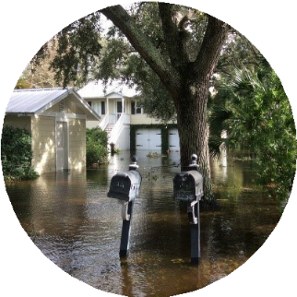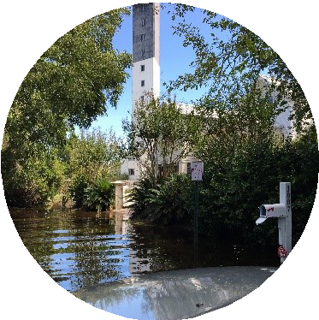
N/A

Inlet

Manhole Pipe IO
N/A

Channel Pipes
Pa rcels
STATION 18 STREET/ATLANTIC AVENUE WATERSHED BASIN

- City of Charleston, Sea Level Rise Strategy December 2015

MAP 10.2

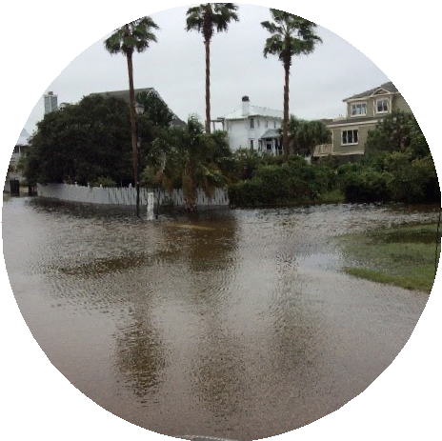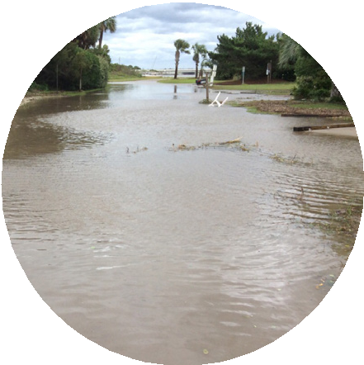
N/A

Inlet

Manhole Pipe IO
N/A

Channel Pipes
Pa rcels

South Basin Improvement: Station 17 to 20 watershed: This project will study the available conveyance system from Station 17 to 20, and between Middle Street and Atlantic Avenue. Severe flooding frequently occurs between Atlantic Avenue and Middle Street during all major flooding events since 2015.
North Basin Drainage Improvement: This project will capture the Station 28 ½ to Station 32 water shed, which falls between Middle Street and Marshall Boulevard. Severe flooding has occurred in this area for each of the above-mentioned storm events and very little drainage is currently available.

Action 2: Drainage Outfall Improvements:
Most of the Island’s surface drainage has long relied upon the major outfalls adjacent to the marsh. The two major watershed basins drain water from highland areas through reinforced concrete pipes (RCP), open ditches, and surface sheet-flow. The Town should encourage SCDOT and Charleston County to improve all pipes, ditches, and outfall junction devices to prevent leakages; and, retrofit pipes with backflow prevention devices to prevent the counter flow of stormwater drainage during king tides, storm surge and rising sea levels.
The drainage outfalls have now been identified as the first step towards improving the island-wide stormwater infrastructure; without functional outfalls the entire system will back up no matter how well it is conveying stormwater towards the outfalls.

Action 3: Enforcement of Local Regulations
Non-conversion Agreements: Non-conversion agreements are a Town strategy for ensuring newly constructed projects remain in compliance with local regulations. Each agreement is considered mandatory prior to allowing the use of a new facility. The agreemeent serves as a deed restriction on the property that confirms no modifications or conversion of enclosed space will occur below the FEMA Base Flood Elevation.
Stormwater plans: In 2016 the Town began requiring property-wide stormwater management plans for any new development proposing an impervious surface of 625 square feet or more. Most new home construction projects and additions select from a variety of best management practices which may be designed as part of their overall building-permit application. A professional civil engineer or registered landscape architect must certify that these plans are constructed correctly and maintained.

The Town staff has been diligently enforcing the regulations for Non-conversion Agreements to ensure compliance with enclosure of spaces located below the FEMA Base Flood Elevation and for Stormwater plans, which require that new constructions and land disturbances that increase impervious surface coverage on a property in excess of 625 square feet are engineered to create no adverse impacts to downstream or adjacent properties. To date, since the Town enacted the ordinance requiring stormwater management plans in 2016, roughly 200 stormwater management plans have been certified and implemented across the island.

MAP 10.3

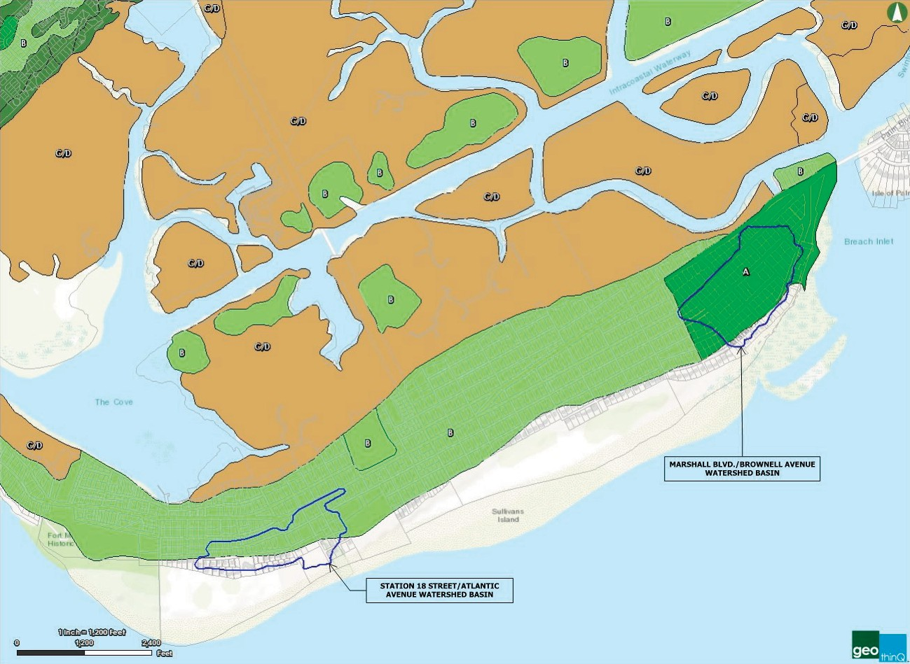

Action 4: Community Outreach Strategies (Community Rating System)
In addition to taking action on Island-wide drainage projects, the Town participates in the National Flood Insurance Program (NFIP). As part of its longtime participation, the Town enforces regulations and building codes that require flood resistant construction and requirements for stormwater quality and control.
The Town has adopted a “freeboard” requirement that mandates all new structures or substantial improvements be built an additional one foot above the designated base flood elevation (BFE). Nearly the entire Island is located within the floodplain or Special Flood Hazard Area (SFHA), so compliance with these standards is of the utmost importance. The Town is also a member of the NFIP Community Rating System (CRS). This program recognizes community outreach practices that make properties more resistant to flood damage and aware of the impacts of sea level rise. The Town recently received an improvement in its ISO flood class rating from a 6 to a 5. This class 5 rating lowers the cost of flood insurance for all citizens and businesses by 25%. In June 2016, FEMA released a draft of the new FIRM data indicating substantial changes to the Island’s SFHAs. Town staff anticipates adoption of this new data in early 2019.

The Town continues its participation in the National Flood Insurance Program’s Community Rating System (NFIP’s CRS) to strengthen the Town’s flood readiness and resistance to flood damages. Using the program for guidance in crafting the Town’s construction requirements and stormwater controls, the Town has earned an ISO flood class rating of 5 in 2019 and maintained that status following the 2023 FEMA inspections. The lower the ISO flood class rating is for a jurisdiction, the lower the insurance rates are for that jurisdiction’s residents; a Class-5 rating earns the Town’s residents a 25% discount on their flood insurance policies. AS of October 1, 2023, there are 1749 communities participating in the CRS program and 47 in South Carolina. Nationwide only 26 communities have a lower rating than the Town of Sullivan’s Island, and in South Carolina, only Charleston County and the City of Folly Beach have lower ratings.
As described in the City of Charleston Sea Level Rise Strategy, “Part of resilience is knowing one can’t plan for everything that may occur but instead being able to deal with and adapt to unexpected situations.” The above noted actions will improve the Town’s “response to, communication during, and management of flooding and related events to minimize service disruptions and to ensure public safety and quality of life. The adaptation actions presented in this chapter will help improve the Town’s response to, communication during, and management of flooding and related events to minimize service disruptions and to ensure public safety and quality of life. The Town anticipates adoption of new FIRM data which will result in lower flood zones island- wide. This will not only 5reduce the number of substantial improvement elevations required but also protect historic structures from damaging the character of their surrounding districts through incompatible alterations.

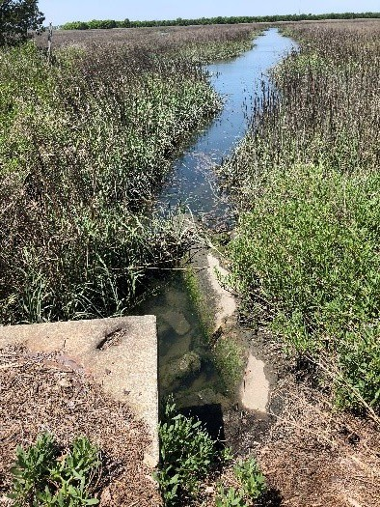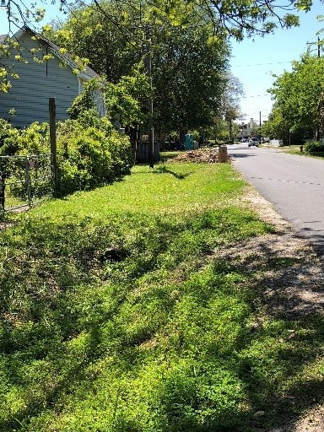

Stormwater outfalls:
A damaged and cracked pipe on the right is located well below the water level creating problems with drainage.
Open ditches:
Unmaintained ditches can obstruct water flow and overall functionality of the storm drainage system.

- City of Charleston, Sea Level Rise Strategy December 2015

