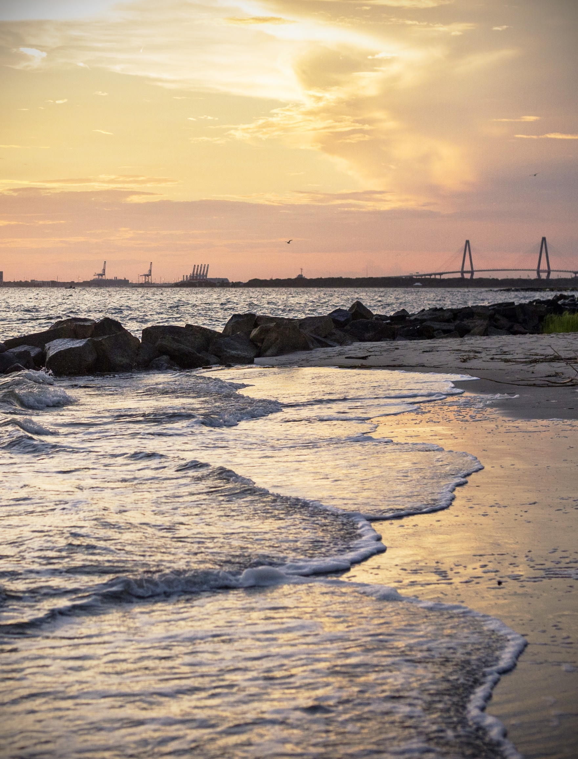

CHAPTER 1: INTRODUCTION

HOW WE BEGIN

Source: Charleston CVB

“Make big plans; aim high in hope and work.”
~Daniel Burnham
The Comprehensive Plan is a “living” document that guides the long-range physical development of the Town. The Plan is developed through a robust public process that involves citizens, staff, and the
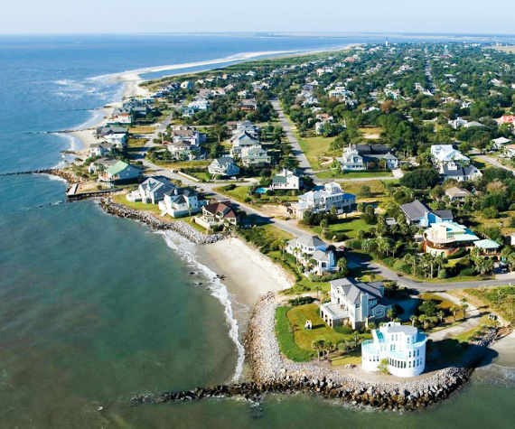
elected and appointed bodies for the Town of Sullivan’s Island.
Each revision of the plan offers Island residents an opportunity to enhance the framework guiding growth and development in the Town over the next 10 to 20 years. Although visions may be different over time, they share
common qualities. As stated in the vision statement, Sullivan’s Island is an exceptional community that focuses on livability, environmental and historic preservation and a place where citizens are true partners in their Town government.
The basis of the comprehensive planning process is in the South Carolina Local Government Comprehensive Planning Enabling Act of 1994 (SC Code
§6-29-310 through §6-29-1200), which repealed and replaced all existing state statutes authorizing municipal planning and zoning. The 1994 Act established the Comprehensive Plan as the essential first step of the planning process and mandated that the plan must be systematically evaluated and updated. As such, elements of the plan must be re-evaluated at least once every five years, and the entire plan must be rewritten every ten years; this document is the five-year review of the 2018 Comprehensive Plan.
A comprehensive plan provides a vision, clearly stated and shared by all, that describes the future of the community. It protects private property rights and also encourages and supports economic development. The plan inventories the Town’s existing conditions and amenities and assesses their functionality and relationship to one another. This inventory enables the Town to take stock of where they are today (strengths and weaknesses) and where they want to go (goals and objectives).

PURPOSE
The Comprehensive Plan provides a primary basis for evaluating all future development, redevelopment and land use decisions in Sullivan’s Island, and assists the community in achieving the development patterns it
desires, such as traditional neighborhoods, infill development, and those creating/maintaining
a sense of place, providing transportation alternatives, protecting natural resources and accommodating economic growth.
The plan is “long-range” in that it has a planning horizon of 20 years, and is “comprehensive”
in that it covers the entire Town. Furthermore, it encompasses all the functions that make a community work and

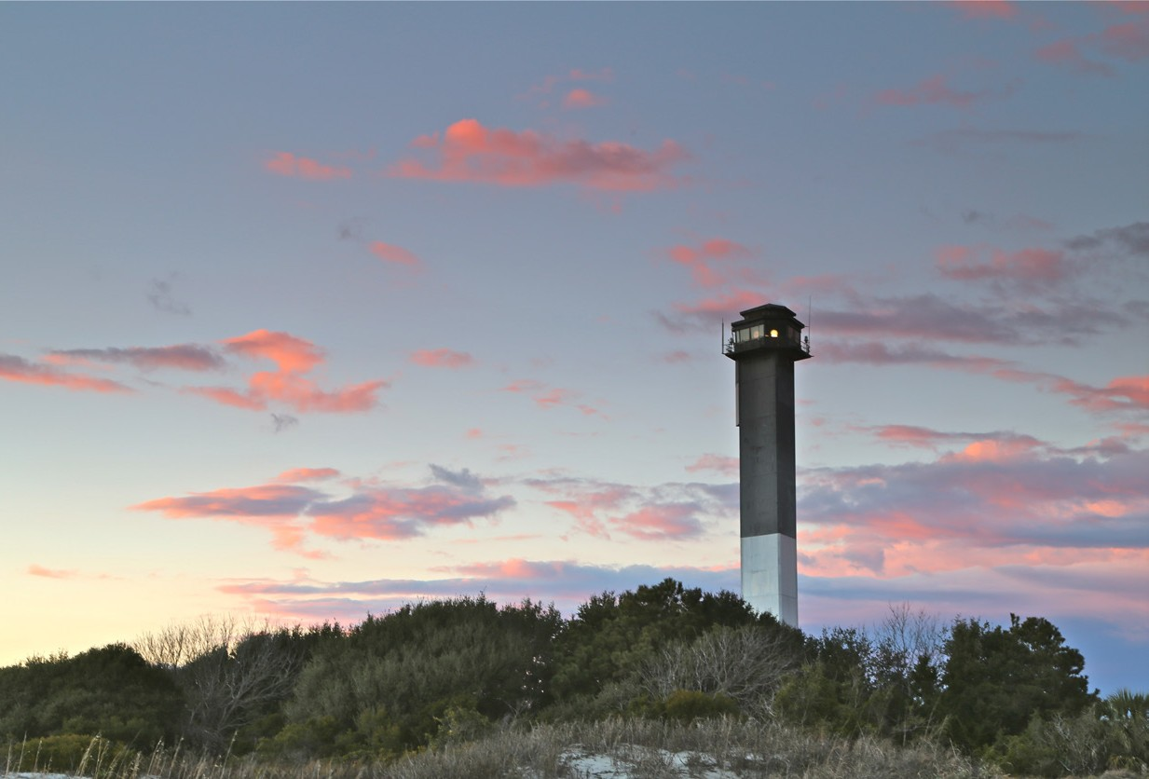
Source: Charleston CVB

considers the interrelatedness of these functions. The Comprehensive Plan is intended to generate local pride and enthusiasm about the future of the community, thereby ensuring that citizens are involved with the implementation of the plan.
As directed by the South Carolina Planning Enabling Act, the following ten elements are included:

- Population
- Housing
- Economic Development
- Natural Resources
- Cultural Resources
- Community Facilities
- Transportation
- Land Use
- Resiliency (and Sea Level-Rise)
- Priority Investment

The Resiliency and Sea Level-Rise Chapter, was added to the 2018 Comprehensive Plan to address the emerging importance of climate change and its effects on coastal communities. The Sullivan’s Island community is at the forefront, feeling the early effects of rapid climate changes, and taking actions to preserve what is important and adapt where it is necessary. The 2018 Comprehensive Plan recognized the need for concerted efforts to address these climate changes, implementing the Resiliency and Sea Level-Rise Chapter two years before the State legislature amended the South Carolina Local Government Comprehensive Planning Enabling Act to require a Resiliency element.
The most important issues identified by residents at the public kickoff meeting in 2018, as well as throughout that planning process by the Planning Commission, continued to be in the spotlight for residents and Commissioners in 2023. These issues include:

- Maintaining the small-town atmosphere
- Preserving open space
- Protecting the natural environment
- Preserving historic buildings and sites
- Protecting the single-family residential character
- Preserving the integrity of the island way of life

Stormwater management is not a new issue to the Island residents, but in the 2023-24 planning process it has risen to the top of mind for many of the Town’s citizens.

Sullivan’s Island Comprehensive Plan 2018-2028: Introduction
4

PUBLIC ENGAGEMENT
An essential component to any plan is public engagement. Public engagement helped to inform this Comprehensive Plan by providing an avenue for citizens to communicate their ideas and needs for the future of the Town. Every meeting from the Open House to each month’s Planning Commission meeting, provided an opportunity for citizen input. An online survey was used to provide an avenue for citizens who could not attend
in-person meetings to provide feedback. Appendix A has fully detailed the public engagement process which lists all of the meetings and feedback that was provided; this information was used to help write the plan.

VISION
Through its long history, Sullivan’s Island has become an exceptional community on the coast of South Carolina that focuses on livability, promotes preservation of the natural environment and its historic character, and fosters a small-scale and unique business district.

GUIDING PRINCIPLES
The guiding principles will help influence the writing for each chapter and the goals and objectives throughout the 2023 Comprehensive Plan review. They are intentionally concise and provide clear direction for the future of Sullivan’s Island.
- Sullivan’s Island will strive to maintain a small-town feel that originated from its past and which continues to this day.
- Sullivan’s Island will work to remain a predominately low density,¬ single family community.
- Sullivan’s Island will work to promote its historic districts and maintain a small and unique business district.
- Sullivan’s Island will continue to maintain and preserve the natural environment including, but not limited to trees, beaches, sand dunes, marshes, creeks, public vistas and access points, as well as the accreted lands to the benefit of all of the residents and wild life it preserves.
- Sullivan’s Island will protect and maintain public amenities, such as parks and town facilities to sustain the town’s sense of community and connectedness.
- Sullivan’s Island will ensure that the architecture is compatible with the existing Island character, neighborhoods and historic fabric.
- Sullivan’s Island will promote and expand public open spaces with a commitment to sustainability for the benefit of future generations.

