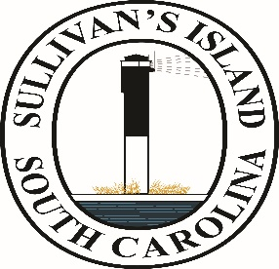

Town of Sullivan’s Island
2027 Holidays Observed

New Year’s Day – January 1, Friday
Martin Luther King Day – January 18, Monday
Presidents’ Day – February 15, Monday
Memorial Day – May 31, Monday
Independence Day – July 5, Monday (Observed day after)
Labor Day – September 6, Monday
Veteran’s Day – November 11, Thursday
Thanksgiving – November 25, Thursday
Day after Thanksgiving – November 26, Friday
Christmas Eve – December 24, Friday
Christmas Day – Observed December 27, Monday
Day after Christmas – Observed December 28, Tuesday

